In early 2009, when she was just 11 years old, Yousafzai began blogging for the BBC about living under the Taliban's threats to deny her an education. In order to hide her identity, she used the name Gul Makai. However, she was revealed to be the BBC blogger in December of that year.
With a growing public platform, Yousafzai continued to speak out about her right, and the right of all women, to an education. Her activism resulted in a nomination for the International Children's Peace Prize in 2011. That same year, she was awarded Pakistan's National Youth Peace Prize.
Yousafzai and her family learned that the Taliban had issued a death threat against her because of her activism. Though Yousafzai was frightened for the safety of her father — an anti-Taliban activist — she and her family initially felt that the fundamentalist group would not actually harm a child.

Shot by the Taliban
On October 9, 2012, when 15-year-old Yousafzai was riding a bus with friends on their way home from school, a masked gunman boarded the bus and demanded to know which girl was Yousafzai. When her friends looked toward Yousafzai, her location was given away. The gunman fired at her, hitting Malala in the left side of her head; the bullet then traveled down her neck. Two other girls were also injured in the attack.
The shooting left Yousafzai in critical condition, so she was flown to a military hospital in Peshawar. A portion of her skull was removed to treat her swelling brain. To receive further care, she was transferred to Birmingham, England.
Once she was in the United Kingdom, Yousafzai was taken out of a medically induced coma. Though she would require multiple surgeries—including repair of a facial nerve to fix the paralyzed left side of her face — she had suffered no major brain damage. In March 2013, she was able to begin attending school in Birmingham.
The shooting resulted in a massive outpouring of support for Yousafzai, which continued during her recovery. Unfortunately, the Taliban still considers Yousafzai a target, although Yousafzai remains a staunch advocate for the power of education.
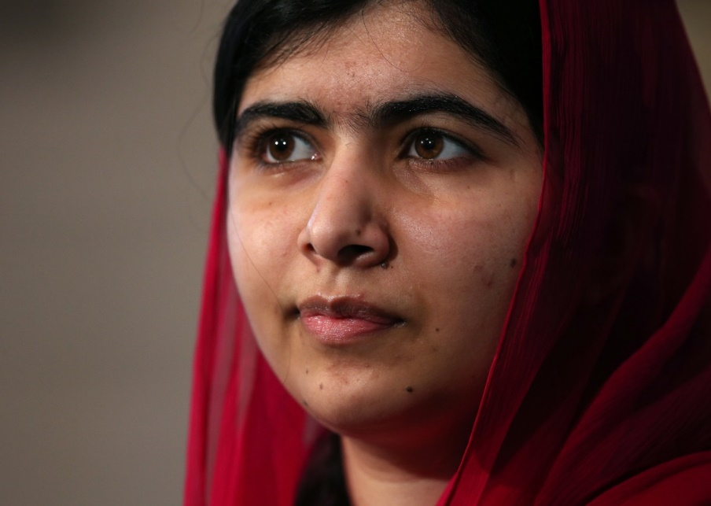
(Photo: Dan Kitwood - WPA Pool/Getty Images)

Speech at the U.N.
Nine months after being shot by the Taliban, Yousafzai gave a speech at the United Nations on her 16th birthday in 2013. Yousafzai highlighted her focus on education and women's rights, urging world leaders to change their policies.
Following the attack, Yousafzai said that “the terrorists thought that they would change our aims and stop our ambitions, but nothing changed in my life except this: weakness, fear and hopelessness died. Strength, power and courage were born.”
Yousafzai also urged action against illiteracy, poverty and terrorism:
“The extremists were, and they are, afraid of books and pens. The power of education frightens them. They are afraid of women... Let us pick up our books and pens. They are our most powerful weapons.”

Malala Day
At Yousafzai’s 2013 speech at the United Nations, Secretary-General Ban Ki-moon pronounced July 12th – Yousafzai's birthday – 'Malala Day' in honor of the young leader’s activism to ensure education for all children. At the announcement, Ban said:
“Malala chose to mark her 16th birthday with the world. No child should have to die for going to school. Nowhere should teachers fear to teach or children fear to learn. Together, we can change the picture.”

Awards
In October 2013, the European Parliament awarded Yousafzai the Sakharov Prize for Freedom of Thought in acknowledgment of her work. In October 2014, Yousafzai became the youngest person to receive the Nobel Peace Prize, at just 17 years old; she received the award along with Indian children's rights activist Kailash Satyarthi.
Yousafzai was first nominated for the Nobel in 2013 but did not win. She was renominated in March 2014. In congratulating Yousafzai, Pakistani Prime Minister Nawaz Sharif said: “She is (the) pride of Pakistan, she has made her countrymen proud. Her achievement is unparalleled and unequaled. Girls and boys of the world should take lead from her struggle and commitment." Former U.N. Secretary-General Ban Ki-moon described Yousafzai as "a brave and gentle advocate of peace who, through the simple act of going to school, became a global teacher.”
In April 2017, United Nations Secretary-General Antonio Guterres appointed Yousafzai as a U.N. Messenger of Peace to promote girls education. The appointment is the highest honor given by the United Nations for an initial period of two years.
Yousafzai was also given honorary Canadian citizenship in April 2017. She is the sixth person and the youngest in the country’s history to receive the honor.

BOOK AVAILABLE IN YOUR LIBRARY
Questions to speak about
- Malala was only 15 years old when she was shot for being an activist. Which of the 9 Habits and SHEPPEY values did she display and how?
- Is there anything in the current news that links to Malala’s activism? How?
- Is there anything you feel strongly about? Why?

