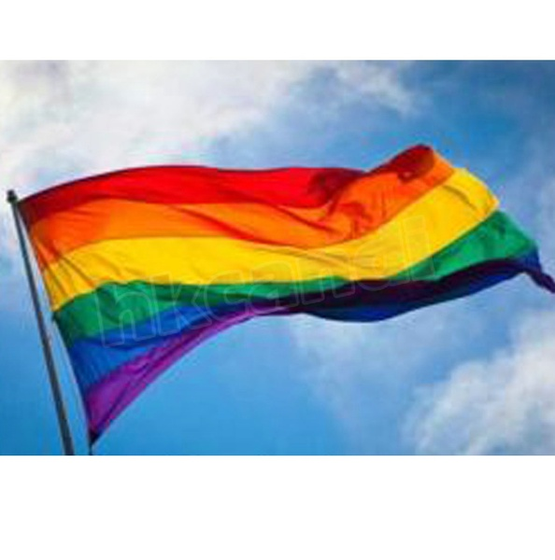Celebrations this year will look different. According to an open list maintained by the European Pride Organisers Association, nearly 500 Pride events have been cancelled or postponed due to the coronavirus pandemic.

To rectify that loss, Taylor — along with the EPOA and InterPride, an international cohort of Pride organizers — are putting together “Global Pride.” The virtual, 24-hour event will begin on Saturday, June 27, and run through Sunday, June 28. Viewers will see performances by Pabllo Vittar, Olivia Newton-John, the Dixie Chicks, and more, according to a May press release.
No login or payment will be required, according to Taylor; the event is free and available to anyone with Wi-Fi.
“Wherever you are in the world, you’ll be able to see content from Prides in India, in Taiwan, in Australia … right the way across to the West Coast, USA,” Taylor said, adding that the online format could also bring Pride events to people who wouldn’t otherwise have access. “Like [the ones] in Central Africa, which are frequently attacked by police. Or the Prides in India, that cause controversy.”
India’s Prince Manvendra Singh Gohil, the first openly gay prince of India, is one of a handful of world leaders who will also be featured in Global Pride, according to the press release. Carlos Alvarado Quesada, president of Costa Rica, where last week same-sex marriage was legalized — will also speak during the event, along with Prime Minister Erna Solberg of Norway, and Prime Minister Xavier Bettel of Luxembourg.
The event, featuring a line-up of world-renowned artists and change-makers, will take place exclusively on a screen. There will be no marching through the streets in unavoidable waves of rainbow, leaving some LGBTQ community members worried that the “virtual” aspect could push already isolated communities further into obscurity.
“It’s easier to ignore if it is not in a physical public space,” said Kieran Robertson, a 23-year-old who identifies as queer from Edinburgh, Scotland. “I know on Twitter, at least, there are words that you can block. So you won’t get any tweets that have that word in it. So if people wanted to do that, they could. Whilst if it’s down the street, that’s much harder to avoid.”
Global Pride will look similar to modern Pride events in one aspect — corporations will be sponsoring the event. Critics say Pride has become a space for companies to virtue-signal their support for the LGBTQ community.
Some LGBTQ community members say it’s those same corporations that exploit and oppress people of colour. Pride is a celebration, but by nature, it’s also a protest. At Toronto Pride in 2016, the city’s Black Lives Matter group staged a sit-in and stopped the parade from proceeding for nearly 30 minutes. They asked for better representation at Pride and a ban on police floats in future parades. Toronto Pride’s executive director signed the list of demands on the spot.
Taylor says activist groups will be a key feature of the virtual Global Pride event.
“We’ll be featuring them, we’ll be featuring their issues. In some countries, you can still be given the death penalty for being LGBTI [lesbian, gay, bisexual, transgender,]. So, it’s absolutely critical that we have a balance between those different issues,” he said

When and where did the first Gay Pride take place.?
What is the prince of India’s name?
How many of the nine habits are used in Pride gatherings.
BLM and LGBTQ want to merge as one, would you think this would work?
Will you have to pay for the “Global Pride” event?

