* Trachea
* Lungs
* Diaphragm
* Pharynx
* Bronchi
* Bronchioles
* Nasal cavity
* Larynx
* Alveoli

**Entry Activity:** 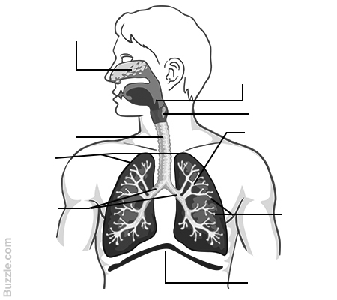

**BTEC Sport**

**Cardio respiratory introduction**

**What is the cardiovascular system made up of**?



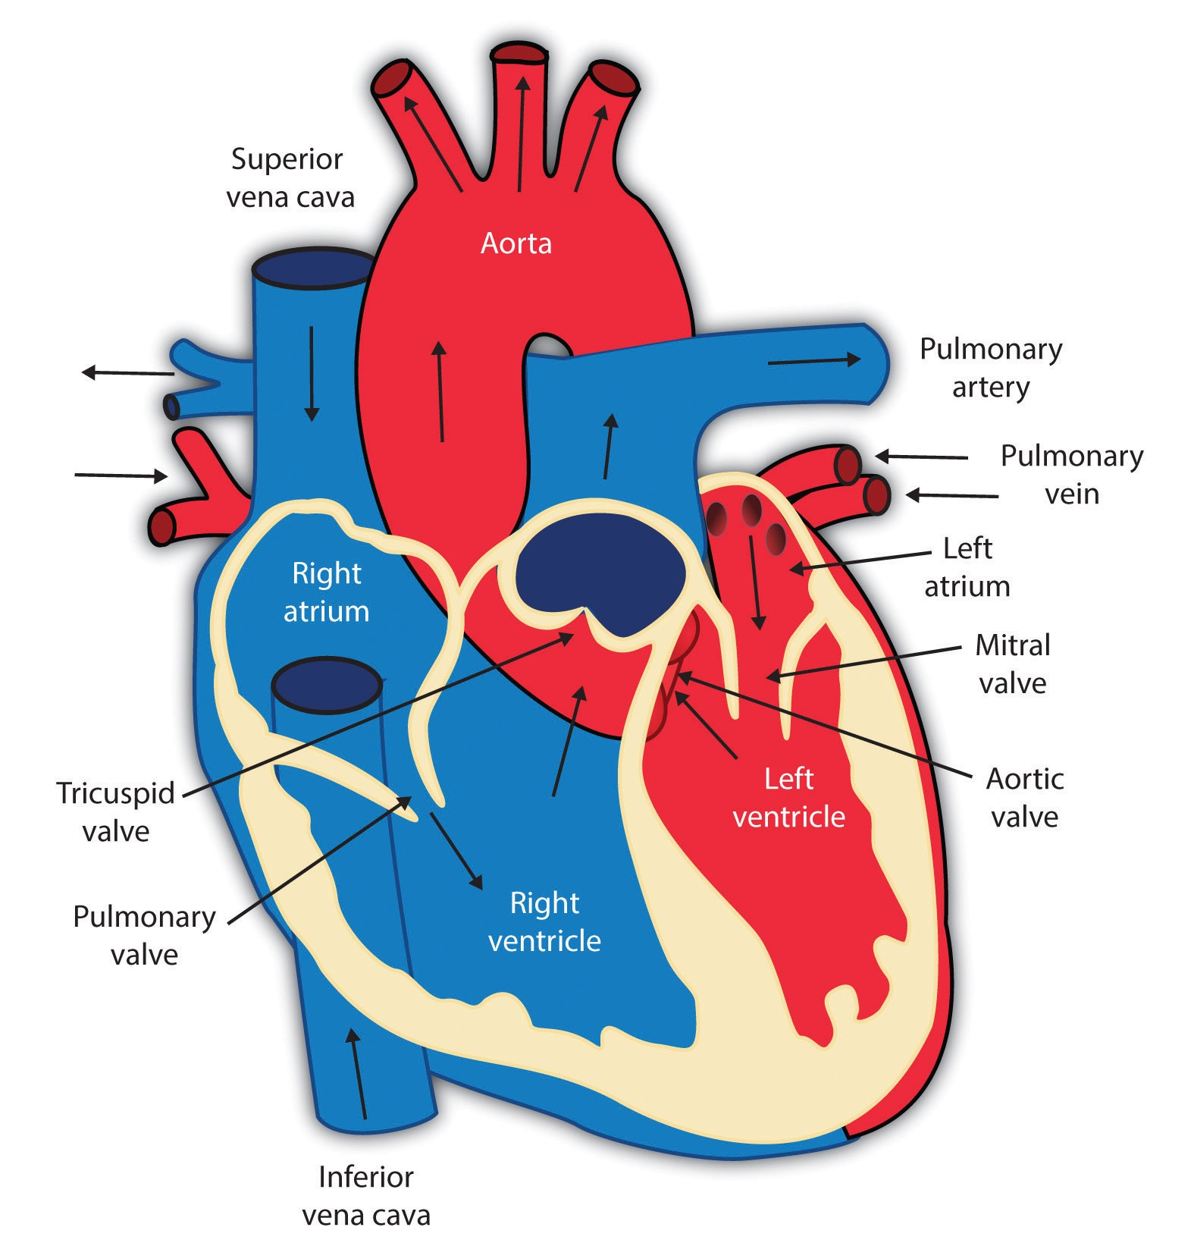

**What is blood made up of?**

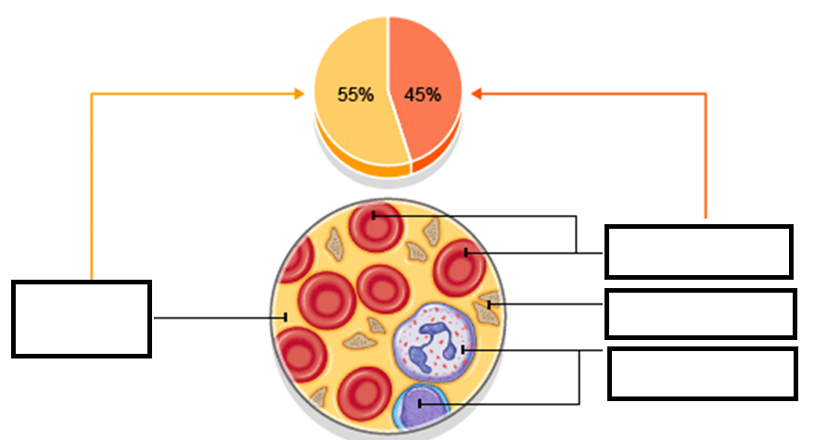

**How does oxygen enter the body?**

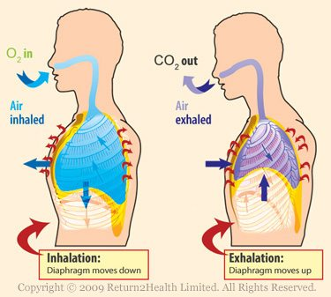

**Inspiration**

The d_____________ contracts and moves ___________. The intercostal m________ contract and move the r______ u_________ and o____________ This increases the size of the _______and decreases the air pressure inside it which sucks air into the lungs.

**Expiration**

The d______________ r___________ and moves u______________. The i__________________ muscles relax so the ribs move inwards and d____________ . This d____________ the size of the c__________ and increases the air pressure in the chest so air is forced out of the lungs.

**Veins**

Function=________________________________________________________________________________________________________________________________________________________________

**Structure**

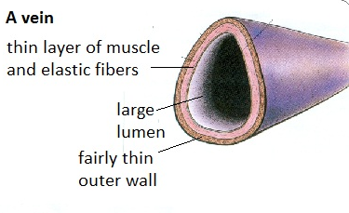

**Arteries**

Function=_______________________________________________________________________________________________________________________________________________________

**Structure**

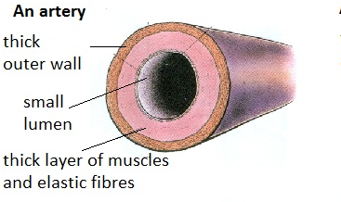

**Capillaries**

Function=_________________________________________________________________________________________________________________________________________________________

**Structure=**

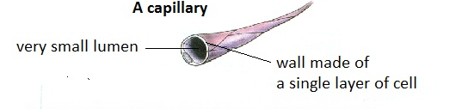

**Question  
  
Using the information recorded on your broadsheet … Explain how the cardiorespiratory system works to deliver oxygen around the body?**

________________________________________________________________________________________________________________________________________________________________________________________________________________________________________________________________________________________________________________________________________________________________________________________________________________________________________________________________________________________________________________________________________________________________________________________________________________________________________________________________________________________________________________________________________________________________________________________________________________________________________________________________________________________________________________________________________________________________________________________________

________________________________________________________________________________________________________________________________________________________________________________________________________________________________________________________________________________________________________________________________________________________________________________________________________________________________________________________________________________________________________________________________________________________________________________________________________________________________________________________________________________________________________________________________________________________________________________________________