**Learning objectives;**

**To know**: the three systems used to supply our body with energy.

**To understand**: the key characteristics of each system.

**To be able to**: Explain how each energy system is utilised within a single sport.

Entry Activity:

The component of fitness which is most important for Usain Bolt is

The component that Mo Farah would rely on is

Usain Bolt would train at between to % of his HR Max. This is in the training zone.

Mo Farah would train at between to % of his HR Max. This is in the training zone.

Key Terms:

Respiration –

Anaerobic –

Aerobic –

Adenosine Triphosphate (ATP) -

**BTEC Sport**

**Energy Systems**

**Lesson 1**

System characteristics:

1. ATP PC System:

Adenosine Triphosphate =

The respiration process;

1. Stored ATP in the muscle fibres is broken down…

2. ADP is then left as…

3. There is enough ATP for…

4. After the ATP stores are depleted…

5. This phosphate then…

6. There’s enough stored Phosphocreatine (PC) to…

7. Once both stores are depleted…

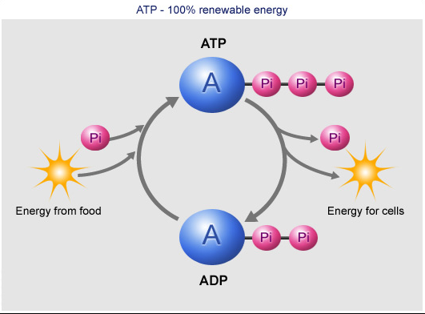

|  |  |
| --- | --- |
| Characteristic: | ATP PC System |
| Fuel source: |  |
| Intensity of activity: |  |
| Duration of production: |  |
| ATP Produced: |  |
| Speed of production: |  |
| Main by-product: |  |

Sports which rely on this energy system;

1.

2.

3.



Key terms:

Glucose:

Glycogen:

Lactic Acid:

Glucose vs Glycogen:

Glucose comes from which is in foods such as and .

Glycogen is because we cannot store glucose.

When we need to create energy the glycogen is as we cannot break glycogen down to create energy.

**BTEC Sport**

**Energy Systems**

**Lesson 2**

**Learning objectives;**

**To know**: the three systems used to supply our body with energy.

**To understand**: the key characteristics of each system.

**To be able to**: Explain how each energy system is utilised within a single sport.

System characteristics:

|  |  |
| --- | --- |
| Characteristic: | Glycolysis |
| Fuel source: |  |
| Intensity of activity: |  |
| Duration of production: |  |
| ATP Produced: |  |
| Main by-product: |  |

Sports which rely on the glycolysis system:

1.

2.

3.

Respiration Process;

1. Glucose is broken down in to , this process creates 2 ATP.

2. A by-product of this process is…

3. When the build up of…

4. Glycolysis can last for up to…

Glycolysis equation;

+

Entry Activity:

1. Glycolysis is the break down of…

2. Glycogen is…

3. The Glycolysis energy system lasts for roughly…

4. Three sports which rely on the ATP PC system as their main source of energy include…

5. The amount of ATP Produced during the Glycolysis respiration process is…

**BTEC Sport**

**Energy Systems**

**Lesson 3**

Respiration Process;

1. Glucose is combined with oxygen inside the…

2. The by-product of this process are…

3. This energy system can continue for a long period of time because..

4. Once glucose stores are depleted the body begins to use…

5. Fatty acids produce a higher yield of ATP, however…

6. This causes the athlete to feel…

Aerobic Equation:

+ + +

System characteristics:

|  |  |
| --- | --- |
| Characteristic: | Aerobic energy system |
| Fuel source: |  |
| Intensity of activity: |  |
| Duration of production: |  |
| ATP Produced: |  |
| Main by-products: |  |

Sports which rely on the glycolysis system:

1.

2.

3.

**Learning objectives;**

**To know**: the three systems used to supply our body with energy.

**To understand**: the key characteristics of each system.

**To be able to**: Explain how each energy system is utilised within a single sport.