**BTEC Sport**

**Musculoskeletal Short Term Adaptations**

**Lesson 1**

Increased Production of Synovial Fluid:

1. As we exercise…
2. This is important because…
3. The synovial fluid becomes…
4. The fluid also…

This would help in a sport such as……..

Because…….

Do Now:

Cranium Patella Clavicle Ulna Tibia Humerus

Pelvis Carpels Femur Ribs Radius Fibula

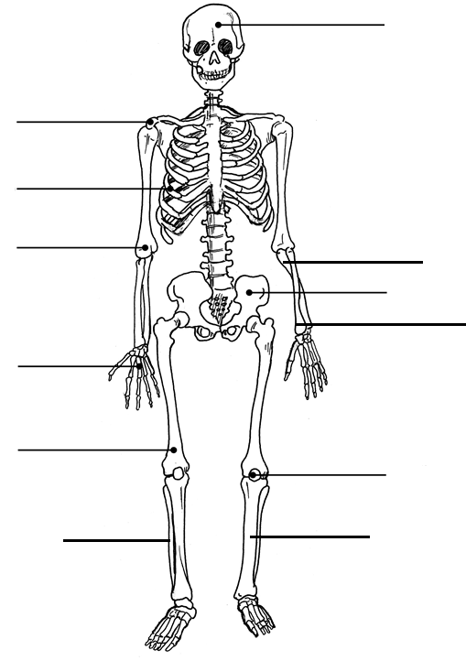

Key Terms:

Musculoskeletal system –

Synovial Fluid –

Skeleton–

Muscles –

Viscous -

Increased Range of Movement:

1. As we exercise…
2. This is because…
3. This allows…
4. Therefore, this is why…

An increased range of movement helps in sports such as……..

Because…….

Micro Tears in Muscle Fibres:

1. Our muscles are…

2. As a result of…

3. These micro tears repair…

What are the benefits?

4. You become…

5. As a result you will be able to …

- This would help in a sport such as… Because…

**BTEC Sport**

**Musculoskeletal Short Term Adaptations**

**Lesson 2**

Do Now:

Abdominals Triceps Latissimus Dorsi Hamstrings

Biceps Gastrocnemius Gluteus Maximus Erector Spinae

Quadriceps Deltoid Pectoralis major Trapezius

Increased metabolic activity:

1. Metabolism is…

2. Exercise causes…

3. To be able to maintain exercise…

This would help in a sport such as… Because…

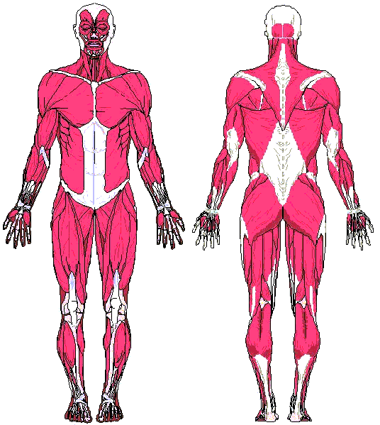

Key Terms:

Synovial joints –

Metabolism –

Tendons –

Pliable -

New Bone Formation:

1. Weight training…

2. Causes osteoblasts to…

What is the benefit of this response?

3. This causes…

4. As a result this...

This would help in a sport such as… Because…