Unit 1
Fitness for Sport and Exercise

Fitness Training Methods

Name: __________________________________________________________

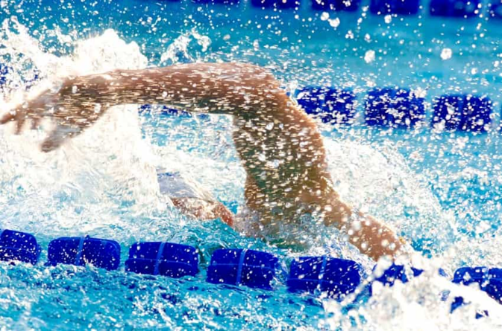 | Speed  Acceleration sprints as a swimmer will need to get faster throughout the short race
Muscular Strength
Weight training for muscular strength as a swimmer will need a lot of fast and explosive strength to move their arms and legs through the water quickly

Power
Plyometrics as a swimmer will need to get a massive amount of power and speed at the start to give them an advantage into the water

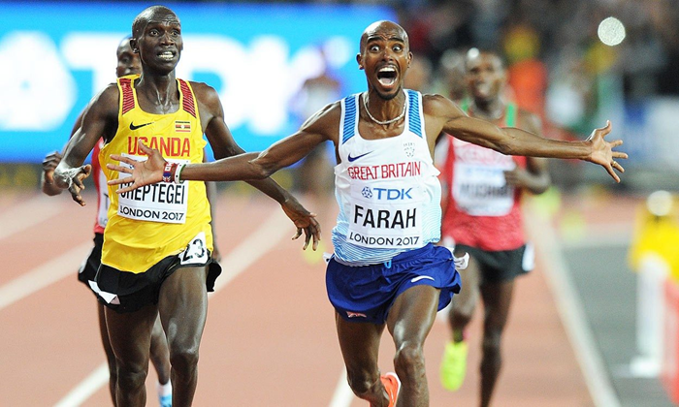 | 10.000m  _____________________________________________  _____________________________________________  _____________________________________________  _____________________________________________  _____________________________________________  _____________________________________________  _____________________________________________  _____________________________________________  _____________________________________________  _____________________________________________  _____________________________________________  _____________________________________________  _____________________________________________  _____________________________________________  _____________________________________________
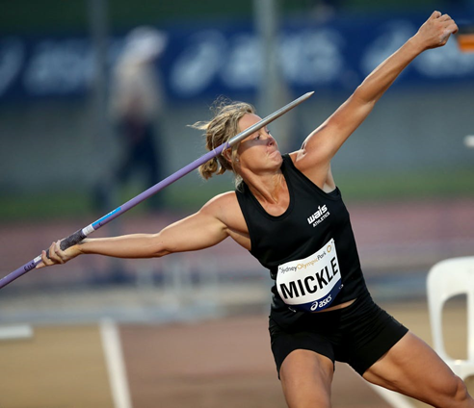 | Javelin  _____________________________________________  _____________________________________________  _____________________________________________  _____________________________________________  _____________________________________________  _____________________________________________  _____________________________________________  _____________________________________________  _____________________________________________  _____________________________________________  _____________________________________________  _____________________________________________  _____________________________________________  _____________________________________________  _____________________________________________
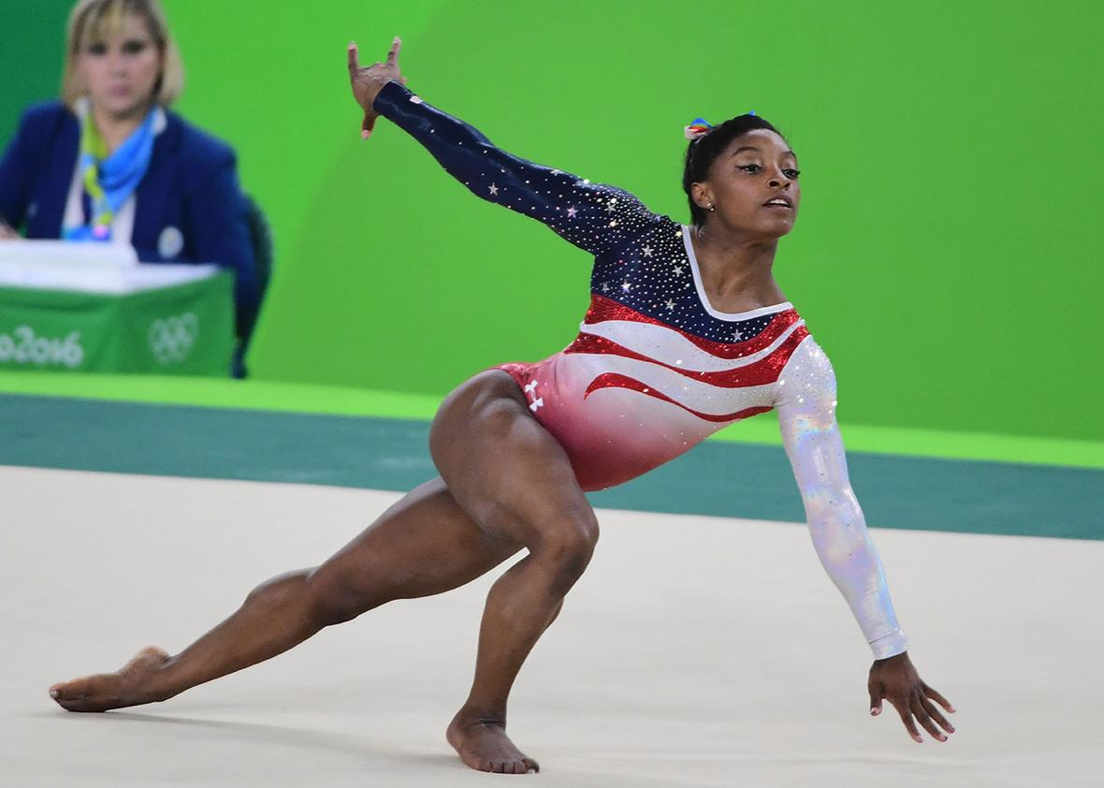 | Gymnastics:  _____________________________________________  _____________________________________________  _____________________________________________  _____________________________________________  _____________________________________________  _____________________________________________  _____________________________________________  _____________________________________________  _____________________________________________  _____________________________________________  _____________________________________________  _____________________________________________  _____________________________________________  _____________________________________________  _____________________________________________
- Identify and justify the two main fitness training methods a boxer would need to include in their training for a competition
(4 marks)









































