Name

Oasis Academy Isle of Sheppey.

Hair and beauty transition pack

Year 9

Hair and beauty Business | Hair and beauty image | Description
Beauty salons | 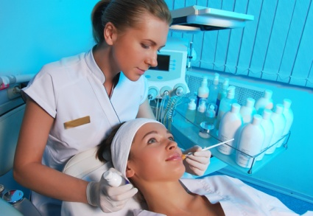
Hair salons | 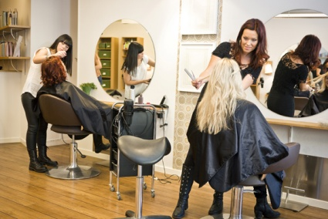
Barber shops | 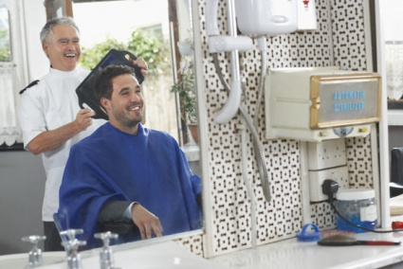
Spas | 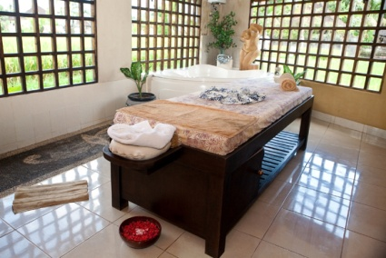
Brow bars | 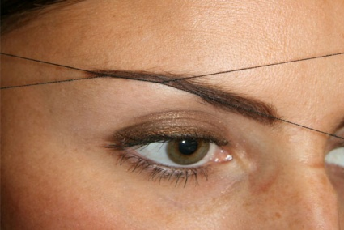
Health clubs / leisure centres | 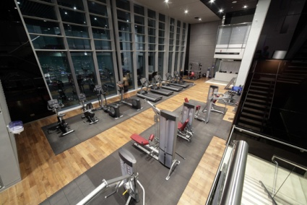
Hotels  /cruise ships | 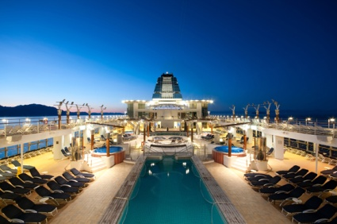
Product manufacturing and distribution

Retail sales

Fashion | 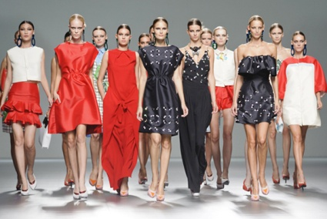
Photographic | 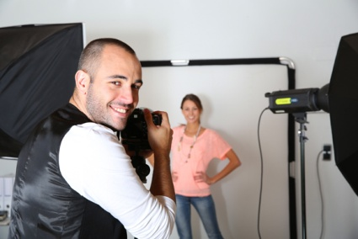
Theatre and media production | 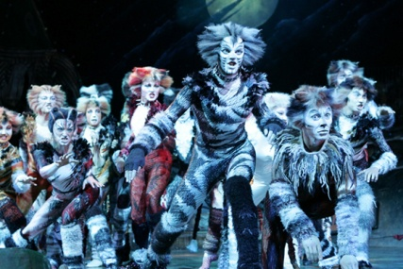
Education and training

Nail bars | 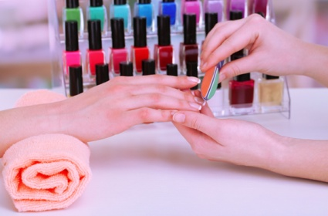

True or false
Use a highlighter or place a circle on the response indicating whether you think the statement is True or False.
- Barber shops mainly focus on cutting and styling the hair of male clients. True / False
- Spas are always found in large stately homes with their own natural spring. True / False
- Nail bars will only offer treatments and services for your fingernails. True / False
- Beauty salons are establishments offering cosmetic treatments for men and women. True / False
- Catwalk models always do their own make-up.
True / False
- Many health clubs offer beauty and spa services.
True / False
- Most product manufacturers sell directly to salons.
True / False
- Education establishments encourage high commercial standards in the industry through ongoing training. True / False

- Fashion and retail businesses display the latest hair, nail and make-up styles to help to set and develop trends. True / False

- Hairdressing salons employ male and female stylists.
True / False

Importance of the hair and beauty sector
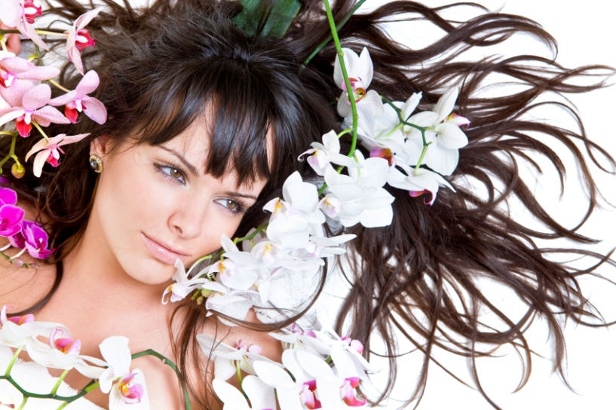  Check out the Habia website then answer the following questions:  - Does the hair and beauty sector have a turnover of £2.6 billion or £6.2 billion a year?  - How many people does the hair and beauty sector employ? |  | How much do products cost
- Check prices in shops of shampoos or online
- List 6

There are over 55,000 hair and beauty businesses in the UK, which accounts for nearly 1% of the UK economy (Source: Habia).
Spoilt for choice? | Glossary
Go into your local supermarket, chemist, department store or hair salon. Conduct some market research. Gather the following evidence: | Research and record the meaning of the terms listed below. The first one has been done for you:
- State the total number of different varieties of shampoo that are available. | Turnover  the amount of money taken by a business over a certain period of time
- Identify the highest priced shampoo | Economy
- Identify the lowest priced shampoo. | GDP
Reflect on the differences between the products; why do you think this is? | Consumer
Gather a little information regarding ingredients, packaging and paying for a branded name or celebrity endorsement. | Statistics

GDP

GDP questions
- Identify what the letters GDP stand for.

- Describe what GDP measures.

- State if hairdressing is classified as a service industry or a manufacturing
industry.

- Explain what domestic means.

- Explain what happens if GDP goes down.

Linked industry | Definition
Leisure and tourism industry
Retail industry
Media industry
Fashion industry
Photographic industry
Health, beauty and holistic therapies
Manufacturing

Try and answer what the link is
Industry | Link to hair and beauty sector
Leisure and tourism

Retail

The Media

Fashion

Photography

Health and complementary therapies

Match to the meaning
 | Sue |  |  |  | An individual whose involvement in a partnership is limited to providing capital to the business
 | Capital |  |  |  | Take legal proceedings against (a person or institution)
 | Silent partner |  |  |  | Money and possessions used for producing more wealth or for starting a new business.
 | Debt |  |  |  | A written or spoken agreement that is intended to be enforceable by law.
 | Financed |  |  |  | Provide funding for (a person or enterprise).
 | Contract |  |  |  | A sum of money that is owed or due.
 | Liability |  |  |  | The state of being legally responsible for something.

The trade and professional organisations

Write these out so you recognise the abbreviation and what each organisation does

- Cosmetic, Toiletry, and Perfumery Association (CTPA)
- National Hairdressing Federation (NHF)
- Federation of Holistic Therapists (FHT)
- Hairdressing Council (HC)
- British Association of Beauty Therapy and Cosmetology (BABTAC)
- British Association of Cosmetic Nurses (BACN)
- Hairdressing and Beauty Industry Authority (HABIA)
- Association of Nail Technicians (ANT)

Research a range of professional bodies’ website
Complete the chart
Website | Acronym /Abbreviation | Full title of organisation | Brief description of the purpose of the organisation
www.ctpa.org.uk | CTPA
www.nhf.info | NHF
www.fht.org.uk | FHT
www.haircouncil.org.uk | HC
www.babtac.com | BABTAC
www.cosmeticnurses.org | BACN

