Geography Year 10 Transition Booklet.

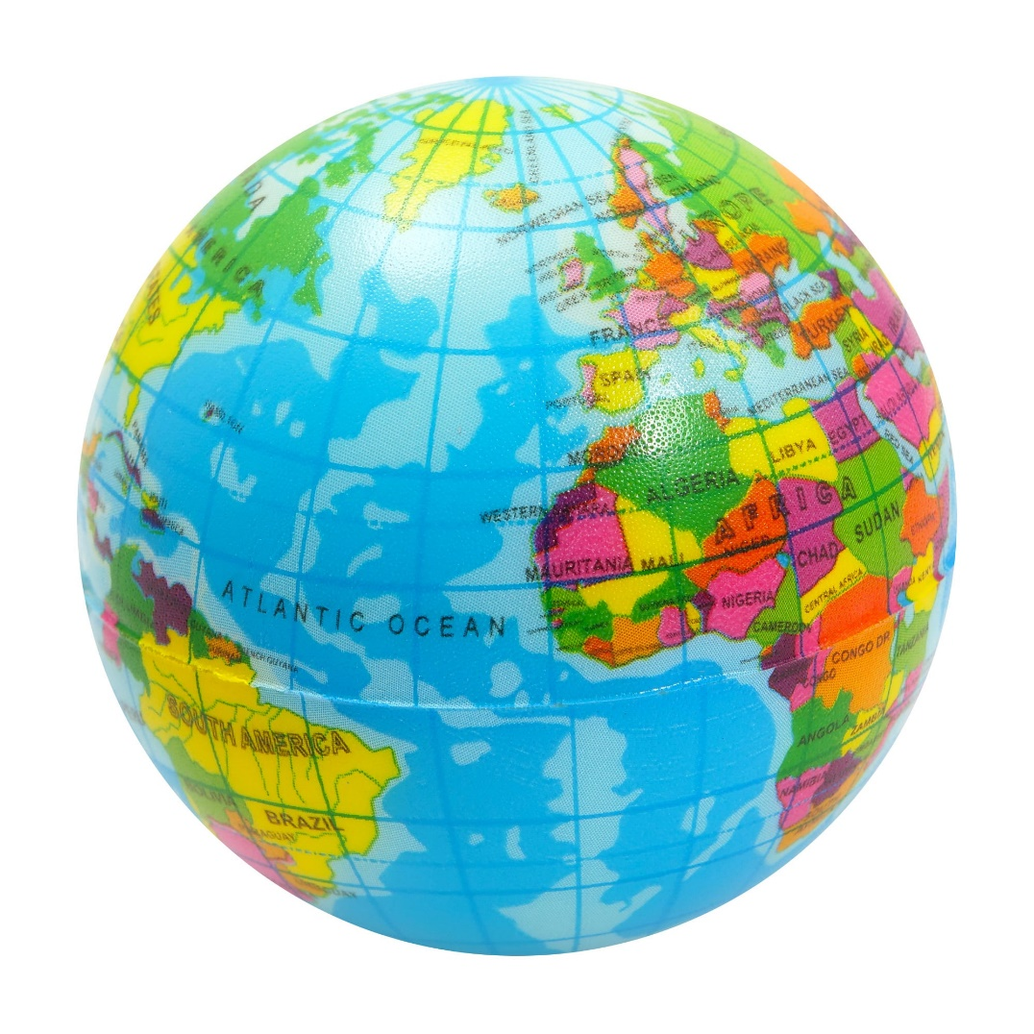

Key words and definitions – Paper 2 Section A: Urban Issues and Challenges
Complete the table.
Brownfield site
Dereliction
Economic opportunities
Greenfield site
I………………………… | Differences between poverty and wealth, as well as in peoples' wellbeing and access to things like jobs, housing and education. Inequalities may occur in housing provision, access to services, access to open land, safety and security.
Integrated transport systems | When different transport methods connect together, making journeys smoother and therefore public transport more appealing. Better integration should result in more demand for public transport and should see people switching from private car use to public modes of transport, which should be more sustainable. It may also lead to a fall in congestion due to less road users.
Mega-cities
Migration
Natural increase
P………………….. | The presence of chemicals, noise, dirt or other substances which have harmful or poisonous effects on an environment.
Rural-urban fringe
Sanitation
Social deprivation
Social opportunities
Squatter settlement
Sustainable urban living | A sustainable city is one in which there is minimal damage to the environment, the economic base is sound with resources allocated fairly and jobs secure, and there is a strong sense of community, with local people involved in decisions made. Sustainable urban living includes several aims including the use of renewable resources, energy efficiency, use of public transport, accessible resources and services.
Traffic congestion
Urban greening
Urbanisation
Urban regeneration
Urban sprawl
Waste recycling | The process of ……………

UK population distribution.
Using Figure 1, describe the UK’s population distribution. [3]
……………………………………………………………………………………………………………………………………………………………………………………………………………………………………………………………………………………………………………………………………………………………………………………………………………………………………………………………………………………………………………………………………………………………………………………………………………………………………………………………..
How many people (in %) live in urban areas in the UK?
- 66%
- 82%
- 74%
- 95%
Why do more people choose to live in urban areas? [3]
……………………………………………………………………………………………………………………………………………………………………………………………………………………………………………………………………………………………………………………………………………………………………………………………………………………………………………………………………………………………………………………………………………………………………………………………………………………………………………………………..
List two positive impacts of migration. [2]
……………………………………………………..
……………………………………………………..

Case Study London:
Describe the location of London. [2]
……………………………………………………………………………………………………………………………………………………………………………………………………………………………………………………………………………………………………………………………………………………………………………………………………………………………………………………………………………………………………………………………………………………………………………………………………………………………………………………………..
What is the importance of London to the UK and the wider world? [3]
……………………………………………………………………………………………………………………………………………………………………………………………………………………………………………………………………………………………………………………………………………………………………………………………………………………………………………………………………………………………………………………………………………………………………………………………………………………………………………………………..
Describe the impacts of national and international migration on the growth and character of London. [4]
……………………………………………………………………………………………………………………………………………………………………………………………………………………………………………………………………………………………………………………………………………………………………………………………………………………………………………………………………………………………………………………………………………………………………………………………………………………………………………………………..……………………………………………………………………………………………………………………………………………………………………………………………………………………………………………………………………………………………………………………………………………………………………………………………………………………………………………………………………………………………………………………………………………………………………………………………………………………………………………………………..
How has urban change created social and economic opportunities within the city? (Cultural mix, recreation and entertainment, employment, integrated transport systems) [6]
……………………………………………………………………………………………………………………………………………………………………………………………………………………………………………………………………………………………………………………………………………………………………………………………………………………………………………………………………………………………………………………………………………………………………………………………………………………………………………………………..……………………………………………………………………………………………………………………………………………………………………………………………………………………………………………………………………………………………………………………………………………………………………………………………………………………………………………………………………………………………………………………………………………………………………………………………………………………………………………………………..……………………………………………………………………………………………………………………………………………………………………………………………………………………………………………………………………………………………………………………………………………………………………………………………………………………………………………………………………………………………………………………………………………………………………………………………………………………………………………………………..……………………………………………………………………………………………………………………………………………………………………………………………………………………………………………………………………………………………………………………………………………………………………………………………………………………………………………………………………………………………………………………………………………………………………………………………………………………………………………………………..
Describe and explain how urban change has created environmental challenges. [6]
……………………………………………………………………………………………………………………………………………………………………………………………………………………………………………………………………………………………………………………………………………………………………………………………………………………………………………………………………………………………………………………………………………………………………………………………………………………………………………………………..……………………………………………………………………………………………………………………………………………………………………………………………………………………………………………………………………………………………………………………………………………………………………………………………………………………………………………………………………………………………………………………………………………………………………………………………………………………………………………………………..……………………………………………………………………………………………………………………………………………………………………………………………………………………………………………………………………………………………………………………………………………………………………………………………………………………………………………………………………………………………………………………………………………………………………………………………………………………………………………………………..……………………………………………………………………………………………………………………………………………………………………………………………………………………………………………………………………………………………………………………………………………………………………………………………………………………………………………………………………………………………………………………………………………………………………………………………………………………………………………………………..
Explain why a particular area of London needed regeneration. [4]
……………………………………………………………………………………………………………………………………………………………………………………………………………………………………………………………………………………………………………………………………………………………………………………………………………………………………………………………………………………………………………………………………………………………………………………………………………………………………………………………..………………………………………………………………………………………………………………………………………………………………………………………………………………………………………………………………………………………………………………………………………………………………………………………………………………………………………………………………………………………………………………………………………………………………………………………………………………………………………………………………
Sustainable urban planning
Freiburg is a sustainable city in Germany. List 3 ways in which Freiburg tried to make their city more sustainable.

Describe one of the sustainable strategies from your list above. [2]
………………………………………………………………………………………………………………………………………………………………………………………………………………………………………………………………………………………………………………………………
In London and other cities in the UK, the local governments have tried to improve pollution and transport around the city. Describe 3 strategies that have been used in London? [6]
……………………………………………………………………………………………………………………………………………………………………………………………………………………………………………………………………………………………………………………………………………………………………………………………………………………………………………………………………………………………………………………………………………………………………………………………………………………………………………………………..……………………………………………………………………………………………………………………………………………………………………………………………………………………………………………………………………………………………………………………………………………………………………………………………………………………………………………………………………………………………………………………………………………………………………………………………………………………………………………………………..……………………………………………………………………………………………………………………………………………………………………………………………………………………………………………………………………………………………………………………………………………………………………………………………………………………………………………………………………………………………………………………………………………………………………………………………………………………………………………………………..……………………………………………………………………………………………………………………………………………………………………………………………………………………………………………………………………………………………………………………………………………………………………………………………………………………………………………………………………………………………………………………………………………………………………………………………………………………………………………………………..

Key words and definitions – Paper 2 Section C: Urban Issues and Challenges
Complete the table.
Renewables
F……………. F…………. | A non-renewable energy source, which is often burnt to create energy. It is also harmful to the environment and will eventually run out.
Hydro-electric power
Energy mix
Surplus
Deficit | When there is not enough of a resource
Transfer
Food/water insecurity
Food consumption
Undernourishment
Hydroponics
Aeroponics
Biotechnology
Irrigation | To artificially ……
Organic farming
Urban farming | Small scale farming in …………..
Agribusiness

General resources
Study Figure 2, a map showing world oil consumption in 2016.
What is the difference between Africa and North America’s share of world oil consumption shown in Figure 2? [1]
……………………………………………………………………..

Using Figure 2 and your own understanding, suggest how inequalities in the consumption of resources influence well-being. [3]
……………………………………………………………………………………………………………………………………………………………………………………………………………………………………………………………………………………………………………………………………………………………………………………………………………………………………………………………………………………………………………………………………………………………………………………………………………………………………………………………..

What percentage of the UK’s water is deemed as being poor quality? [1]
- 27%
- 45%
- 73%
- 50%
Suggest how the UK is trying to improve water quality. [6]
……………………………………………………………………………………………………………………………………………………………………………………………………………………………………………………………………………………………………………………………………………………………………………………………………………………………………………………………………………………………………………………………………………………………………………………………………………………………………………………………..……………………………………………………………………………………………………………………………………………………………………………………………………………………………………………………………………………………………………………………………………………………………………………………………………………………………………………………………………………………………………………………………………………………………………………………………………………………………………………………………..……………………………………………………………………………………………………………………………………………………………………………………………………………………………………………………………………………………………………………………………………………………………………………………………………………………………………………………………………………………………………………………………………………………………………………………………………………………………………………………………..……………………………………………………………………………………………………………………………………………………………………………………………………………………………………………………………………………………………………………………………………………………………………………………………………………………………………………………………………………………………………………………………………………………………………………………………………………………………………………………………..

Study Figure 3, a graph showing the UK’s changing energy mix from 2006 to 2016.
Using Figure 3 and your own understanding, discuss the issues arising from the UK’s changing energy mix. [6]
……………………………………………………………………………………………………………………………………………………………………………………………………………………………………………………………………………………………………………………………………………………………………………………………………………………………………………………………………………………………………………………………………………………………………………………………………………………………………………………………..……………………………………………………………………………………………………………………………………………………………………………………………………………………………………………………………………………………………………………………………………………………………………………………………………………………………………………………………………………………………………………………………………………………………………………………………………………………………………………………………..……………………………………………………………………………………………………………………………………………………………………………………………………………………………………………………………………………………………………………………………………………………………………………………………………………………………………………………………………………………………………………………………………………………………………………………………………………………………………………………………..……………………………………………………………………………………………………………………………………………………………………………………………………………………………………………………………………………………………………………………………………………………………………………………………………………………………………………………………………………………………………………………………………………………………………………………………………………………………………………………………..

Food
Outline one reason why some countries have a limited food supply. [2]
………………………………………………………………………………………………………………………………………………………………………………………………………………………………………………………………………………………………………………………………………………………………………………………………………………………………………………………………………………………………
Explain how different strategies can be used to make food supplies more sustainable. [6]
……………………………………………………………………………………………………………………………………………………………………………………………………………………………………………………………………………………………………………………………………………………………………………………………………………………………………………………………………………………………………………………………………………………………………………………………………………………………………………………………..……………………………………………………………………………………………………………………………………………………………………………………………………………………………………………………………………………………………………………………………………………………………………………………………………………………………………………………………………………………………………………………………………………………………………………………………………………………………………………………………..……………………………………………………………………………………………………………………………………………………………………………………………………………………………………………………………………………………………………………………………………………………………………………………………………………………………………………………………………………………………………………………………………………………………………………………………………………………………………………………………..……………………………………………………………………………………………………………………………………………………………………………………………………………………………………………………………………………………………………………………………………………………………………………………………………………………………………………………………………………………………………………………………………………………………………………………………………………………………………………………………..

Outline one advantage of the UK trend towards agribusiness in the UK. [2]
………………………………………………………………………………………………………………………………………………………………………………………………………………………………………………………………………………………………………………………………………………………………………………………………………………………………………………………………………………………………
Describe the main features of a large scale agricultural development project you have studied. [6]
……………………………………………………………………………………………………………………………………………………………………………………………………………………………………………………………………………………………………………………………………………………………………………………………………………………………………………………………………………………………………………………………………………………………………………………………………………………………………………………………..……………………………………………………………………………………………………………………………………………………………………………………………………………………………………………………………………………………………………………………………………………………………………………………………………………………………………………………………………………………………………………………………………………………………………………………………………………………………………………………………..……………………………………………………………………………………………………………………………………………………………………………………………………………………………………………………………………………………………………………………………………………………………………………………………………………………………………………………………………………………………………………………………………………………………………………………………………………………………………………………………..……………………………………………………………………………………………………………………………………………………………………………………………………………………………………………………………………………………………………………………………………………………………………………………………………………………………………………………………………………………………………………………………………………………………………………………………………………………………………………………………..

Use the following key words to answer the question above. There is a sentence starter to get you started.

GREENHOUSE CARBON CAPTURE RECYCLE WATER HYDROPONICS

‘………..is a large scale agricultural development in………., ….…..-…….. England.
It uses massive………………in order to……….’
……………………………………………………………………………………………………………………………………………………………………………………………………………………………………………………………………………………………………………………………………………………………………………………………………………………………………………………………………………………………………………………………………………………………………………………………………………………………………………………………..……………………………………………………………………………………………………………………………………………………………………………………………………………………………………………………………………………………………………………………………………………………………………………………………………………………………………………………………………………………………………………………………………………………………………………………………………………………………………………………………..……………………………………………………………………………………………………………………………………………………………………………………………………………………………………………………………………………………………………………………………………………………………………………………………………………………………………………………………………………………………………………………………………………………………………………………………………………………………………………………………..……………………………………………………………………………………………………………………………………………………………………………………………………………………………………………………………………………………………………………………………………………………………………………………………………………………………………………………………………………………………………………………………………………………………………………………………………………………………………………………………..
The Makueni food and water security programme.
Where is Makueni located? [1]
- South Africa
- Kenya
- Nigeria
- Egypt
Describe what a sand dam is and how it works. [4]
……………………………………………………………………………………………………………………………………………………………………………………………………………………………………………………………………………………………………………………………………………………………………………………………………………………………………………………………………………………………………………………………………………………………………………………………………………………………………………………………..……………………………………………………………………………………………………………………………………………………………………………………………………………………………………………………………………………………………………………………………………………………………………………………………………………………………………………………………………………………………………………………………………………………………………………………………………………………………………………………………..
How did a sand dam help the people of Makueni? [4]
……………………………………………………………………………………………………………………………………………………………………………………………………………………………………………………………………………………………………………………………………………………………………………………………………………………………………………………………………………………………………………………………………………………………………………………………………………………………………………………………..……………………………………………………………………………………………………………………………………………………………………………………………………………………………………………………………………………………………………………………………………………………………………………………………………………………………………………………………………………………………………………………………………………………………………………………………………………………………………………………………..

Resources

Figure 1 UK population distribution. Persons per KM square.
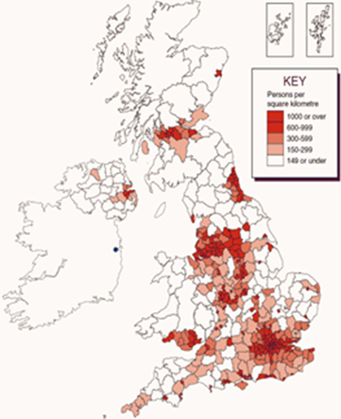

Figure 2 A map showing the consumption of oil around the world
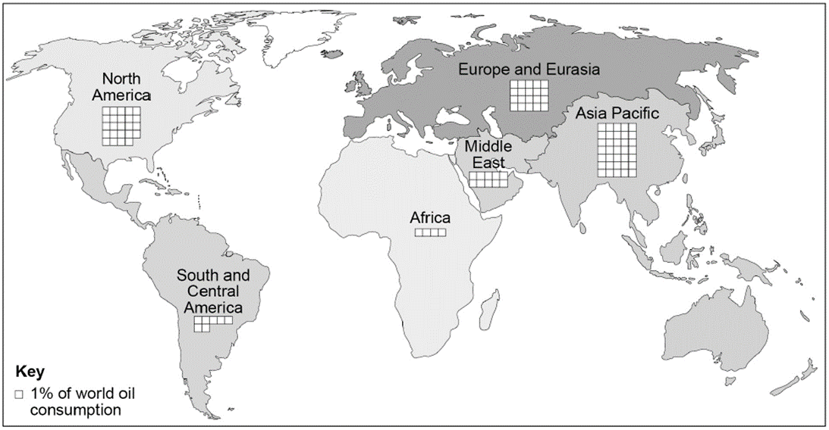

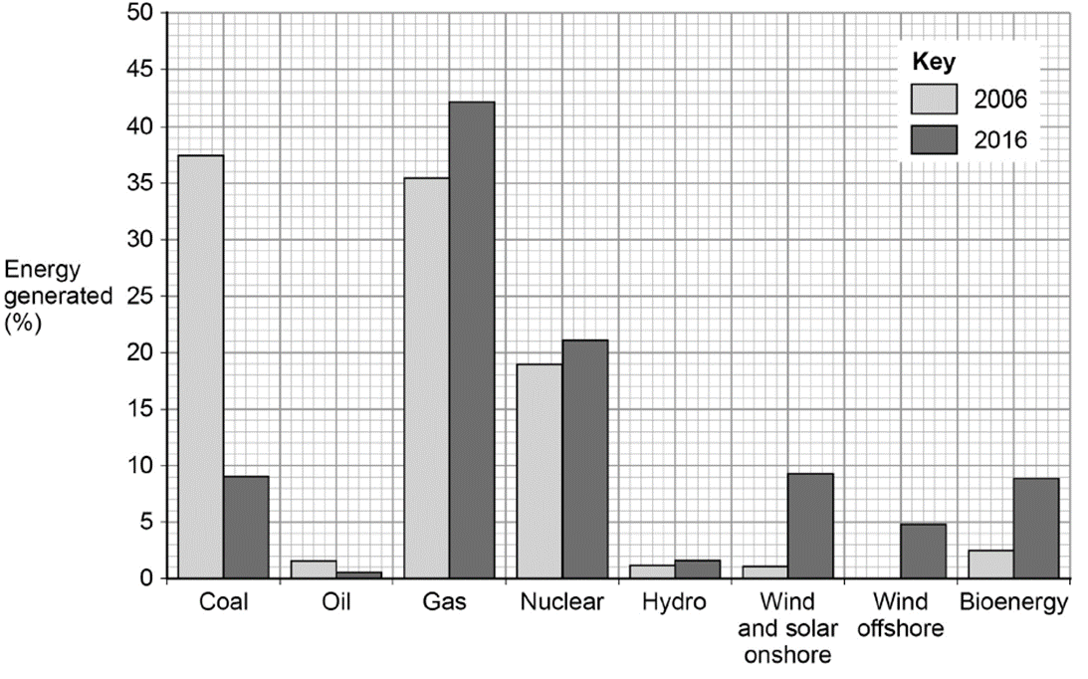
Figure 3 A graph showing the percentage of energy generated by different energy sources.

