**Geography Year 8 Transition Booklet.**



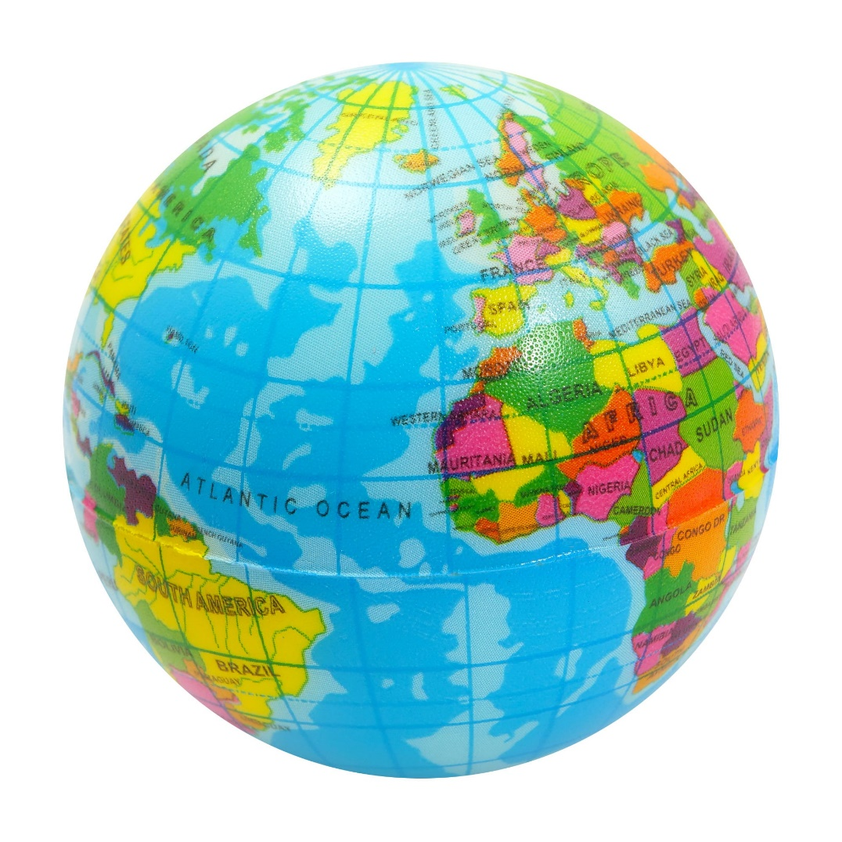

**Key words and definitions – Coasts**

**Complete the table.**

|  |  |
| --- | --- |
| **Coastline** |  |
| **Social** |  |
| **Economic** |  |
| **Environmental** |  |
| **E………………….** | The wearing away or breakdown of rocks |
| **Hydraulic action** | The power of the waves forces water and air into cracks in the cliff. The increase in pressure and force causes cracks to get bigger. |
| **A……………** | Rocks in the sea hit into each other. This makes then smaller, smoother and rounder. |
| **Abrasion** |  |
| **Corrosion** |  |
| **Weathering** | The breakdown of rock caused by day-to-day changes in the atmosphere. |
| **Biological** |  |
| **Chemical** |  |
| **F………-T…………** | The repeated freezing and thawing of water within the rock causing pressure on the crack that leads to the rock break |
| **Headland** |  |
| **Bay** |  |
| **Arch** |  |
| **Stack** |  |
| **Transportation** |  |
| **D……………** | The laying down of material as a result of the wave losing energy or a change in coastline direction |
| **Swash** |  |
| **Backwash** |  |
| **Longshore Drift** | Waves that hit the beach at an angle carry sand and gravel up the beach face at an angle. When the water washes back the sediment is carried straight back down the beach face. Individual particles are moved along the beach in a zig zag pattern |
| **Spit** |  |
| **Bar** |  |
| **Hard Engineering** |  |
| **Soft Engineering** |  |
| **Groyne** | Wooden or stone fences that are built out to sea. They trap sediment moving down the coastline due to longshore drift, therefore creating a larger beach. |
| **Gabions** |  |
| **B………..N…………..** | Adding sediment (sand and shingle) to the beach to make it wider |

**Section 1: AO1 – knowledge**

1. **What is the definition of a coastline? (1 mark)**
   1. The coastline is the outline of the land where the land meets the sea
   2. The coastline is the point where the river meets the sea
   3. The coastline is the line that runs between to different ports
   4. The coastline is the edge of the estuary
2. **Which of the below is not an example of erosion? (1 mark)**
3. Hydraulic action
4. Corrosion
5. Longshore drift
6. Abrasion
7. **What is the definition of weathering? (1 mark)**
   1. The wearing away of rocks caused by powerful waves.
   2. The transportation of material along the coast in a zig zag pattern.
   3. The breakdown of rock caused by day-to-day changes in the atmosphere.
   4. The dropping of sediment caused due to a lack in energy.
8. **Freeze thaw is caused by……..(1 mark)**
9. A change in temperature
10. Animals burrowing in the cliff
11. Water hitting against the rocks
12. Chemicals in the water
13. **Which of the below is a coastal landform created due to weathering and erosion. (1 mark)**
14. Spit
15. Beach
16. Cave, arch, stack
17. Bar
18. **Define longshore drift? (1 mark)**
19. Longshore drift is the movement of waves up and down a beach
20. Longshore drift is the movement of sediment along the coast by the waves
21. Longshore drift is a bulldozer moving pebbles along the beach
22. Longshore drift is the longest distance a wave has travelled to move pebbles
23. **Which of the below is the definition of a tombolo? (1 mark)**
24. A long band of sand that extends out into the sea from the land.
25. A stretch of sand that joins the mainland to an island.
26. A stretch of sand that joins two headlands.
27. A mound of sand found at the back of the beach.
28. **Which of the below is the name of large rocks placed in front of a cliff or settlement. These absorb the waves’ energy to reduce the risk of erosion. (1 mark)**
29. Sea wall
30. Rock armour
31. Groynes
32. Beach nourishment
33. **What is the definition of managed retreat? (1 mark)**
34. Adding sediment to the beach to make it wider.
35. The repairing of sand dunes that have been damaged.
36. A concrete wall built in front of coastal cliffs or settlements. This absorbs the waves’ energy and reduces the risk of erosion.
37. The deliberate decision to allow the sea to flood low value land to protect higher value land.
38. **Which ONE of the below is the shoreline management plan that is used to protect high value land? (1 mark)**
39. Managed retreat
40. Hold the line
41. Do nothing

**Section 2: AO2 – understanding and application**

1. **Study Figure 1, a diagram of a cave, arch, stack. Explain how processes of erosion and weathering have created this landform. (6 marks)**

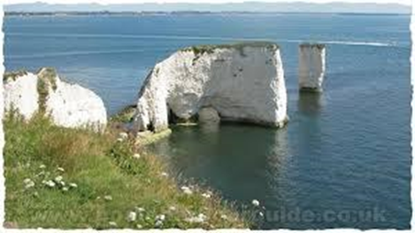

………………………………………………………………………………………………………………………………………………………………………………………………………………………………………………………………………………………………………………………………………………………………………………………………………………………………………………………………………………………………………………………………………………………………………………………………………………………………………………………………………………………………………………………………………………………………………………………………………………………………………………………………………………………………………………………………………………………………………………………………………………………………………………………………………………………………………………………………………………………………………………………………………………………………………………………………………………………………………………………………………………………………………………………………………………………………………………………………………………………………………………………………………………………………………………………………………………………………………………………………………………………………………………………………………………………………………………………………………………………………………………………………………………………………………………………………………………………………………………………………………………………………………………………………………………………………………………………………………………………………………………………………………………………………………………………………………………………………………………………………………………………………………………………………………………………………………………………………………………………………………………………………………………………………………………………………………………………………………………………………………………………………………………………………………………………………………………………………………………………………………………………………………………………………………………………………………………………………………………………………………………………………………………………………………………………………………………………………………………………………………………………………………………………………………………………………………………………………………………………………………………………………………………………………

……………………………………………………………………………………………………………………………………………………………………………………………………………………………………………………………………………………………………………………………………………………………………………………………………………………………………………………………………………………………………………………………………………………………………………………………………………………………………………………………………………………………………………………………………………………………………………………………………………………………………………………………………………………………………………………………………………………………………………………………………………………………………………..

1. **Evaluate the effectiveness of the hard engineering strategies at protecting the coastline from erosion.**

**(8 marks)**

………………………………………………………………………………………………………………………………………………………………………………………………………………………………………………………………………………………………………………………………………………………………………………………………………………………………………………………………………………………………………………………………………………………………………………………………………………………………………………………………………………………………………………………………………………………………………………………………………………………………………………………………………………………………………………………………………………………………………………………………………………………………………………………………………………………………………………………………………………………………………………………………………………………………………………………………………………………………………………………………………………………………………………………………………………………………………………………………………………………………………………………………………………………………………………………………………………………………………………………………………………………………………………………………………………………………………………………………………………………………………………………………………………………………………………………………………………………………………………………………………………………………………………………………………………………………………………………………………………………………………………………………………………………………………………………………………………………………………………………………………………………………………………………………………………………………………………………………………………………………………………………………………………………………………………………………………………………………………………………………………………………………………………………………………………………………………………………………………………………………………………………………………………………………………………………………………………………………………………………………………………………………………………………………………………………………………………………………………………………………………………………………………………………………………………………………………………………………………………………………………………………………………………………………………………………………………………………………………………………………………………………………………………………………………………………………………………………………………………………………………………………………………………………………………………………………………………………………………………………………………………………………………………………………………………………………………………………………………………………………………………………………………………………………………………………………………………………………………………………………………………………………………………………………………………………………………………………………………………………………………………………………………………………………………………………………………………………………………………………………………………………………………………………………………………………………………………………………………………………………………………………………………………………………………………………………………………………………………………………………………………………………………………………………………………………………………………………………………………………………………………………………………………………………………………………………………………………………………………………………………………………………………………………………………………………………………………………………………………………………………………………………………………………………………………………………………………………………………………………………………………………………………………………………………………………………………………………………………………………………………………………………………………………………………………………………………………………………………………………………………………………………………………………………………………………………………………………………………………………………………………………………………………………………………………………………………………………………………………………………………………………………………………………………………………………………………………………………………………………………………………………………………………………………………………………………………………………………………………………………………………………………………………………………………………………………………………………………………………………………………………………………………………………………………………………………………………………………………………………………………………………………………………………………………………………………………………………………………………………………………………………………………………………………………………………………………………………………………………………………………………………………………………………………………………………………………………………………………………………………………………………………………………………………………………………………………………………………………………………………………………………………………………………………………………………………………………………………………………………………………………………………………………………………………………………………………………………………………………………………………………………………………………………………………………………………………………………………………………………………………………………………………………………………………………………………………………………………………………………………………………………………………………………………………

**Section 3: AO3 – geographical skills**

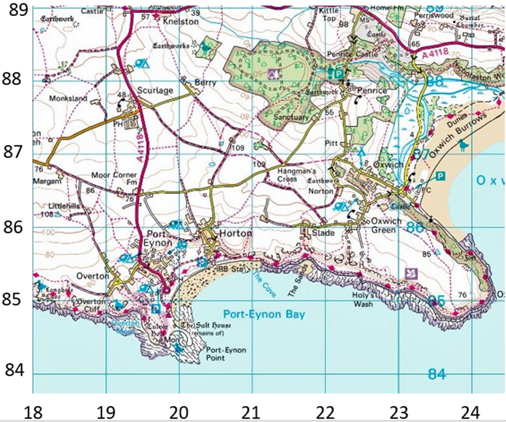



1. **A nature reserve is an environmental use of the coastline. At what four figure grid reference is there a nature reserve? (1 mark) Circle the correct answer:**

(23, 87) (19, 87) (22, 84) (22, 88)

1. **What is the name of the bay on the south of the map? (1 mark)**

………………………………………………………………………………………………………………………………………………………………

1. **In which of the following grid squares do you find a headland? (1 mark) Circle the correct answer:**

(18, 87) (23, 87) (20, 84) (20, 85)

1. **What do the below coastal landforms show? (3 marks)**

|  |  |  |
| --- | --- | --- |
| Image result for headland and bay | http://www.geomorph.org/gal/mslattery/IAG11.jpg | Image result for rotational slump |
| ……………………………………………………… | ……………………………………………………… | ……………………………………………………… |

**Key words and definitions – Resource Management**

**Complete the table.**

|  |  |
| --- | --- |
| **Natural Resource** |  |
| **Renewable** |  |
| **Non-renewable** |  |
| **G……………………E….……** | Heat from the earth can be used to create energy. It can only be found in certain places and produces very clean energy. |
| **Fossil Fuels** | Oil and gas are examples of fossil fuels. They were formed millions of years ago from the remains of dead animals and plants and will run out. We use these for many things such as plastics and fuelling cars and creating electricity. |
| **Economic Water Scarcity** |  |
| **Physical water scarcity** |  |
| **W………T……….** | Some areas have more water than is needed (surplus) and this can be moved by pipes and canals to areas where there is less water (deficit). |
| **Desalinisation** | The process of removing salt from seawater. It can be very expensive and uses lots of energy. |
| **Crude Oil** |  |
| **Solar Power** |  |
| **H……….E………..P………** | Using fast flowing water to turn generators to produce electricity. |
| **Wind Power** |  |
| **Biomass** | Biomass burns plants, trees and organic matter to heat steam to drive turbines and generate electricity |
| **Nuclear Power** |  |
| **Carbon Emissions** |  |
| **Irrigation** |  |
| **Food Insecurity** |  |
| **A……………**  **T………………** | Using skills or materials that are cheap and easily available to increase output without putting people out of work. It meets the needs of local people. |
| **Fertiliser** | A chemical or natural substance added to soil or land to increase its fertility |
| **Genetic Modification** |  |
| **Food Miles** |  |

**Section 1: AO1 – knowledge**

**1. Which is the correct definition for a *Natural Resource*? (1 mark)**

1. Resources that are found underground.
2. Something that occurs naturally that we can make use of.
3. Something that we can sell to make money.
4. A resource that does not run out.

**2. Identify *two* renewable resources. (1 mark)**

1. Coal
2. Wind
3. Water
4. Oil

**3. Which following statements is true about water? (1 mark)**

* 1. 97% of water on the earth is fresh water we can use
  2. 97% of water on the earth is salt water we can use
  3. 3% of water is available for us to use
  4. Less than 1% of water is available for us to use

**4. Which sentence best describes *economic water scarcity* (1 mark)**

* 1. Not enough water in a place to meets the needs of the people
  2. When there is water but people cannot access it
  3. When there is not enough rain falling in a place
  4. When a place suffers from drought

1. **Which of the following disadvantages is untrue about wind power? (1 mark)**
   1. It causes water pollution.
   2. It caused harm to birds that may fly into the blades
   3. They can be expensive to build
   4. They can cause visual pollution
2. **Which one of the following is not a way to increase food supply? (1 mark)**
   1. Genetically modify crops
   2. Irrigation
   3. Open up more supermarkets in poorer countries
   4. Appropriate technology
3. **Which of the following is not an impact on people of water scarcity. (1 mark)**
   1. Disease
   2. Conflict
   3. Increase in food production
   4. Water pollution

**8. Micro-hydro scheme in Peru provided which of the following for the rural community? (1 mark)**

* 1. Water
  2. Electricity
  3. Food supply
  4. Fossil fuels

1. **Identify two reasons for food insecurity? (1 mark)**
   1. Conflicts
   2. Climate change
   3. GM foods
   4. Deforestation
2. **Identify two solutions to water challenges. (1 mark)**
   1. Desalination
   2. Water conflicts
   3. Water pollution
   4. Water Transfer schemes

**Section 2: AO2 – understanding and application**

1. 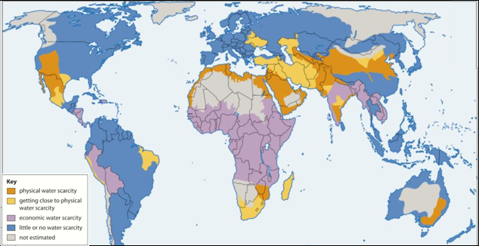**Using Figure 1, describe distribution (spread) of physical water scarcity. (3 marks)**

……………………………………………………………………………………………………………………………………………………………………………………………………………………………………………………………………………………………………………………………………………………………………………………………………………………………………………………………………………………………………………………………………………………………………………………………………………………………………………………………………………………………………………………………………………………………………………………………………………………………………………………………………………………………………………………………………………………………………………………………………………………………………………………………………………………………………………………………………………………………………………………………………………………………………………………………………………………………………………………………………………………………………………………………………………………………………………………………………………………….……………………………………………………………………………………………………………………………………………………………

1. 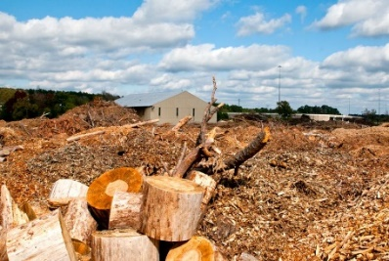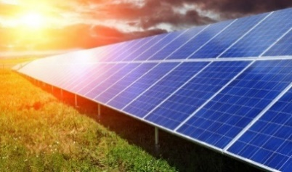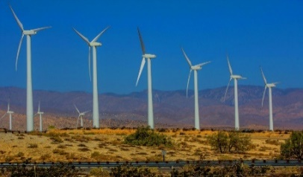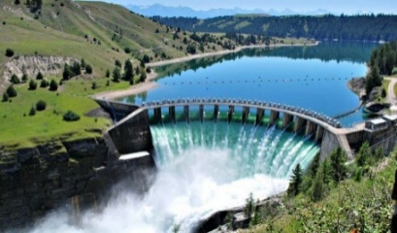**Use Figure 2 (photographs below) and your own knowledge, to describe the advantages and disadvantages of renewable energies. (6 marks)**

…………………………………………………………………………………………………………………………………………………………………………………………………………………………………………………………………………………………………………………………………………………………………………………………………………………………………………………………………………………………………………………………………………………………………………………………………………………………………………………………………………………………………………………………………………………………………………………………………………………………………………………………………………………………………………………………………………………………………………………………………………………………………………………………………………………………………………………………………………………………………………………………………………………………………………………………………………………………………………………………………………………………………………………………………………………………………………………………………………………………………………………………………………………………………………………………………………………………………………………………………………………………………………………………………………………………………………………………………………………………………………………………………………………………………………………………………………………………………………………………………………………………………………………………………………………………………………………………………………………………………………………………………………………………………………………………………………………………………………………………………………………………………………………………………………………………………………………………………………………………………………………………………………………………………………………………………………………………………………………………………………………………………………………………………………………………………………………………………………………………………………………………………………………………………………………………………………………………………………………………………………………………………………………………….……………………………………………………………………………………………………………………………………………………………………………………………………………………………………………………………………………………………………………………………………………………………………………..

1. **Using a specific example, explain how renewable energies can benefit local communities. (8 marks)**

**Chosen example**:……………………………………………………………………………………………………………………………………………………..…

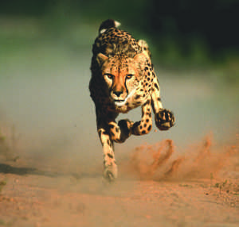……………………………………………………………………………………………………………………………………………………………………….………………………………………………………………………………………………………………………………………………………………………………………………………………………………………………………………………………………………………………………………………………………………………………………………………………………………………………………………………………………………………………………………………………………………………………………………………………………………………………………………………………………………………………………………………………………………………………………………………………………………………………………………………………………………………………………………………………………………………………………………………………………………………………………………………………………………………………………………………………………………………………………………………………………………………………………………………………………………………………………………………………………………………………………………………………………………………………………………………………………………………………………………………………………………………………………………………………………………………………………………………………………………………………………………………………………………………………………………………………………………………………………………………………………………………………………………....……………………………………………………………………………………………………………………………………………………………….………………………………………………………………………………………………………………………………………………………………………………………………………………………………………………………………………………………………………………………………………………………………………………………………………………………………………………………………………………………………………………………………………………………………………………………………………………………………………………………………………………………………………………………………………………………………………………………………………………………………………………………………………………………………………………………………………………………………………………………………………………………………………………………………………………………………………………………………………………………………………………………………………………………………………………………………………………………………………………………………………………………………………………………………………………………………………………………………………………………………………………………………………………………………………………………………………………………………………………………………………………………………………………………………………………………………………………………………………………………………………………………………………………………………………………………………………………………………………………………………………………………………………………………………………………………………………………………………………………………………………………………………………………………………………………………………………………………………………………………………………………………………………………………………………………………………………………………………………………………………………………………………………………………………………………………………………………………………………………………………………………………………………………………………………………………………………………………………………………………………………………………………………………………………………………………………………………………………………………………………………………………………………………………………………………………………………………………………………………………………………………………………………………………………………………………………………………………………………………………………………………………………………………………………………………………………………………………………………………………………………………………………………………………………………………………………………………………………………………………………………………………………………………………………………………………………………………………………………………………………………………………………………………………………………………………………………………………………………………………………………………………………………………………………………………………………………………………………………………………………………………………………………………………………………………………………………………………………………………………………………………………………………………………………………………………………………………………………………………………………………………………………………………………………………………………………………………………………………………………………………………………………………………………………………………………………………………………………………………………………………………………………………………………………………………………………………..

**Section 3: AO3 – geographical skills**



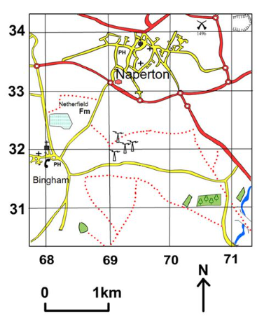

Study the map and key to the right.

1. **In which grid square is the public house in Bingham located? Give the four figure grid reference. (1 mark)**

……………………………………………………………………

1. **Measure the distance from the public house near Naperton to the battlefield? (1 mark)**

……………………………………………………………………

1. **What direction is the mast if you were standing in Bingham? (1 mark)**

……………………………………………………………………

1. **Study the map showing the total amount of water available per person in Africa in 2010**

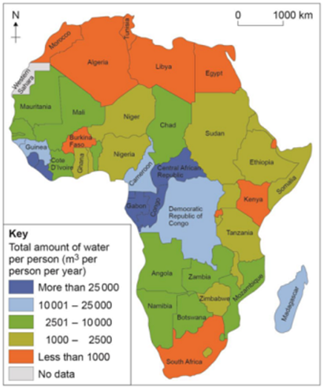

**What was the total amount of water per person in Ethiopia in 2010? Shade the correct circle below**

|  |  |  |
| --- | --- | --- |
| **A** | Less than 1000 cubic metres per person per year | *https://app.doublestruck.eu/content/AG_GEO/HTML/Q/QSP25p1_files/img02.png* |
| **B** | 1000–2500 cubic metres per person per year | https://app.doublestruck.eu/content/AG_GEO/HTML/Q/QSP25p1_files/img02.png |
| **C** | 2501–10 000 cubic metres per person per year | https://app.doublestruck.eu/content/AG_GEO/HTML/Q/QSP25p1_files/img02.png |
| **D** | 10 001–25 000 cubic metres per person per year | https://app.doublestruck.eu/content/AG_GEO/HTML/Q/QSP25p1_files/img02.png |

1. **Using the map, describe the distribution of countries in Africa where there was less than 1000 cubic metres of water per person per year in 2010. (2 marks)**

………………………………………………………...................................................................................................................................

………………………………………………………...................................................................................................................................

………………………………………………………...................................................................................................................................

1. **Study the graph below showing global energy consumption, 2008–2035.**

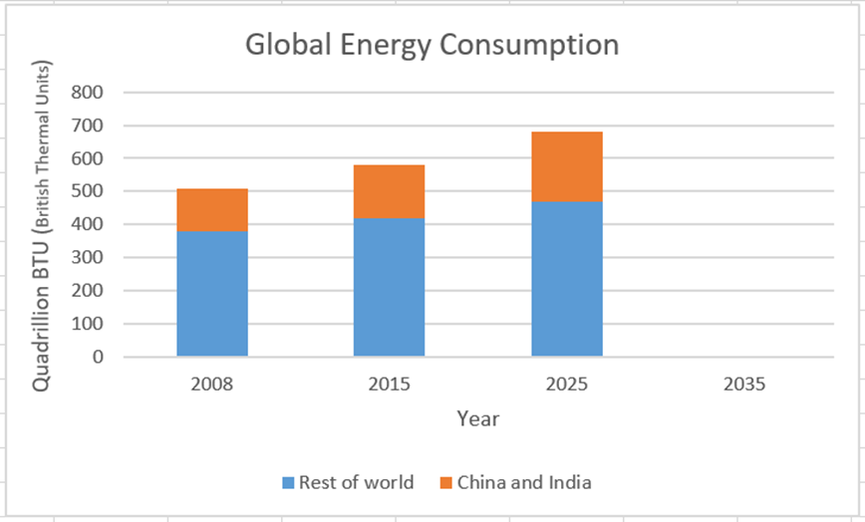

1. **Use the following data to complete the graph above; (2 marks)**

|  |  |
| --- | --- |
|  | Energy consumption in quadrillion BTU 2035 |
| Rest of the world | 520 |
| China and India | 240 |