Geography Year 9 Transition Booklet.

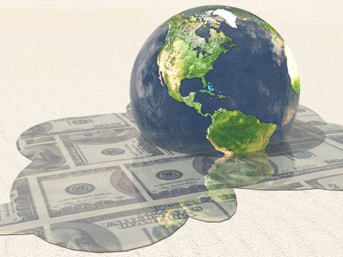

Key words and definitions – Paper 2 Section B: The Changing Economic World
Complete the table.

Birth rate

Death rate

De-industrialisation

Development

I………………………… | A model showing how populations should change over time in terms of their birth rates, death rates and total population size.
D…………………… G…….. | The difference in standards of living and wellbeing between the world’s richest and poorest countries (between HICs and LICs).

European Union

Fairtrade

Globalisation
G………………….. | A measurement of economic activity that is calculated by dividing the gross (total) national income by the size of the population. It also takes into account not just the value of goods and services, but also the income earned from investments overseas.

Human Development Index (HDI)

Infant mortality

Life expectancy

Literacy rate

Microfinance loans

Trade
Development Indicators
Identify 2 development indicators. [2]
……………………………………………………………………………………………………………………………………………………………………………………………………………………………………………………………………………………………………………………………………………………………………………………………………………………………………………………………………………………………………………………………………………………………………………………………………………………………………………………………..
Which of these is not a measure of development?
- Adult literacy Rate
- Life Expectancy
- Number of people per doctor
- Population
Explain how indicators are useful measures of development? [4]
……………………………………………………………………………………………………………………………………………………………………………………………………………………………………………………………………………………………………………………………………………………………………………………………………………………………………………………………………………………………………………………………………………………………………………………………………………………………………………………………..
Explain why the human development index is an effective way to measure development.. [4]

……………………………………………………………………………………………………………………………………………………………………………………………………………………………………………………………………………………………………………………………………………………………………………………………………………………………………………………………………………………………………………………………………………………………………………………………………………………………………………………………..

Comparing Countries:
Explain why we do not just use GDP or GNI to determine a countries level of development. [4]
……………………………………………………………………………………………………………………………………………………………………………………………………………………………………………………………………………………………………………………………………………………………………………………………………………………………………………………………………………………………………………………………………………………………………………………………………………………………………………………………..
What are the main differences between LICs and NEEs? [3]
……………………………………………………………………………………………………………………………………………………………………………………………………………………………………………………………………………………………………………………………………………………………………………………………………………………………………………………………………………………………………………………………………………………………………………………………………………………………………………………………..
The Demographic Transition Model.
Describe the key characteristics of the DTM. [4]
……………………………………………………………………………………………………………………………………………………………………………………………………………………………………………………………………………………………………………………………………………………………………………………………………………………………………………………………………………………………………………………………………………………………………………………………………………………………………………………………..……………………………………………………………………………………………………………………………………………………………………………………………………………………………………………………………………………………………………………………………………………………………………………………………………………………………………………………………………………………………………………………………………………………………………………………………………………………………………………………………..
The Demographic Transition Model shows changes in 3 things what are they? [3]
……………………………………………………………………………………………………………………………………………………………………………………………………………………………………………………………………………………………………………………………………………………………………………………………………………………………………………………………………………………………………………………………………………………………………………………………………………………………………………………………..………………………………………………………………………………………………………………………………………………………………………………………………………………………………………………………………………………………………………………………………………………………………………………………………………………………………………………………………………………………………
Study Figure 1 Explain how Mexico’s Population has changed and suggest why they have occurred. [6]
……………………………………………………………………………………………………………………………………………………………………………………………………………………………………………………………………………………………………………………………………………………………………………………………………………………………………………………………………………………………………………………………………………………………………………………………………………………………………………………………..……………………………………………………………………………………………………………………………………………………………………………………………………………………………………………………………………………………………………………………………………………………………………………………………………………………………………………………………………………………………………………………………………………………………………………………………………………………………………………………………..……………………………………………………………………………………………………………………………………………………………………………………………………………………………………………………………………………………………………………………………………………………………………………………………………………………………………………………………………………………………………………………………………………………………………………………………………………………………………………………………..……………………………………………………………………………………………………………………………………………………………………………………………………………………………………………………………………………………………………………………………………………………………………………………………………………………………………………………………………………………………………………………………………………………………………………………………………………………………………………………………..
Study figure 2. Japan’s population is predicted to change in the next 35 years. [6]
The birth rate is expected to stay similar. I know this because……………..…………………………………………………………………………………………………………………………………………………………………………………………………………………………………………………………………………………………………………………………………………………………………………………………………………………………………………………………………………………………………………………………………………………………………………………………………………………………………………………………………………………………..
There are going to more/less elderly people (over 65). I know this because……………………….……………………………………………………………………………………………………………………………………………………………..………………………………………………………………………………………………………………………………………………………………………………………………………………………………………………………………………………………………………………………………………………………………………………………………………………………………………………………………………………………………
The life expectancy is expected to increase/decrease. I know this because…………………………
………………………………………………………………………………………………………………………………………………………………………………………………………………………………………………………………………………………………………………………………………………………………………………………………………………………………………………………………………………………………………………………………………………………………………………………………………………………………………………………………

The Development Gap.

Describe how an poor-quality education mean a lack of development? [2]
………………………………………………………………………………………………………………………………………………………………………………………………………………………………………………………………………………………………………………………………
Explain the causes of global inequalities. [6]
……………………………………………………………………………………………………………………………………………………………………………………………………………………………………………………………………………………………………………………………………………………………………………………………………………………………………………………………………………………………………………………………………………………………………………………………………………………………………………………………..……………………………………………………………………………………………………………………………………………………………………………………………………………………………………………………………………………………………………………………………………………………………………………………………………………………………………………………………………………………………………………………………………………………………………………………………………………………………………………………………..……………………………………………………………………………………………………………………………………………………………………………………………………………………………………………………………………………………………………………………………………………………………………………………………………………………………………………………………………………………………………………………………………………………………………………………………………………………………………………………………..

What is the difference between Africa and North America’s share of world oil consumption shown in Figure 2? [1]
……………………………………………………………………..

Using Figure 3 and 4 and your own understanding, What evidence can you find that proves that uneven development leads to Disparities (differences) in wealth and Health [9]
……………………………………………………………………………………………………………………………………………………………………………………………………………………………………………………………………………………………………………………………………………………………………………………………………………………………………………………………………………………………………………………………………………………………………………………………………………………………………………………………..……………………………………………………………………………………………………………………………………………………………………………………………………………………………………………………………………………………………………………………………………………………………………………………………………………………………………………………………………………………………………………………………………………………………………………………………………………………………………………………………..……………………………………………………………………………………………………………………………………………………………………………………………………………………………………………………………………………………………………………………………………………………………………………………………………………………………………………………………………………………………………………………………………………………………………………………………………………………………………………………………..……………………………………………………………………………………………………………………………………………………………………………………………………………………………………………………………………………………………………………………………………………………………………………………………………………………………………………………………………………………………………………………………………………………………………………………………………………………………………………………………..……………………………………………………………………………………………………………………………………………………………………………………………………………………………………………………………………………………………………………………………………………………………………………………………………………………………………………………………………………………………………………………………………………………………………………………………………………………………………………………………..……………………………………………………………………………………………………………………………………………………………………………………………………………………………………………………………………………………………………………………………………………………………………………………………………………………………………………………………………………………………………………………………………………………………………………………………………………………………………………………………..

Explain how tourism can help a country to develop. [6]
……………………………………………………………………………………………………………………………………………………………………………………………………………………………………………………………………………………………………………………………………………………………………………………………………………………………………………………………………………………………………………………………………………………………………………………………………………………………………………………………..……………………………………………………………………………………………………………………………………………………………………………………………………………………………………………………………………………………………………………………………………………………………………………………………………………………………………………………………………………………………………………………………………………………………………………………………………………………………………………………………..……………………………………………………………………………………………………………………………………………………………………………………………………………………………………………………………………………………………………………………………………………………………………………………………………………………………………………………………………………………………………………………………………………………………………………………………………………………………………………………………..……………………………………………………………………………………………………………………………………………………………………………………………………………………………………………………………………………………………………………………………………………………………………………………………………………………………………………………………………………………………………………………………………………………………………………………………………………………………………………………………..

State 3 causes of the development gap. [3]
……………………………………………………………………………………………………………………………………………………………………………………………………………………………………………………………………………………………………………………………………………………………………………………………………………………………………………………………………………………………………………………………………………………………………………………………………………………………………………………………..………………………………………………………………………………………………………………………………………………………………………………………………………………………………………………………………………………………………………………………………………………………………………………………………………………………………………………………………………………………………………………………………

Chad
Study figure 5. Evaluate Chads problems and propose how we could fix them. [9]
……………………………………………………………………………………………………………………………………………………………………………………………………………………………………………………………………………………………………………………………………………………………………………………………………………………………………………………………………………………………………………………………………………………………………………………………………………………………………………………………………………………………………………………………………………………………………………………………………………………………………………………………………………………………………………………………………………………………………………………………………………………………………………………………………………………………………………………………………………………………..……………………………………………………………………………………………………………………………………………………………………………………………………………………………………………………………………………………………………………………………………………………………………………………………………………………………………………………………………………………………………………………………………………………………………………………………………………………………………………………………..……………………………………………………………………………………………………………………………………………………………………………………………………………………………………………………………………………………………………………………………………………………………………………………………………………………………………………………………………………………………………………………………………………………………………………………………………………………………………………………………..………………………………………………………………………………………………………………………………………………………………………………………………

Study figure 6, an extract from a website about a microfinance program in Africa.
Use figure 6 and your own knowledge to explain how people in poorer part of the world can attempt to improve their own quality of life. [6]
……………………………………………………………………………………………………………………………………………………………………………………………………………………………………………………………………………………………………………………………………………………………………………………………………………………………………………………………………………………………………………………………………………………………………………………………………………………………………………………………..……………………………………………………………………………………………………………………………………………………………………………………………………………………………………………………………………………………………………………………………………………………………………………………………………………………………………………………………………………………………………………………………………………………………………………………………………………………………………………………………..………………………………………………………………………………………………………………………………………………………………………………………………………………………………………………………………………………………………………………………………………………………………………………………………………………………………………………………………

Overall tourism benefits Jamaica. Do you agree with this statement?
Justify your answer. [6]
……………………………………………………………………………………………………………………………………………………………………………………………………………………………………………………………………………………………………………………………………………………………………………………………………………………………………………………………………………………………………………………………………………………………………………………………………………………………………………………………..……………………………………………………………………………………………………………………………………………………………………………………………………………………………………………………………………………………………………………………………………………………………………………………………………………………………………………………………………………………………………………………………………………………………………………………………………………………………………………………………..……………………………………………………………………………………………………………………………………………………………………………………………………………………………………………………………………………………………………………………………………………………………………………………………………………………………………………………………………………………………………………………………………………………………………………………………………………………………………………………………..………………………………………………………………………………………………

Nigeria
What is Nigeria classed as? [1]
- HIC
- LIC
- NEE
- EEN
Explain why Nigeria is considered globally important. [4]
……………………………………………………………………………………………………………………………………………………………………………………………………………………………………………………………………………………………………………………………………………………………………………………………………………………………………………………………………………………………………………………………………………………………………………………………………………………………………………………………..……………………………………………………………………………………………………………………………………………………………………………………………………………………………………………………………………………………………………………………………………………………………………………………………………………………………………………………………………………………………………………………………………………………………………………………………………………………………………………………………..
Describe how politics has shaped economic development of Nigeria? [4]
……………………………………………………………………………………………………………………………………………………………………………………………………………………………………………………………………………………………………………………………………………………………………………………………………………………………………………………………………………………………………………………………………………………………………………………………………………………………………………………………..……………………………………………………………………………………………………………………………………………………………………………………………………………………………………………………………………………………………………………………………………………………………………………………………………………………………………………………………………………………………………………………………………………………………………………………………………………………………………………………………..

Resources

Figure 1

Figure 2

Figure 2

Figure 3

Figure 4

Figure 5
MAJOR PROBLEMS FACING CHAD TODAY
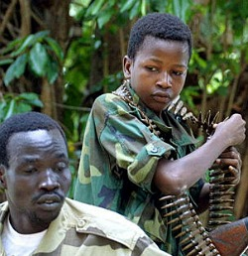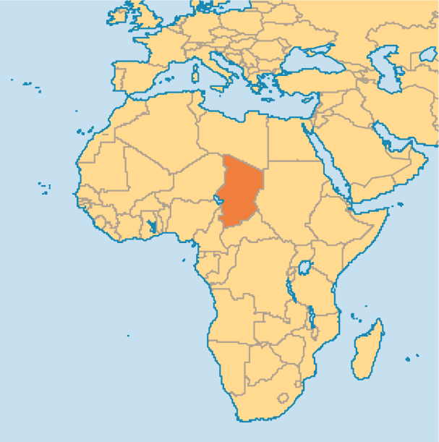
Chad is a country in the heart of Africa (Central Africa). It shares borders with the Sudan to the east, Niger to the west, Cameroon and Nigeria to the southwest and Libya to the north.
The Republic of Chad has a total land area of about 1,284,000 squared kilometres and a population of about 11 million people with the population growth rate around 2.6%. Only about 28% of the total Chadian population live in urban areas. Majority of the population live in rural areas. N'djamena the capital of Chad contains about 1 million people.
Chad like its neighbouring countries is blessed with abundance of natural resources including gold, petroleum, uranium, limestone, kaolin, fish(from lake Chad), sand and gravel, salt, etc. However, despite the abundance of natural resources in Chad today, it remains one of the poorest countries in Africa. It has one of the worst literacy rates in all of Africa. The literacy rate in Chad today is around 25.7% for the total population with the female literacy rate around 12.8%. In other words, just about 25.7% of the total population of Chad above age 15 can read and write.
Although the southern parts of Chad are tropical, the northern parts are mostly deserts with inadequate supply of portable water. The improper waste disposal and poor practices including poor farming practices especially in the rural areas contribute greatly to land and water pollution and also desertification.
Despite the numerous HIV/AIDS awareness campaigns, more than 210,000 people were living with HIV/AIDS in 2009 with about 11,000 deaths recorded within the same year. Although the northern parts are somehow spared, the southern parts of Chad remains one of the malaria killing zones in Africa today. Diarrhoea, rabies, and several other diseases continue to threaten people in this part of the world.
Due to its geographic location, violence in neighbouring countries easily spread to Chad making Chad one of the few unstable countries in Africa today. Political and ethnic violence are very common with women and children often being the target group. In his numerous attempts to overthrow the current Chadian president, Chad's violent neighbour Omar al-Bashir the president of North Sudan often sponsors several rebel groups to destabilize the region. Like most other poor countries in Africa, poor leadership and corruption continue to tear Chad into pieces.

Figure 6
