History Year 10
Transition booklet

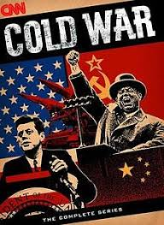

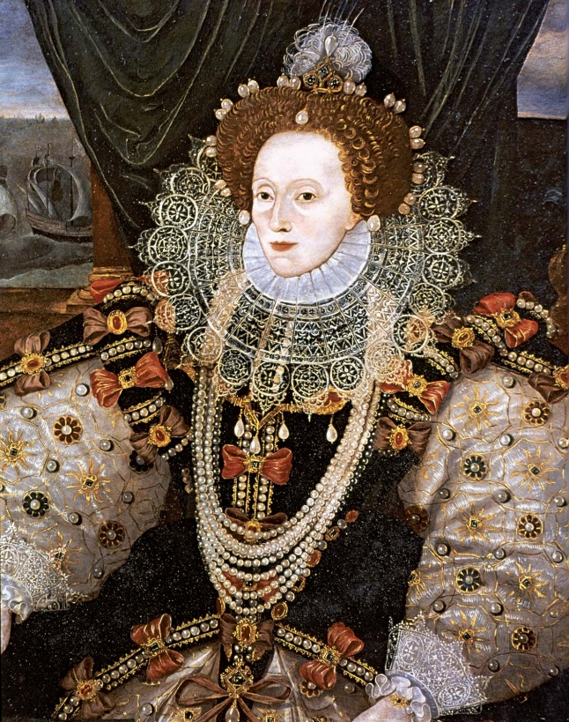
Name:
This booklet will help you prepare for your return to school. Make sure you read it carefully and complete all activities.
Glossary of key terms
Key term | Definition | Example
Fascism | a form of far-right, authoritarian ultranationalism characterized by dictatorial power, forcible suppression of opposition, and strong regimentation of society and of the economy which came to prominence in early 20th-century Europe | The National Socialist German Workers Party and the Third Reich in Germany 1933 to 1945.
dictatorship | a form of government characterized by a single leader or group of leaders and little or no toleration for political pluralism or independent programs or media | the Modern North Korean government is a communist dictatorship
Totalitarianism | a system of government that is centralized and dictatorial and requires complete subservience to the state. | The government controls nearly all aspects of peoples lives.
Economics | the condition of a region or group as regards material prosperity. | The wealth of a country will dictate economic policy
propaganda | information, especially of a biased or misleading nature, used to promote a political cause or point of view. | The government used propaganda to persuade people that they were right
indoctrination | the process of teaching a person or group to accept a set of beliefs uncritically. | The German people were indoctrinated at their schools
Politics | the activities associated with the governance of a country or area, especially the debate between parties having power. | Political parties argued how to best run the country
constitution | body of fundamental principles or established precedents according to which a state or other organization is acknowledged to be governed | The countries constitution allowed for regular general elections.
Monarchy | a form of government with a monarch at the head. | Italy had a constitutional monarchy
Berlin | Capital City of Germany | There was immense tension over Berlin in
Treaty | a formally concluded and ratified agreement between states. | The treaty of Versailles was despised by the German people
Alliance | a union or association formed for mutual benefit, especially between countries or organizations. | Italy and Germany were allied with the Pact of Steel
Nuclear Weapon | A destructive weapon that vaporises matter and creates a large amount of radiation | The USSR and the USA competed for more powerful Nuclear weapons
Communism | a theory or system of social organization in which all property is owned by the community and each person contributes and receives according to their ability and needs. | North Korea has a communist regime
Puritan | a member of a group of English Protestants of the late 16th and 17th centuries who regarded the Reformation of the Church under Elizabeth I as incomplete and sought to simplify and regulate forms of worship | Puritans opposed Elizabeth I
Catholic | a member of the Roman Catholic Church | Elizabeth became Queen after her Catholic sister Mary I – commonly know as Bloody Mary

Task 1:
What were the main aspects of Detente?
For example: SALT 1 and the Helsinki acccords
Write a narrative account explaining the key aspects of detente as you know it. (8 marks)
Consider:
- Domestic policy
- International policy
- Theory
- Arms Linitations

____________________________________________________________________________________________________________________________________________________________________________________________________________________________________________________________________________________________________________________________________________________________________________________________________________________________________________________________________________________________________________________________________________________________________________________________________________________________________________________________________________________________________________________________________________________________________________________________________________________________________________________________________________________________________________________________________________________________________________________________________________________________________________________________________________________________________________________________________________________________________________________________________________________________________________________________________________________________________________________________________________________________________________________________________________________________________________________________________________________________________________________________________________________________________________________________________________________________________________________________________________________________________________________________________________________________________________________________________________________________________________________________________________________________________________________________________________________________________________________________________________________________________________________________________________________________________________________________________________________________________________________________________________________________________________________________________________________________________________________________________________________________________________________________________________________________________________________________________________________________________________________________________________________________________________________________________________________________________________________________________________________________________________________________________________________________________________________________________________________________________________________________________________________________________________________________________________________________________________________________________________________________________________________________________________________________________________________________________________________________________________________________________________________________________________

Task 2:
The End if the Cold War and the USSR
Why did the Cold War end?
Explain the importance of the role of Gorbachev in the end of the Cold War (8 marks)
Please use the glossary and try to use correct subject terminology in your essay.

____________________________________________________________________________________________________________________________________________________________________________________________________________________________________________________________________________________________________________________________________________________________________________________________________________________________________________________________________________________________________________________________________________________________________________________________________________________________________________________________________________________________________________________________________________________________________________________________________________________________________________________________________________________________________________________________________________________________________________________________________________________________________________________________________________________________________________________________________________________________________________________________________________________________________________________________________________________________________________________________________________________________________________________________________________________________________________________________________________________________________________________________________________________________________________________________________________________________________________________________________________________________________________________________________________________________________________________________________________________________________________________________________________________________________________________________________________________________________________________________________________________________________________________________________________________________________________________________________________________________________________________________________________________________________________________________________________________________________________________________________________________________________________________________________________________________________________________________________________________________________________________________________________________________________________________________________________________________________________________________________________________________________________________________________________________________________________________________________________________________________________________________________________________________________________________________________________________________________________________________________________________________________________________________________________________________________________________________________________________________________________________________________________________________________________________________________________________________________________________________________________________________________________________________________________________________________________________________________________________________________________________________________________________________________________________

Task 3:
Elizabeth I’s early life.
What major problems did Elizabeth I face?
Think about politics, economics and Religion.
Write a minimum of 500 words.
Please use the glossary and try to use correct subject terminology in your essay.
____________________________________________________________________________________________________________________________________________________________________________________________________________________________________________________________________________________________________________________________________________________________________________________________________________________________________________________________________________________________________________________________________________________________________________________________________________________________________________________________________________________________________________________________________________________________________________________________________________________________________________________________________________________________________________________________________________________________________________________________________________________________________________________________________________________________________________________________________________________________________________________________________________________________________________________________________________________________________________________________________________________________________________________________________________________________________________________________________________________________________________________________________________________________________________________________________________________________________________________________________________________________________________________________________________________________________________________________________________________________________________________________________________________________________________________________________________________________________________________________________________________________________________________________________________________________________________________________________________________________________________________________________________________________________________________________________________________________________________________________________________________________________________________________________________________________________________________________________________________________________________________________________________________________________________________________________________________________________________________________________________________________________________________________________________________________________________________________________________________________________________________________________________________________________________________________________________________________________________________________________________________________________________________________________________________________________________________________________________________________________________________________________________________________________________________________________________________________________________________________________________________________________________________________________________________________________________________________________________________________________________________________________________________________________________________

Task 4:
Elizabethan Religious Settlement
- Three problems Elizabeth faced with Religion were? _________________________________________________________________________________________________________________________________________________________________________________________________________________________________.
- The church was important in Elizabethan England because
________________________________________ ……………………………………………………………………………………………………………………………………………………………………………………………………………………………………………………………………………………………………………………………………………………………………………………………………………………………………………………………………………………………………………………………………………………………………………………………...
- The Puritans opposed Elizabeth’s changes to the church because ________________________________________ ……………………………………………………………………………………………………………………………………………………………………………………………………………………………………………………………………………………………………………………………………………………………………………………………………………………………………………………………………………………………………………………………………………………………………………………………..
- Describe 2 features of the problems faced by Elizabeth. (4 marks) _________________________________________________________________________________________________________________________________________________________________________________________________________________________________.
- Explain why most people accepted the religious settlement? 12 marks.
________________________________________________________________________________________________________________________________________________________________________________________________________________________________ .
______________________________________________________________________________________________________________________________________________________________________________________________________________________________________________________________________________________________________________________________________________________________________________________ . ________________________________________________________________________________________________________________________________________________________________________________________________________________________________ .
______________________________________________________________________________________________________________________________________________________________________________________________________________________________________________________________________________________________________________________________________________________________________________________________________________________________________________________________________________________________________________________________________________________________________________________________________________________ .
______________________________________________________________________________________________________________________________________________________________________________________________________________________________________________________________________________________________________________________________________________________________________________________________________________________________________________________________________________________________________________________________________________________________________________________________________________________ .
______________________________________________________________________________________________________________________________________________________________________________________________________________________________________________________________________________________________________________________________________________________________________________________________________________________________________________________________________________________________________________________________________________________________________________________________________________________ .
______________________________________________________________________________________________________________________________________________________________________________________________________________________________________________________________________________________________________________________________________________________________________________________________________________________________________________________________________________________________________________________________________________________________________________________________________________________ .
______________________________________________________________________________________________________________________________________________________________________________________________________________________________________________________________________________________________________________________________________________________________________________________

