History Year 8
Transition booklet

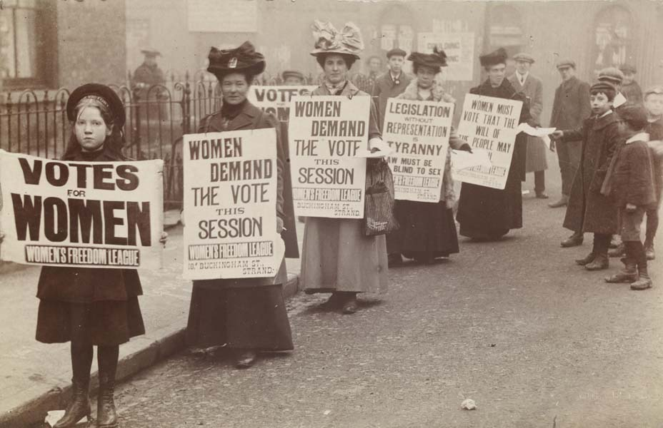
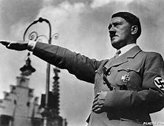

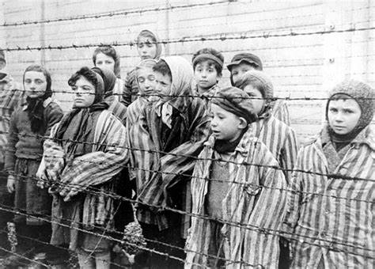

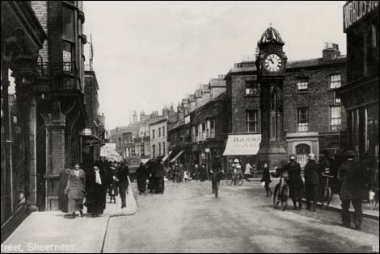

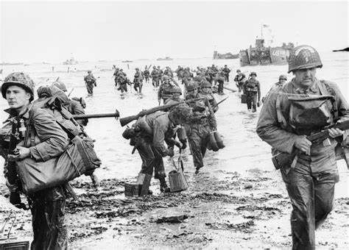

Name:
This booklet will help you prepare for your return to school. Make sure you read it carefully and complete all activities.
Glossary of key terms
Key term | Definition | Example
Infer | deduce or conclude (something) from evidence and reasoning | I can infer that children were used to support Suffragette movement (picture above)
COPS | Content, Own knowledge, Provenance, Say why is useful
Provenance | The origin, nature or purpose of something | The origin of this source is from 1914, its nature is a newspaper article –its purpose is to inform us about the event
Franz Ferdinand | Archduke of Austria who was assassinated in 1914 | Archduke Franz Ferdinand’s assassination was one of the starting points for World War One
Police State | A government exercises control through the power of police | The Nazis used a police state to help enforce their laws in Germany
WSPU | Women’s Social and Political Union | The WSPU were a major force in the Suffragette movement…
Ghetto | Put in or restrict to an isolated or segregated area or group. | The Jews were segregated before the Holocaust into ghettos
Hitler Youth | Group of young people who were indoctrinated to follow Nazi ideals | The Hitler Youth was based on the Scout movement
Muswell Manor | Airfield based at Eastchurch on the Isle of Sheppey | Muswell Manor was the birthplace of British aviation
SS Montgomery | American Battleship that sunk of the Sheppey coastline | The Montgomery sunk and has stored explosives which pose a danger to the island
Holocaust | Genocide of Jews in Europe between 1941-45
Indoctrination | The process of teaching a person or group to accept a set of beliefs uncritically. | The German people were indoctrinated at their schools
Propaganda | information, especially of a biased or misleading nature, used to promote a political cause or point of view. | The government used propaganda to persuade people that they were right

Task 1:
What knowledge can you remember from the topics over the course of this year?
- What was the Schlieffen Plan?
Germany to ally with Russia and invade Poland | Germany to invade France and take over within 6 weeks and turn to Russia | Germany to invade Britain and France with Austria support by 1917
2. Who assassinated Archduke Franz Ferdinand?
Gavrillo Princip | Harold Anschluss | Adolf Hitler
3. Who were the Triple Entente?
Britain, France and Russia | Russia, Italy and Germany | Austria-Hungary, Britain and Germany
4. The leader of the WSPU was?
Emily Davison | Emmeline Pankhurst | Millicent Fawcett
5. The WSPU stands for?
Women’s Society for Political Uprising | Women’s Social and Political Union | Women Standing Proud and United
6. The Cat and Mouse act was created in?
1913 | 1903 | 1919
7. The Leader of Propaganda in Nazi Germany was?
Adolf Eichmann | Rudolf Hess | Dr Josef Goebbels
8. The Nazi Party was created in?
1923 | 1919 | 1920
9. Who was the leader of the Schutzstaffel?
Heinrich Himmler | Herman Goering | Josef Mengele
10. What does NSDAP stand for?
National Society of German Artists and Painters | National Socialist German Worker’s Party | National Society for German Women
11. The Hitler Youth did which activities?
Music, Babysitting and Eugenics | Cooking, Cleaning, and Making Beds | Shooting, Camping, Hiking and Tactics
12. Who were the Gestapo?
The Brown Shirts | Secret Police | Intelligence Service
13. What is the Aryan Race?
Non German blue eyed and blonde haired people | Mixed race Germans | Blonde hair and blued eyed Germans
14. What is the Holocaust?

Nazi attack on Europe | Extermination of the Jews | Invasion of Poland
15. What is the famous Death Camp?
Bergen-Belsen | Dachau | Auschwitz-Birkenau
16. How many people died in the Holocaust?
Six Million | Twelve Million | Hundred Thousand
17. When was Kristallnacht?
9th November 1929 | 9th November 1938 | 9th November 1936
18. Who orchestrated the Final Solution?
Josef Goebbels | Josef Mengele and Rudolf Hess | Heinrich Himmler, Reinhardt Heydrich and Hermann Goering
19. What did the Dutch do to Sheppey
Trade spice materials and goods | Invade and take over the Island | Set up a new colony in England
20. The Garrison Point was created for what reason?
Defend Sheppey and the Thames from Attack | To help Sheppey become richer | Able to provide weapons for Britain
21. The HMS Princess Irene was..
Sunken boat of the Sheppey coast | Boat the left Britain for supporting the Medway | Ship that exploded off Queenborough
22. The Short Brothers were important to Sheppey because…
Famous lords born on Sheppey | They built planes and an airstrip from Muswell Manor | They created fishing boats for the local community
23. Who honeymooned on the Isle of Sheppey?
Henry VIII and Anne Boleyn | Queen Elizabeth II and Prince Phillip | Edward and Wallis Simpson

Task 2:
The 5 main causes of World War One can be identified with the acronym MANIA, can you write down what the 5 reasons are and explain what they mean?

_M________________________________________________________________________________________________________________________________________________________________________________________________________________________________________________________________________________________________________________________________________________________________________________________________________________________A_______________________________________________________________________________________________________________________________________________________________________________________________________________________________________________________________________________________________________________________________________N_________________________________________________________________________________________________________________________________________________________________________________________________________________________________________________________________________________________________________________________________________________________________________________________________________________________I_______________________________________________________________________________________________________________________________________________________________________________________________________________________________________________________________________________________________________________________________________A________________________________________________________________________________________________________________________________________________________________________________________________________________________________________________________________________________________________________________________________________________________________________________________________________________________

Which of the above causes for World War One do YOU feel is the most important reason for war starting and WHY?
____________________________________________________________________________________________________________________________________________________________________________________________________________________________________________________________________________________________________________________________________________________________________________________________________________________________________________________________________________________________________________________________________________________________________________________________________________________________________________________________________________________________________________________________________________________________________________________________________________________________________________________

Task 3:
The Suffragette movement

Using the source below – What two things, can you infer from this source about the Suffragette movement?
(think the 5 Ws to help you)
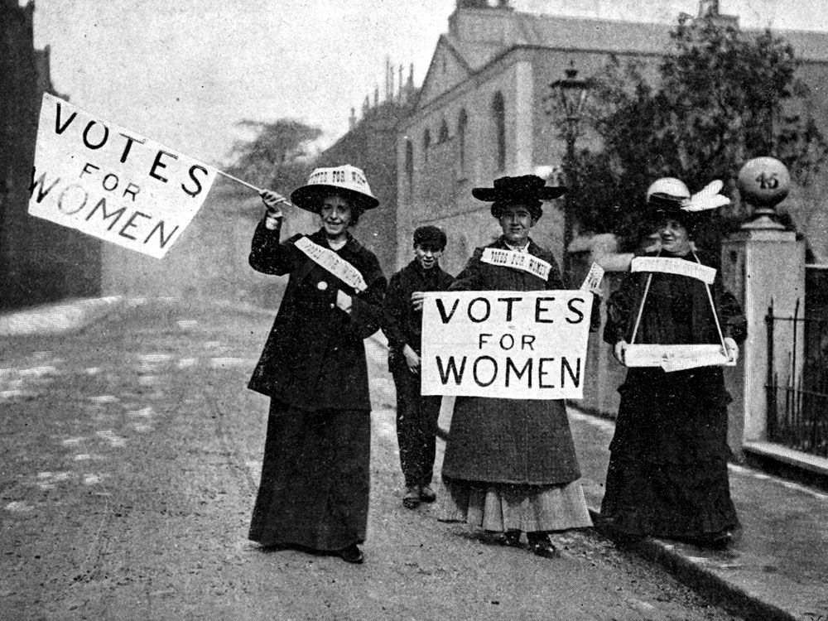

One thing I can infer from this source ______________________________________________________________________________________________________________________________________________________________________________________________________________________________________________________________________________________________________________________________________________________________________________________________________________________________________________________________________________________________________________________________________________________________________________________________A detail that tells me this is… ____________________________________________________________________________________________________________________________________________________________________________________________________________________________________________________________________________________________________________________________________________________________________________________________________________________________________________________________________________________________________________Another inference I can make is …. ______________________________________________________________________________________________________________________________________________________________________________________________________________________________________________________________________________________________________________________________________________________________________________________________________________________________________________________________________________________________________________________________________________________________________________________________A detail that tells me this is… ____________________________________________________________________________________________________________________________________________________________________________________________________________________________________________________________________________________________________________________________________________________________________________________________________________________________________________________________________________________________________________

Task 4:
Nazi Control
- Three ways the Nazis used Propaganda to control the population were….
_________________________________________________________________________________________________________________________________________________________________________________________________________________________________.
- Explain One way the Nazis used terror to control Germany
……………………………………………………………………………………………………………………………………………………………………………………………………………………………………………………………………………………………………………………………………………………………………………………………………………………………………………………………………………………………………………………………………………………………………………………………...
- The Nazis also controlled children through the Hitler Youth, what tasks were the boys to complete? ……………………………………………………………………………………………………………………………………………………………………………………………………………………………………………………………………………………………………………………………………………………………………………………………………………………………………………………………………………………………………………………………………………………………………………………………..
- Explain How the Nazis were able to control through a “Police State” (12 marks) ________________________________________________________________________________________________________________________________________________________________________________________________________________________________ .
______________________________________________________________________________________________________________________________________________________________________________________________________________________________________________________________________________________________________________________________________________________________________________________ . ________________________________________________________________________________________________________________________________________________________________________________________________________________________________ .
______________________________________________________________________________________________________________________________________________________________________________________________________________________________________________________________________________________________________________________________________________________________________________________________________________________________________________________________________________________________________________________________________________________________________________________________________________________ .
______________________________________________________________________________________________________________________________________________________________________________________________________________________________________________________________________________________________________________________________________________________________________________________________________________________________________________________________________________________________________________________________________________________________________________________________________________________ .
______________________________________________________________________________________________________________________________________________________________________________________________________________________________________________________________________________________________________________________________________________________________________________________________________________________________________________________________________________________________________________________________________________________________________________________________________________________ .
______________________________________________________________________________________________________________________________________________________________________________________________________________________________________________________________________________________________________________________________________________________________________________________________________________________________________________________________________________________________________________________________________________________________________________________________________________________ .
______________________________________________________________________________________________________________________________________________________________________________________________________________________________________________________________________________________________________________________________________________________________________________________

Task 5:
The Holocaust
During the late 1930s, Ghettoes were set up to isolate the Jewish community from large cities. The most infamous Ghetto was in Warsaw, Poland
Below is a picture of the Warsaw Ghetto
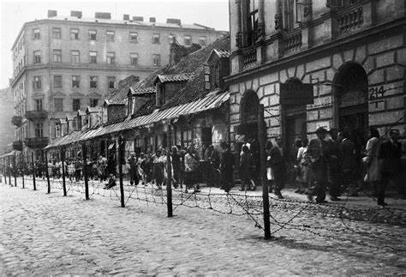

From your own knowledge, can you describe two features of a Ghetto?

One feature was...
______________________________________________________________________________________________________________________________________________________________________________________________________________________________________________________
This was when…
______________________________________________________________________________________________________________________________________________________________________________________________________________________________________________________
Another feature of a Ghetto was…
______________________________________________________________________________________________________________________________________________________________________________________________________________________________________________________
This was when…
______________________________________________________________________________________________________________________________________________________________________________________________________________________________________________________

Task 6:
The history of the Isle of Sheppey

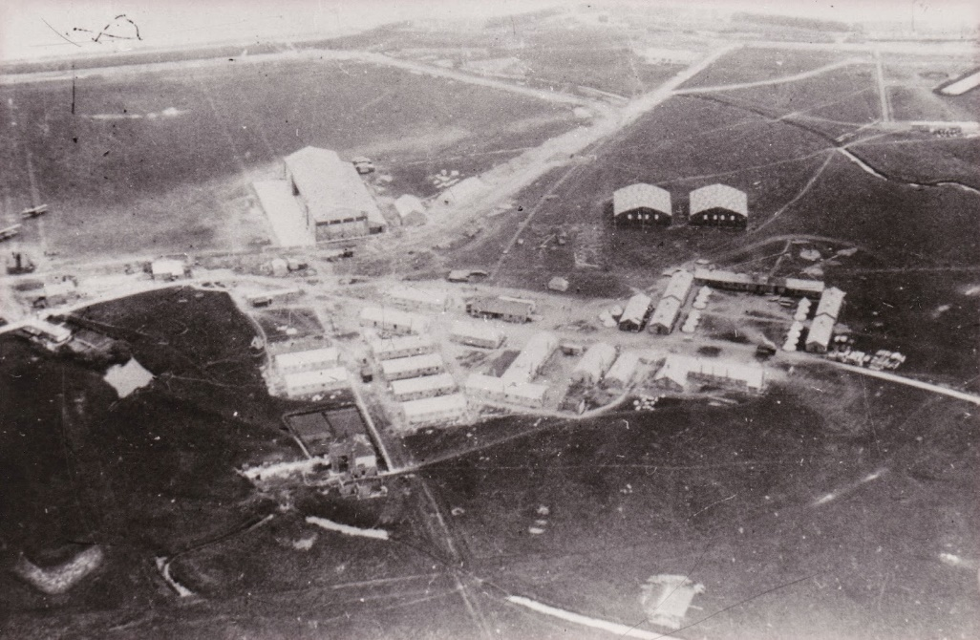
Source A: Leysdown Ranges, 1930 (airfield)

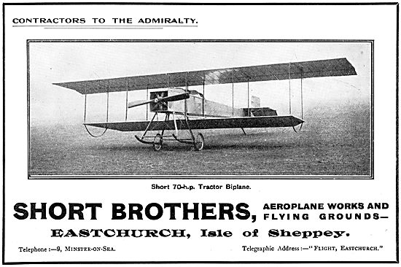
Source B: Advert for the Short Brothers - Short Biplane 1913

How useful are sources A and B for an enquiry into the development of British Aviation? Explain your answer, using sources B and C and your own knowledge of the historical context.
Remember to use COPS (content, own knowledge, provenence, say why it is useful)
Also use the 5 w’s (who made it, what is it of, when was it made, WHY was it made, where is this from?)

Source A is….
________________________________________________________________________________________________________________________________________________________________________________________________________________________________________________________________________________________________________________________

From my own knowledge of the period, I know that aviation on Sheppey was important because…
____________________________________________________________________________________________________________________________________________________________________________________________________________________________________________________________________________________________________________________________________________________________________________________________________________________________________________________________________________________________________________

This source is a
____________________________________________________________________________________________________________________________________________________________________
It was made in
____________________________________________________________________________________________________________________________________________________________________
It was made by…
____________________________________________________________________________________________________________________________________________________________________
The purpose of this source is to show us
______________________________________________________________________________________________________________________________________________________________________________________________________________________________________________________
This source is useful because its shows us…
______________________________________________________________________________________________________________________________________________________________________________________________________________________________________________________
Repeat for source B
____________________________________________________________________________________________________________________________________________________________________________________________________________________________________________________________________________________________________________________________________________________________________________________________________________________________________________________________________________________________________________________________________________________________________________________________________________________________________________________________________________________________________________________________________________________________________________________________________________________________________________________________________________________________________________________________________________________________________________________________________________________________________________________________________________________________________________________________________________________________________________________________________________________________________________________________________________________________________________________________________________________________________________________________________________________________________________________________________________________________________________________________________________________________________________________________________________________________________________________________________________________________________________________________________________________________________________________________________________________________________________________________________________________________________________________________________________________________________________________________________________________________________________________________________________________________________________________________________________________________________________________________________________________________________________________________________________________________________________________________________________________________________________________________________________________________________________________________________________________________________________________________________________________________________________________________________________________________________________________________________________________________________________________________________________________________________________________________________________________________________________________________________________________________________________________________________________________________________________________________________________________________________________________________________________________________________________________________________________________________________________________________________________________________________________________________________________________________________________________________________________________________________________________________________________________________________________________________________________________________________________________________________________________________________________________

