Student Details

First Name Last Name
[_______________________________________________] [_______________________________________________]

TRANSITION ASSESSMENT PACK
YEAR: 7

TOPIC: GEOMETRY
- You will need to watch the six lessons before attempting this pack.
- Please show all steps in your working.
- Attempt all questions.
- Total marks for the paper is 44.
- You may use a calculator if you have one.
- Time allowed is 60 minutes.
Complete the self-assessment when you have finished the paper.

Learning Objective
I can calculate perimeter of rectangles
I can calculate area of rectangles
I can calculate perimeter of triangles
I can calculate area of triangles
I can calculate circumference of circles
I can calculate area of circles
I can calculate perimeter of compound shapes
I can calculate area of compound shapes

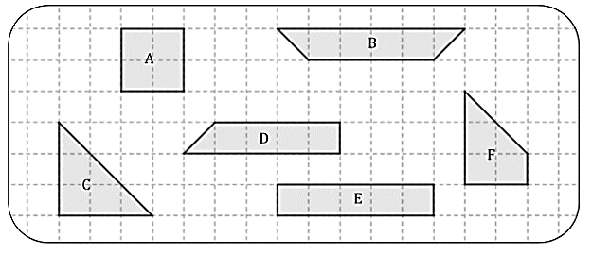
1) Put the shapes below into pairs of equal area.

……………&……………..
……………&……………..
……………&……………..
(3)
2) Work out the perimeter of the shape below.

…………………(2)

3) Find the area of this rectangle.

…………………(2)
4) Work out the area of the triangle below.

……………(2)

5) Work out the area of the triangle below.
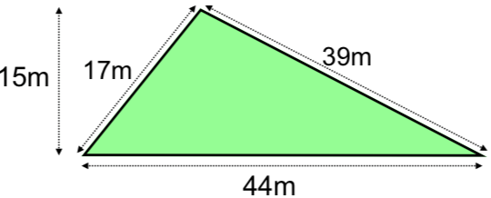

………..…… ( 3)

6) Work out the area of the compound shape below.

………..…… ( 3)
7) A plan of a play area is shown below.
a) Calculate the length of x and y.

…………………….(2)
b) Calculate the perimeter of the play area.

………..…… ( 2)

8) James is working out the circumference of a circle with radius 4cm.
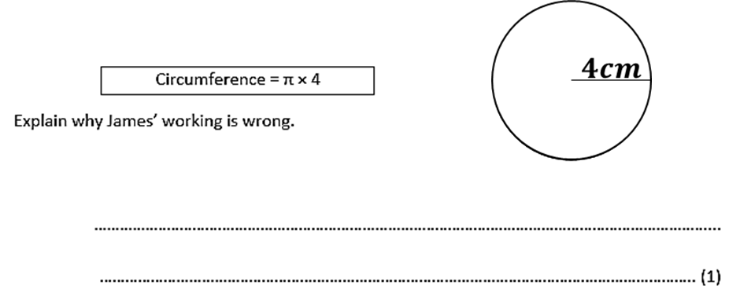
He writes

9) (a) Find the perimeter of this semi-circle with diameter, $d=67cm$.
Give your answer rounded to 1d.p.

…………………………..(3)

(b) Find the area of a circle with radius, $r=6.08m$.
Give your answer correct to 2d.p.

……………………..….(3)

10) Isabella is making a display board for the school trip. The display board is a 10ft by 6ft rectangle. She needs to add a ribbon border around the entire display board. What is the length of ribbon that she needs?

……………………..….(2)

11) Danny has a rectangular rose garden that measures 8m by 10m. One bag of fertilizer can cover 16m². How many bags will he need to cover the entire garden?

……………………..….(3)
12) The area of a rectangle is 28 square meters. The length is 7 meters.
What is the width of the rectangle?

……………………..…. (3)

13) Mark wants to put a border around his circular pond. He measures the diameter of the pond to be 5.5m. Fencing is sold in lengths of 2m.
a) How much fencing dose mark need for his border?

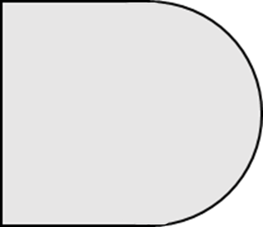
$$7cm$$
……………………..…. (2)

b) How many packs of fencing will he need to buy?

……………………..…. (2)

14) Find the perimeter of the shape below.

……………………..…. (3)
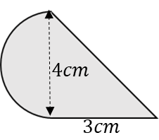
15) Find the area of the shape below

……………………..…. (3)

