English Year 9
Transition booklet

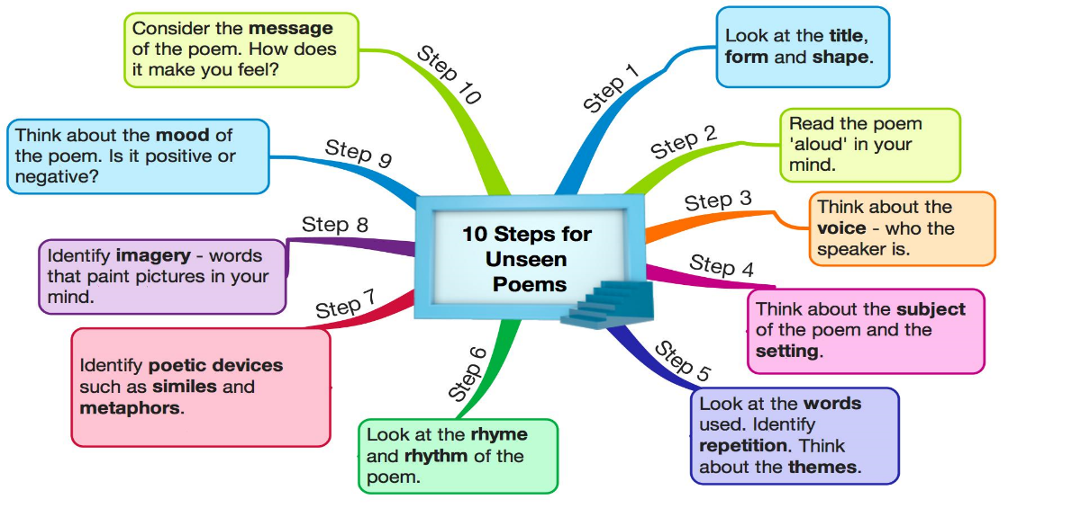

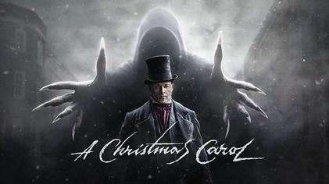
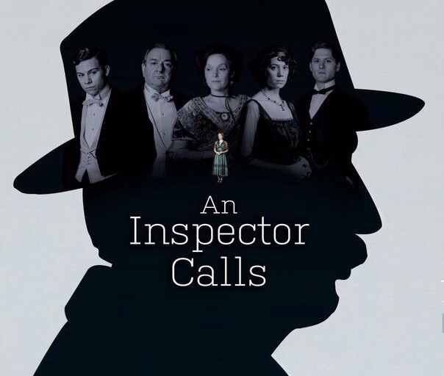

Name:
This booklet will help you prepare for your return to school. Make sure you read it carefully and complete all activities.

Literature Exam Paper 1: 1 hour and 45 minutes
Section A: The Tempest (Shakespeare) 55 minutes
One essay question. (AO1, AO2 & AO3)
The first bullet point will ask you to focus on a theme in the extract.
The second bullet point will focused on this theme is explored elsewhere in the play.
You will be given a mark out of 4 for SPaG. (AO4)

Section B: A Christmas Carol (19th-century novel) 50 minutes
One essay question. (AO1, AO2 & AO3)
The first bullet point will ask you to focus on a theme in the extract.
The second bullet point will focused on this theme is explored elsewhere in the play.

Literature Paper 2: 2 hours 15 minutes

Section B: Power & Conflict Poetry (Poetry Anthology) 40 minutes
One question comparing a named poem from the Power & Conflict collection to another poem from that collection. (AO1, AO2 & AO3)
Section C: Unseen Poetry 45 minutes
Two questions comparing two unseen contemporary poems.
Part 1: Analyse how one unseen presents a theme (AO1 & AO2)
Part 2: Compare how the unseen poem in part 1 and a second unseen poem present the named theme.

An Inspector Calls
by J. B. Priestley
Section A: An Inspector Calls (Post-1914 Literature) 50 minutes
One essay question. (AO1, AO3, AO2 & AO4)
Task one:
Read through An Inspector Calls Summary for the play.

One evening in the spring of 1912, the Birlings are celebrating their daughter Sheila’s engagement to Gerald Croft, who is also present. Husband and wife Arthur and Sybil Birling, along with their son Eric, are pleased with themselves. Birling toasts the happy couple, and Gerald presents Sheila with a ring which absolutely delights her.

Birling makes a lengthy speech, not only congratulating Gerald and Sheila, but also commenting on the state of the nation. He predicts prosperity, particularly referring to the example of the “unsinkable” Titanic, which set sail the week earlier. Birling styles himself as a “hard-headed man of business.”

The women leave the room, and Eric follows them. Birling and Gerald discuss the fact that Gerald might have “done better for [himself] socially”: Sheila is Gerald’s social inferior. Birling confides to Gerald that he is in the running for a knighthood in the next Honours List. When Eric returns, Birling continues giving advice, and he is passionately announcing his “every man for himself” worldview when the doorbell rings.

It is an Inspector, who refuses a drink from Birling. Birling is surprised, as an ex-Lord Mayor and an alderman, that he has never seen the Inspector before, though he knows the Brumley police force pretty well. The Inspector explains that he is here to investigate the death of a girl who died two hours ago in the Infirmary after committing suicide by drinking disinfectant. Her name was Eva Smith, and the Inspector brings with him a photograph, which he shows to Birling—but not to anyone else.

It is revealed that Eva Smith worked in Birling’s works, from which she was dismissed after being a ringleader in an unsuccessful strike to demand better pay for Birling’s workers. The Inspector outlines that “a chain of events” might be responsible for the girl’s death, and—for the rest of the play—interrogates each member of the family, asking questions about the part they played in Eva Smith’s life. We then discover that Sheila Birling encountered Eva Smith at Milwards, where Sheila jealously insisted that she was dismissed. Sheila feels tremendously guilty about her part in Eva’s death. It becomes clear that each member of the family might have part of the responsibility.

Eva Smith then, we discover, changed her name to Daisy Renton—and it is by this name that she encountered Gerald Croft, with whom she had a protracted love affair. Sheila is not as upset as one might expect; indeed, she seems to have already guessed why Gerald was absent from their relationship last summer. He put her up in a cottage he was looking after, made love to her, and gave her gifts of money, but after a while, he ended the relationship. Gerald asks the Inspector, whose control over proceedings is now clear, to leave—and Sheila gives him back his engagement ring.

The Inspector next interrogates Mrs. Birling, who remains icily resistant to accepting any responsibility. Eva Smith came to her, pregnant, to ask for help from a charity committee of which Mrs. Birling was chairperson. Mrs. Birling used her influence to have the committee refuse to help the girl. Mrs. Birling resists the Inspector’s questioning, eventually forcefully telling him that the father of the child is the one with whom the true responsibility rests.

It transpires, to Mrs. Birling’s horror, that Eric was, in fact, the father of the child, and she has just unwittingly damned her own son. Once Eric returns, the Inspector interrogates him about his relationship with Eva Smith. After meeting her in a bar when he was drunk (he has a drinking problem), he forced his way into her rooms, then later returned and continued their sexual relationship. He also gave her money that he had stolen from his father’s works, but after a while, Eva broke off the relationship, telling Eric that he did not love her.

The Inspector makes a final speech, telling the Birlings, “We don’t live alone. We are members of one body. We are responsible for each other. And I tell you that the time will soon come when, if men will not learn that lesson, then they will be taught it in fire and blood and anguish.” He exits.

After his exit, the Birlings initially fight among themselves. Sheila finally suggests that the Inspector might not have been a real police inspector. Gerald returns, having found out as much from talking to a policeman on the corner of the street. The Birlings begin to suspect that they have been hoaxed. Significantly, Eric and Sheila, unlike their parents and Gerald, still see themselves as responsible. “He was our police inspector all right,” Eric and Sheila conclude, whether or not he had the state’s authority or was even real.

Realizing that they could each have been shown a different photograph, and after calling the Chief Constable to confirm their suspicions, Mr. and Mrs. Birling and Gerald conclude that they have been hoaxed, and they are incredibly relieved. Gerald suggests that there were probably several different girls in each of their stories. They call the Infirmary and learn delightedly that no girl has died that night—the Infirmary has seen no suicide for months. Everyone, it seems, is off the hook, even if each of their actions was immoral and irresponsible. Only Sheila and Eric fail to agree with that sentiment and recognize the overall theme of responsibility. As Birling mocks his children’s feelings of moral guilt, the phone rings.

He answers it and is shocked, revealing the play’s final twist: “That was the police. A girl has just died—on her way to the Infirmary—after swallowing some disinfectant. And a police inspector is on his way here—to ask some—questions—”

Structure (layout)

J. B. Priestley opens the play with a celebration, as two of the characters have just got engaged.
1) Why does the playwright (writer of the play) open the play with celebration, a dinner party, an engagement and talk of a good future?
Answer:
The playwright uses this opening scene to show the audience what could have been if everything had gone according to plan. Later, when the characters are implicated in a crime, the audience can clearly see exactly what has been taken away. The audience feels a sense of dread as they are waiting until the “inspector calls”.

Task two:
Significant Events of the 20th Century
Event | Date
Titanic sinks | 1912
World War I begins | 1914
World War I ends | 1918
Women can vote from the age of 30 | 1918
Women can vote from the age of 21 | 1928
World War II begins | 1939
World War II ends | 1945
An Inspector Calls first performed in the UK | 1946

Research the context of ‘An Inspector Calls’ (you will need the internet for this task) The play was first performed in 1946 but it is set in 1912.
Research into the following topics adding key points into the box:
The Titanic
Women’s rights
Priestley’s background
Impact of WWI and WWII
Changes in society between 1912 and 1946
Politics

Task three:
Produce an A4 revision sheet as a group for the context of ‘An Inspector Calls’.
Remember:
Include key dates.
Make your information clear and concise.
Do not copy large chunks of information from the articles.
Cover a range of topics. this context sheet will help you when you are revising for your mocks and your final exams!

Task four:
Socialism and Capitalism
Key words:
socialism: the wealth of the community should be distributed fairly to everyone and everything should be organized by the community.
capitalism: the wealth and industry is owned and controlled by private owners for profit.
Key Quotation:
"Still, I can’t accept any responsibility.”
(Mr Birling, Act I)
J.B. Priestley fought during the first world war in which he experienced a lot of ‘fire and blood and anguish’. After World War I Priestley studied at Cambridge University and became an accomplished novelist. It was during the 1930s that Priestley started to show his concern over the social attitudes towards the working classes and in 1942 he started a political party with many socialist ideas at its heart.

Task five:
Key words:
dramatic irony: when the audience knows more information than the characters.
viewpoint: A person's opinion or point of view.
Key Quotation:
“And I say there isn’t a chance of war.”
(Mr Birling, Act I)

Birling’s Monologue in Act I
Highlight quotations that show use of dramatic irony
“Just let me finish, Eric. You’ve a lot to learn yet. And I’m talking as a hard-headed, practical man of business. And I say there isn’t a chance of war. The world’s developing so fast it’ll make war impossible. Look at the progress we’re making. In a year of two we’ll have aeroplanes that will be able to go anywhere. And look at the way the auto-mobile’s making headway-bigger and faster all the time. And then ships. Why, a friend of mine went over this new liner last week – the Titanic – she sails next week – forty six thousand eight hundred tons – New York in five days – and every luxury – and unsinkable, absolutely unsinkable.
That’s why you’ve got to keep your eye on, facts like that, progress like that – and not a few German officers talking nonsense and a few scaremongers here making a fuss about nothing. Now you three young people, just listen to this – and remember what I’m telling you now. In twenty or thirty years’ time – let’s say, in 1940 – you may be giving a little party like this – your son or daughter might be getting engaged – and I tell you, by that time you’ll be living in a world that’ll have forgotten all these Capital versus Labour agitations and all these silly little war scares. There’ll be peace and prosperity and rapid progress everywhere – except of course in Russia, which will always be behindhand naturally.”

- Why does Priestley use dramatic irony in Mr Birling’s speech?
_____________________________________________________________________________________________________________________________________________________________________________________________________________________________________________________________________________________________________________________________________________________________________________________________________________________________________________________________________________________________________________________________________________________________________________________________________________________________________________________________________________________________________________________________________________________________________________________________________________________________________________________________________________________________________________________________________________________________________________________________________________________________________________________________________________________________________________________________________________________________________________________________________________________________________________________________________________________________________________________________________________________________________________________________________________________________________________________________________________________________________________________________________________________________________________________________________________________________________________________________________________________________________________________________________________________________________________________________________________________________________________________________________________________________________________________________________________________________________________________________________________________________________________________________________________________________________________________________________________________________________________________________________________________________________________________________________________________________________________________________________________________________________________________________________________________

- How does Priestley want the audience to respond to Mr Birling?
________________________________________________________________________________________________________________________________________________________________________________________________________________________________________________________________________________________________________________________________________________________________________________________________________________________________________________________________________________________________________________________________________________________________________________________________________________________________________________________________________________________________________________________________________________________________________________________________________________________________________________________________________________________________________________________________________________________________________________________________________________________________________________________________________________________________________________________________________________________________________________________________________________________________________________________________________________________________________________________________________________________________________________________________________________________________________________________________________________________________________________________________________________________________________________________________________________________________________________________________________________________________________________________________________________________________________________________________________________________________________________________________________
Task six:
The Characters
Key words:
views: a particular way of considering or regarding something; an attitude or opinion.
social responsibility: acting with concern and sensitivity, aware of the impact of your actions on others, particularly the disadvantaged.

Key Quotation:
"a man has to make his own way."
(Mr Birling, Act I)

What do the quotations suggest about the characters?

- Mr Birling: Still, I can’t accept any responsibility’
____________________________________________________________________________________________________________________________________________________________________________________________________________________________________________________________________________________________________________
- Mrs Birling: ‘a rather cold woman and her husband’s social superior’
____________________________________________________________________________________________________________________________________________________________________________________________________________________________________________________________________________________________________________
- Sheila Birling: ‘And if I could help her now, I would-’
____________________________________________________________________________________________________________________________________________________________________________________________________________________________________________________________________________________________________________

- Eric Birling: ‘He could have kept her on instead of throwing her out’
____________________________________________________________________________________________________________________________________________________________________________________________________________________________________________________________________________________________________________
- Gerald Croft: ‘I don’t come into this suicide business’
____________________________________________________________________________________________________________________________________________________________________________________________________________________________________________________________________________________________________________

Task seven:
Act III: The Inspector’s Final Monologue
Inspector: But just remember this. One Eva Smith has gone – but there are millions and millions of Eva Smiths and John Smiths still left with us, with their lives, their hopes and fears, their suffering and chance of happiness, all intertwines with our lives, with what we think and say and do. We don’t live alone. We are members of one body. We are responsible for each other. And I tell you that the time will come when, if will not learn their lesson, then they will be taught it in fire and blood and anguish. Good night.

Analytical Paragraph
How does Priestley use language in the Inspector’s final monologue to voice his views on society?
Comment on the effect on the audience. Remember you are assessed on AO1, AO2, AO3 and AO4.
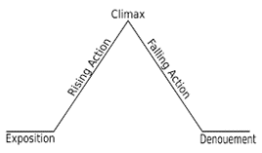
In the of the morality play ‘An Inspector Calls’, Priestley uses ______________________________________________________________________________________________________________________________________________________ This is portrayed when the Inspector ____________________________________________: “________________________________________________________________________”. In other words, _________________________________________________________________________________________________________________________________________________________________________________________________________________________________.
More specifically, Priestley has used ____________________________________________
in the Inspector’s monologue in order to highlight _________________________________ _________________________________________________________________________________________________________________________________________________________________________________________________________________________________.
This would make a post war audience realise _______________________________________________________________________________________________________________________________________________________________________________________________________________________________________________________________________________________________________________________________________________________________________________________.
Task eight:
In one paragraph, summarise the role of Inspector Goole in the play.
_____________________________________________________________________________________________________________________________________________________________________________________________________________________________________________________________________________________________________________________________________________________________________________________________________________________________________________________________________________________________________________________________________________________________________________________________________________________________________________________________________________________________________________________________________________________________________________________________________________________________________________________________________________________________________________________________________________________________________________________________________________________________________________________________________________________________________________________________________________________________________________________________________________________________________________________________________________________________________________________________________________________________________________________________________________________________________________________________________________________________________________________________________________________________________________________________________________________________________________________________________________________________________________________________________________________________________________________________
A Christmas Carol
Task one:
A Christmas Carol Plot Summary

A mean-spirited, miserly old man named Ebenezer Scrooge sits in his counting-house on a frigid Christmas Eve. His clerk, Bob Cratchit, shivers in the anteroom because Scrooge refuses to spend money on heating coals for a fire. Scrooge's nephew, Fred, pays his uncle a visit and invites him to his annual Christmas party. Two portly gentlemen also drop by and ask Scrooge for a contribution to their charity. Scrooge reacts to the holiday visitors with bitterness and venom, spitting out an angry "Bah! Humbug!" in response to his nephew's "Merry Christmas!" Later that evening, after returning to his dark, cold apartment, Scrooge receives a chilling visitation from the ghost of his dead partner, Jacob Marley. Marley, looking haggard and pallid, relates his unfortunate story. As punishment for his greedy and self-serving life his spirit has been condemned to wander the Earth weighted down with heavy chains. Marley hopes to save Scrooge from sharing the same fate. Marley informs Scrooge that three spirits will visit him during each of the next three nights. After the wraith disappears, Scrooge collapses into a deep sleep. He wakes moments before the arrival of the Ghost of Christmas Past, a strange childlike phantom with a brightly glowing head. The spirit escorts Scrooge on a journey into the past to previous Christmases from the curmudgeon's earlier years. Invisible to those he watches, Scrooge revisits his childhood school days, his apprenticeship with a jolly merchant named Fezziwig, and his engagement to Belle, a woman who leaves Scrooge because his lust for money eclipses his ability to love another. Scrooge, deeply moved, sheds tears of regret before the phantom returns him to his bed. The Ghost of Christmas Present, a majestic giant clad in a green fur robe, takes Scrooge through London to unveil Christmas as it will happen that year. Scrooge watches the large, bustling Cratchit family prepare a miniature feast in its meager home. He discovers Bob Cratchit's crippled son, Tiny Tim, a courageous boy whose kindness and humility warms Scrooge's heart. The specter then zips Scrooge to his nephew's to witness the Christmas party. Scrooge finds the jovial gathering delightful and pleads with the spirit to stay until the very end of the festivities. As the day passes, the spirit ages, becoming noticeably older. Toward the end of the day, he shows Scrooge two starved children, Ignorance and Want, living under his coat. He vanishes instantly as Scrooge notices a dark, hooded figure coming toward him. The Ghost of Christmas Yet to Come leads Scrooge through a sequence of mysterious scenes relating to an unnamed man's recent death. Scrooge sees businessmen discussing the dead man's riches, some vagabonds trading his personal effects for cash, and a poor couple expressing relief at the death of their unforgiving creditor. Scrooge, anxious to learn the lesson of his latest visitor, begs to know the name of the dead man. After pleading with the ghost, Scrooge finds himself in a churchyard, the spirit pointing to a grave. Scrooge looks at the headstone and is shocked to read his own name. He desperately implores the spirit to alter his fate, promising to renounce his insensitive, avaricious ways and to honour Christmas with all his heart. Whoosh! He suddenly finds himself safely tucked in his bed. Overwhelmed with joy by the chance to redeem himself and grateful that he has been returned to Christmas Day, Scrooge rushes out onto the street hoping to share his newfound Christmas spirit. He sends a giant Christmas turkey to the Cratchit house and attends Fred's party, to the stifled surprise of the other guests. As the years go by, he holds true to his promise and honours Christmas with all his heart: he treats Tiny Tim as if he were his own child, provides lavish gifts for the poor, and treats his fellow human beings with kindness, generosity, and warmth.

Key words:
preface: an introduction to a book, typically stating its subject, scope, or aims
miser: a person who hoards wealth and spends as little money as possible
novella: a short novel or long short story.

Preface
Read the synopsis and the preface of ‘A Christmas Carol’. Highlight key words in the preface.
Hints that the spirits in the text present the main messages in the novella.

Highlights the importance of the Christmas spirit
I have endeavoured in this Ghostly little book, to raise the Ghost of an Idea, which shall not put my readers out of humour with themselves, with each other, with the season, or with me. May it haunt their house pleasantly, and no one wish to lay it.
Their faithful Friend and Servant,
C. D.
December 1843

Dickens hopes that the ideas and themes he is trying to highlight to the reader, will remain after they have finished reading the novella.

- Can you spot any writer’s methods (language devices) used in the preface? What effect do they have?
_________________________________________________________________________________________________________________________________________________________________________________________________________________________________________________________________________________________________________________________________________________________________________________________________________________________________________________________________________________________________________________________________________________________________________________________________________________________________________________________________________________________________________________________________________________________________________________________________________________________________________________________

Task two:
Key words:
Victorian: a descriptive term for the time when Victoria was queen of England, from 1837 to 1901
workhouse: a ​building where very ​poor ​people in ​Britain used to ​work, in the past, in ​exchange for ​food and ​shelter.
key quotation:
“decrease the surplus population”
(Scrooge, Stave One)

Annotate the quotation:
As the poor don’t add wealth into society, they are of no use.
Cold, economical language: the poor are numbers on a ledger to Scrooge

“decrease the surplus population”
Scrooge dehumanises the poor and separates them from the rich.
- Using the above quotation and your knowledge of the Victorian era, answer this question in an analytical paragraph: What is Scrooge’s attitude to the poor?
Scrooge thinks the poor ____________________________________________________________________________________________________________________________________________________________________________________________________________________________________________________________________________________________________________
In other words _______________________________________________________________________________________________________________________________________________________________________________________________________________________________________________________________________________________________________________________________________________________________________________________
More specifically
__________________________________________________________________________________________________________________________________________________________________________________________________________________________________________________________________________________________________________________________________________________________________________________________________________________________________________________________________
The reader may feel
________________________________________________________________________________________________________________________________________________________________________________________________________________________________________________________________________________________________________________________________________________________________________________________________________________________________________________________________________________________________________________________________________________________________________________________________________________________

Task three:
Research the Industrial Revolution.
Write a summary of how does this link to the ideas presented in the text?
_______________________________________________________________________________________________________________________________________________________________________________________________________________________________________________________________________________________________________________________________________________________________________________________________________________________________________________________________________________________________________________________________________________________________________________________________________________________________________________________________________________________________________________________________________________________________________________________________________________________________________________________________________________________________________________________________________________________________________________________________________________

Task four:
Key words:
foreshadow: to show or indicate beforehand
supernatural: manifestations or events considered to be of supernatural origin, such as ghosts
omniscient narrator: the ​voice in which a ​story is written that is ​outside the ​story and ​knows everything about the ​characters and ​events in the ​story

Purpose of the omniscient narrator
The narrator puts the reader at ease immediately with a casual tone and humorous observations e.g. “dead as a doornail”. The narrator comes across as a talkative, witty storyteller – Dickens does this so that the reader likes and trusts the narrator.
After gaining the reader’s trust, they give a lot of negative opinions about Scrooge, such as “old sinner”. This encourages the reader to despise Scrooge.

- As Scrooge starts to transform later in the novella, the narrator reveals Scrooge’s feelings. How do you think this would impact on the reader?
_________________________________________________________________________________________________________________________________________________________________________________________________________________________________________________________________________________________________________________________________________________________________________________________________________________________________________________________________________________________________________________________________________________________________________________________________________________________________________________________________________________________________________________________________________________________________________________________________________________________________________________________
Task five:
tension: mental or emotional strain; intense, suppressed suspense, anxiety, or excitement
dramatic irony: a literary technique where the audience know things the characters do not.
Key Quotation:
“I will honour Christmas in my heart and try to keep it all the year.”
(Scrooge, Stave Four)

Tension
Examples of literary techniques used to create tension, match the technique to the definition.
Technique: |  | Definition:
cliff-hanger: |  | hints about what is to come
dramatic irony: |  | writers create a list of fearful or worrying details, which creates an overwhelming, claustrophobic or intense feeling
flashforward: |  | make the pressure loom by using a ticking clock device-there needs to be a destination in the future that is looming- worried thoughts can also work to help emphasize the time
foreshadowing: |  | ending with incomplete excitement
long sentences: |  | running, or runs-this makes it feel as if it's happening right now
narrative hook: |  | punchy dramatic or abrupt facts are delivered in a shocking way that visually stands out
present tense: |  | when the audience knows more information than the characters
short sentences: |  | opening excitement that captures attention
time: |  | narration of future events

Unseen poetry.
Glossary Key Definitions:
Key term | Definition | Example
language: | The writer’s choice of words and phrases and their impact. | When analysing poetry consider the effect of specific words.
structure: | The arrangement of a poem. When analysing poetry this could include repetition, punctuation, line/stanza length or the number and order of stanzas | The structure of a poem refers to the way it is presented to the reader. This could include technical things such as the line length and stanza format. Or it could include the flow of the words used and ideas conveyed. Line length shows the reader how it should be read.
form: | Some poems adopt specific forms/type of text e.g. sonnets or narrative poems | A poetic form just refers to a type of poem that follows a particular set of rules, whether it be the number of lines, the length or number of stanzas, rhyme scheme, subject matter.
context: | The circumstances that form the setting for an event, statement, or idea. The background. | Context can include: Knowing about these things can give us an insight into the poet’s intentions and purpose in writing a poem.

Subject terminology:
imagery – visually descriptive or figurative language, especially in a literary work. it helps you to imagine what is being described
analyse - examine something methodically and in detail, typically in order to explain and interpret it
technique - language devices are techniques which allow the writer to convey meaning (e.g. metaphors)
inference - an interpretation which goes beyond the literal information given
deduction - an understanding based on the evidence
personification - the attribution of a personal nature or human characteristics to something non-human
rhythm - the beat and movement of language (rise and fall, repetition and variation, change of pitch, mix of syllables, melody of words)
rhyme - words that sound alike, especially words that end in the same sound
stanza - group of lines in a poem that make up a single unit; like a paragraph in prose
free verse - poetry that does not rhyme or have a regular rhythm
alliteration – close repetition of consonant sounds, especially initial consonant sounds
assonance – close repetition of vowel sounds
refrain - a repeated line within a poem, similar to the chorus of a song

Term Definition

hyperbole. | Hyperbole is an exaggeration that is created to emphasize a point or bring out a sense of humour.
metaphor | When you say something is something else, but you know it can’t be. “She is a star!”
simile | When you compare two things using ‘as’ or ‘like’. “As brave as a lion
oxymoron | When two words are placed together with opposite meanings.
emotive language | Language used to create a particular emotion in the reader.
figurative language | language that’s intended to create an image, association, or other effect in the mind of the listener or reader
personification | Personification is a type of figurative language that gives human characteristics to non-living
imagery | When something is described in way that appeals to our senses.
structure | The way that the poem is arranged/organised.
sibilance | A repeated ‘s’, ’sh’ or ‘z’ sound.
semantic field | A group of words in the poem that are all about the same thing/idea.
enjambment | When one line runs into another without a pause.
juxtaposition | When two contrasting ideas are placed together to highlight their differences.

Task One:
Write five sentences using the words in the definition.
- Hyperbole. - I have a million things to do this weekend.
1)______________________________________________________________________
2)______________________________________________________________________
3) ______________________________________________________________________
4)______________________________________________________________________
5)______________________________________________________________________

Task two:
Answer the following questions in full sentences.
- Rain, hail, sleet, snow is an example of what technique?
______________________________________________________________________________________________________________________________________________________
- What is an extended metaphor?
______________________________________________________________________________________________________________________________________________________
- True or False. A narrative is a type of poem where every line rhyme.
______________________________________________________________________________________________________________________________________________________
- True or False. The E in GO MASSIVE stands for emotive language.
---------------------------------------------------------------------------------------------------------------------------------------------------------------------------------------------------------------------------------------------------
5) What technique is:
“icy caverns of a cruel heart”?
----------------------------------------------------------------------------------------------------------------------------------------------------------------------------------------------------------------------------------------------------

Key words:
Unseen: not previously read or studied.
Convey: to communicate; impart; make known.
Contemporary poetry: poetry produced in our time

Literature Exam Component 2

Part 2 45 minutes - One question comparing two unseen contemporary poems.
AO1 Read, understand and respond to texts. Students should be able to:
maintain a critical style and develop an informed personal response
use textual references, including quotations, to support and illustrate interpretations.
AO2 Analyse the language, form and structure used by a writer to create meanings and effects, using relevant subject terminology where appropriate.
Part 2 45 minutes - One question comparing two unseen contemporary poems. (AO1 & AO2)

Task three:
1. Read and underline important words in your question.
Analyse how the writer presents the ways that some students approach poetry and how it should be approached?
Introduction to Poetry

I ask them to take a poem
and hold it up to the light
like a colour slide

or press an ear against its hive.
I say drop a mouse into a poem
and watch him probe his way out,

or walk inside the poem’s room
and feel the walls for a light switch.

I want them to waterski
across the surface of a poem
waving at the author’s name on the shore.

But all they want to do
is tie the poem to a chair with rope
and torture a confession out of it.

They begin beating it with a hose
to find out what it really means.

BILLY COLLINS

In your answer you should consider:
- the ideas in the poems
- the poet’s use of language
- the poet’s use of form and structure.
- Use evidence from the poem to support your ideas.
______________________________________________________________________________________________________________________________________________________________________________________________________________________________________________________________________________________________________________________________________________________________________________________________________________________________________________________________________________________________________________________________________________________________________________________________________________________________________________________________________________________________________________________________________________________________________________________________________________________________________________________________________________________________________________________________________________________________________________________________________________________________________________________________________________________________________________________________________________________________________________________________________________________________________________________________________________________________________________________________________________________________________________________________________________________________________________________________________________________________________________________________________________________________________________________________________________________________________________________________________________________________________________________________________________________________________________________________________________________________________________________________________________________________________________________________________________________________________________________________________________________________________________________________________________________________________________________________________________________________________________________________________________________________________________________________________________________________________________________________________________________________________________________________________________________________________________________________________________________________________________________________________________________________________________________________________________________________________________________________________________________________________________________________________________________________________________________________________________________________________________________________________________________________________________________________________________________________________________________________________________________________________________________________________________________________________________________________________________________________________________________________________________________________________________________________________________________________________________________________________________________________________________________________________________________________________________________________________________________________________________________________________________________________________________________________________________________________________________________________________________________________________________________________________________________________________________________________________________________________________________________________________________________________________________________________________________________________________________________________________________________________________________________________________________________________________________________________________________________________________________________________________________________________________________________________________________________________________________________________________________________________________________________________________________________________________________________________________________________________________________________________________________________________________________________________________________________________________________________________________________________________
Task four:
Structure

Key words:
war photographer: someone who travels to war zones in order to capture the atrocities on camera and report show the world what it is really like.
caesura: a break in the middle of a line of poetry.
cyclical: in a circle.
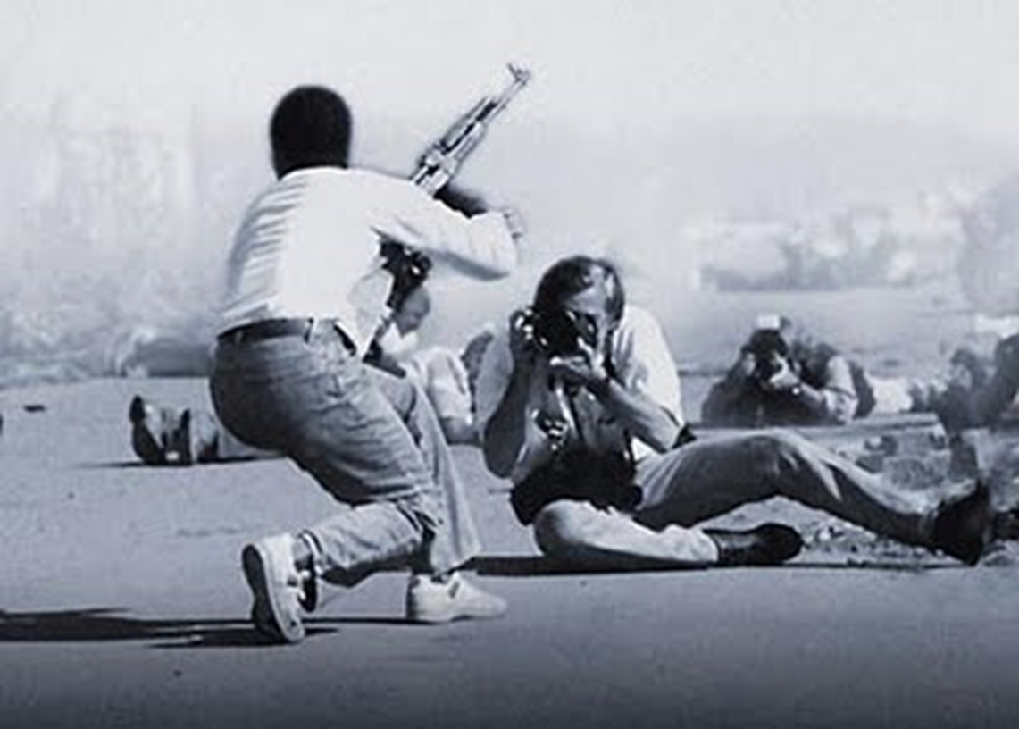

What emotions are in this photo? _________________________________________________________________________________________________________________________________________________________________________________________________________________________________

What is happening in this photo?
_________________________________________________________________________________________________________________________________________________________________________________________________________________________________

Success Criteria AO2 – Structure

Level 1 | Identification of structure is minimal
Level 2 | There is some comment on the structure of the poems
Level 3 | The response shows sound understanding of structure and links it to its effect
Level 4 | Analysis of structure and its effect is sustained
Level 5 | There is perceptive grasp of structure and its effect

Task five:
‘War Photographer’
Carol Ann Duffy
First stanza
Enjambment
Long line, like the long ‘rows’ of ‘suffering’
Rhyming couplets
Rhyme scheme is ABBCDD
‘dark’ turns to ‘light’
In his darkroom he is finally alone
with spools of suffering set out in ordered rows.
The only light is red and softly glows,
as though this were a church and he
a priest preparing to atone a Mass.
Belfast. Beirut. Phnom Penh. All flesh is grass.

Caesura

- Why has these techniques been used?
What might it reflect/suggest?
What does it make you think/feel?
_____________________________________________________________________________________________________________________________________________________________________________________________________________________________________________________________________________________________________________________________________________________________________________________________________________________________________________________________________________________________________________________________________________________________________________________________________________________________________________________________________________________________________________________________________________________________________________

He has a job to do. Solutions slop in trays
beneath his hands which do not tremble then
though seem to now. Rural England. Home again
to ordinary pain which simple weather can dispel,
to fields which don’t explode beneath the feet
of running children in nightmare heat.

Something is happening. A stranger’s features
faintly start to twist before his eyes,
a half-formed ghost. He remembers the cries
of this man’s wife, how he sought approval
Without words to do what someone must
and how the blood stained into foreign dust.

A hundred agonies in black-and-white
from which his editor will pick out five or six
for Sunday’s supplement. The reader’s eyeballs prick
with tears between the bath and pre-lunch beers.
From the aeroplane he stares impassively at where
He earns his living and they do not care.

Look at the rest of the poem. Are the same structural techniques used throughout? Why/why not? What does each one suggest?
_______________________________________________________________________________________________________________________________________________________________________________________________________________________________________________________________________________________________________________________________________________________________________________________________________________________________________________________________________________________________________________________________________________________________________________________________________________________________________________________________________________________________________________________________________________________________________________________________________________________________________________________________________________________________________________________________________________________________________________________________________________________________________________________________________________________________________________________________________________________________________________________________________________________________________________________________________________________________________________________________________________________________________________________________________________________________________________________________________________________________________________________________________________________________________________________________________________________________________

Task six:
How does Duffy present the realities of conflict in ‘War Photographer’?
In this poem Duffy present the realities of the conflict of war ___________________________________________________________________________________________________________________________________________________________________________________________________________________________________________________________________________________________________________________________________________________________________________________________________________________________________________________________________________________________________________________________________________________________________________________________________________________________________________________________________________________________________
In other words _______________________________________________________________________________________________________________________________________________________________________________________________________________________________________________________________________________________________________________________________________________________________________________________More specifically,
____________________________________________________________________________________________________________________________________________________________________________________________________________________________________________________________________________________________________________This might make the reader
____________________________________________________________________________________________________________________________________________________________________________________________________________________________________________________________________________________________________________

Task seven:
Comparing Personas
compare: to examine in order to note similarities and differences.
contrast: to differ strikingly.
free verse: poetry that does not rhyme or have a regular rhythm.
persona: a character or voice the poet creates in their poem.
You must refer to this ‘poetic device’ when responding to the poem.

Read both poems:

Havisham by Carol Ann Duffy  Beloved sweetheart bastard. Not a day since then  I haven’t wished him dead. Prayed for it  so hard I’ve dark green pebbles for eyes,  ropes on the back of my hands I could strangle with.  Spinster. I stink and remember. Whole days  in bed cawing Nooooo at the wall; the dress  yellowing, trembling if I open the wardrobe;  the slewed mirror, full-length, her, myself, who did this  to me? Puce curses that are sounds not words.  Some nights better, the lost body over me,  my fluent tongue in its mouth in its ear  then down till I suddenly bite awake. Love’s  hate behind a white veil; a red balloon bursting  in my face. Bang. I stabbed at a wedding cake.  Give me a male corpse for a long slow honeymoon.  Don’t think it’s only the heart that b-b-b-breaks. |  | Cinderella by Sylvia Plath  The prince leans to the girl in scarlet heels,  Her green eyes slant, hair flaring in a fan  Of silver as the rondo slows; now reels  Begin on tilted violins to span  The whole revolving tall glass palace hall  Where guests slide gliding into light like wine;  Rose candles flicker on the lilac wall  Reflecting in a million flagons' shine,  And glided couples all in whirling trance  Follow holiday revel begun long since,  Until near twelve the strange girl all at once  Guilt-stricken halts, pales, clings to the prince  As amid the hectic music and cocktail talk  She hears the caustic ticking of the clock.

Answer the following questions, based on the poems you have just read.
Who is the persona and how do you know?
Person B – ‘Havisham’ by Carol Ann Duffy | Person A – ‘Cinderella’ by Sylvia Plath
How is the persona feeling? Find at least two quotations to support your ideas.
Person B – ‘Havisham’ | Person A – ‘Cinderella’
What is the tone of the poem and why do you think the poet has created this?
Person B – ‘Havisham’ | Person A – ‘Cinderella’
What do you notice about the structure of the poem? How does this contribute to the tone of the poem?
Person B – ‘Havisham’ | Person A – ‘Cinderella’
Are there any significant sounds in the poem? (Any specific examples of alliteration, points in which the pace changes or effective use of punctuation?)
Person B – ‘Havisham’ | Person A – ‘Cinderella’

Task eight:
Compare the ways the writers present women in Havisham and Cinderella.
Similarities | Differences
Both poems are titled after famous women from literary works: “Havisham” and “Cinderella”. The readers already have an image in their minds. | The persona in ‘Havisham’ presents an angry tone and hatred towards men as one mistreated her: “Give me a male corpse”. In comparison, the persona in ‘Cinderella’ longs for the romantic, idyllic fairy-tale that requires a “Prince” (the lack of details regarding him and the focus on the atmosphere and environment suggest the man himself is secondary).
Society expects a woman to settle with a “Prince” and live happily ever after. However, in both cases, the reality is not so, particularly in the final lines. In ‘Cinderella’, the fricative alliteration of “the caustic ticking of the clock” sharply awakens the persona from the fairy-tale whereas in ‘Havisham’, the stuttering of the final word “b-b-b-breaks” suggests that the hard exterior held by the persona is one to merely protect her from society rather than reflecting her real emotions. | Time  In ‘Havisham’, time slowly passes due to the persona’s depressed state: “Whole days  in bed cawing Nooooo at the wall (enjambment) whereas in ‘Cinderella’, the “ticking of the clock” comes too soon.

- Compare the ways the writers present women in Havisham and Cinderella.
- In your answer, you should compare:
- • the ideas in the poems
- • the poets’ use of language
- • the poets’ use of form and structure.
- Use evidence from the poems to support your comparison.
_______________________________________________________________________________________________________________________________________________________________________________________________________________________________________________________________________________________________________________________________________________________________________________________________________________________________________________________________________________________________________________________________________________________________________________________________________________________________________________________________________________________________________________________________________________________________________________________________________________________________________________________________________________________________________________________________________________________________________________________________________________________________________________________________________________________________________________________________________________________________________________________________________________________________________________________________________________________________________________________________________________________________________________________________________________________________________________________________________________________________________________________________________________________________________________________________________________________________________________________________________________________________________________________________________________________________________________________________________________________________________________________________________________________________________________________________________________________________________________________________________________________________________________________________________________________________________________________________________________________________________________________________________________________________________________________________________________________________________________________________________________________________________________________________________________________________________________________________________________________________________________________________________________________________________________________________________________________________________________________________________________________________________________________________________________________________________________________________________________________________________________________________________________________________________________________________________________________________________________________________________________________________________________________________________________________________________________________________________________________________________________________________________________________________________________________________________________________________________________________________________________________________________________________________________________________________________________________________________________________________________________________________________________________________________________________________________________________________________________________________________________________________________________________________________________________________________________________________________________________________________________________________________________________________________________________________________________________________________________________________________________________________________________________________________________________________________________________________________________________________________________________________________________________________________________________________________________________________________________________________________________________________________________________________________________________________________________________________________________________________________________________________________________________________________________________________________________________________________________________________________________________________________________________________________________________________________________________________________________________________________________________________________________________________________________________________________________________________________________________________________________________________________________________________________________________________________________________________________________________________________________________________________________________________________________________________________________________________________________________________________________________________________________________
Task nine:
Form
Key words:
dramatic monologue: a poem in the form of a speech or narrative by an imagined person, in which the speaker reveals aspects of their character while describing a particular situation or series of events.
enjambment: the continuation of a sentence without a pause beyond the end of a line.
effect: cause (something) to happen.

Top tip on how to approach an unseen poem:
Does the title of the poem ring any bells?
Look at the first and last line: do they support the title of the poem? Do they highlight key themes? Is there a clear difference between the two?

Read the following poem:
MEDUSA

Carol Ann Duffy

A suspicion, a doubt, a jealousy
grew in my mind,
which turned the hairs on my head to filthy snakes
as though my thoughts
hissed and spat on my scalp.

My bride’s breath soured, stank
in the grey bags of my lungs.
I’m foul mouthed now, foul tongued,
yellow fanged.
There are bullet tears in my eyes.
Are you terrified?

Be terrified.
It’s you I love,
perfect man, Greek God, my own;
but I know you’ll go, betray me, stray
from home.
So better by for me if you were stone.

I glanced at a buzzing bee,
a dull grey pebbly fell
to the ground.
I glanced at a singing bird,
a handful of dusty gravel
spattered down

I looked at a ginger cat,
a housebrick
shattered a bowl of milk.
I looked at a snuffling pig,
a boulder rolled
in a heap of shit.

I stared in the mirror.
Love gone bad
showed me a Gorgon.
I stared at a dragon.
Fire spewed
from the mouth of a mountain.

And here you come
with a shield for a heart
and a sword for a tongue
and your girls, your girls.
Wasn’t I beautiful
Wasn’t I fragrant and young?

Look at me now.

Persona:
Draw Medusa and label with at least three apt quotations.

Why has Duffy used the form of a dramatic monologue?
_________________________________________________________________________________________________________________________________________________________________________________________________________________________________________________________________________________________________________________________________________________________________________________________________________________________________________________________________________________________________________________________________________________________________________________________________________________________________________________________________________________________________________________________________________________________________________________________________________________________________________________________
Why a dramatic monologue?
- Duffy also uses a dramatic monologue for ‘Havisham’. Why?
__________________________________________________________________________________________________________________________________________________________________________________________________________________________________________________________________________________________________________________________________________________________________________________________________________________________________________________________________
- Plath uses a form that resembles a sonnet in ‘Cinderella’. Why did she make this choice rather than a dramatic monologue as well?
__________________________________________________________________________________________________________________________________________________________________________________________________________________________________________________________________________________________________________________________________________________________________________________________________________________________________________________________________

Task ten:
- Why might a poet use a dramatic monologue to present their persona?
A poet might use a dramatic monologue to present their persona because ____________________________________________________________________________________________________________________________________________________________________________________________________________________________________________________________________________________________________________________________________________________________________________________________________________________________________________________________________________________________________________________________________________________________________________________________________________________________________________________________________________________________________________________________________________________________________________________________________________________________________________________________________________________________________________________________________
In other words, ‘Medusa’ Duffy uses this form to
__________________________________________________________________________________________________________________________________________________________________________________________________________________________________________________________________________________________________________________________________________________________________________________________________________________________________________________________________
More specifically
__________________________________________________________________________________________________________________________________________________________________________________________________________________________________________________________________________________________________________________________________________________________________________________________________________________________________________________________________This might make the reader
_______________________________________________________________________________________________________________________________________________________________________________________________________________________________________________________________________________________________________________________________________________________________________________________
Similarly, Duffy also uses the form of a dramatic monologue in ‘Havisham’ because
______________________________________________________________________________________________________________________________________________________________________________________________________________________________________________________________________________________________________________________________________________________________________________________
In other words, this is exemplified in the line……
_______________________________________________________________________________________________________________________________________________________________________________________________________________________________________________________________________________________________________________________________________________________________________________________
More specifically, Duffy uses_____________________________________________________________________________________________________________________________________________________________________________________________________________________________
To show
____________________________________________________________________________________________________________________________________________________________________________________________________________________________________________________________________________________________________________This has a greater impact on the reader in the form of a dramatic monologue because
____________________________________________________________________________________________________________________________________________________________________________________________________________________________________________________________________________________________________________
Contrastingly, Plath uses a sonnet form in ‘Cinderella’ rather than a dramatic monologue because
__________________________________________________________________________________________________________________________________________________________________________________________________________________________________________________________________________________________________________________________________________________________________________________________________________________________________________________________________
In other words this is exemplified in the line
____________________________________________________________________________________________________________________________________________________________________________________________________________________________________________________________________________________________________________More specifically, here, Plath uses
____________________________________________________________________________________________________________________________________________________________________________________________________________________________________________________________________________________________________________
to show
_________________________________________________________________________________________________________________________________________________________________________________________________________________________________This has a greater impact on the reader in the form of a sonnet because
____________________________________________________________________________________________________________________________________________________________________________________________________________________________________________________________________________________________________________

