IEU Year 8 Term 5 Worksheet 3
In one of the most significant scenes in the film, Mrs Gruwell notices her students are passing round notes throughout the classroom which have racially offensive images on them. She realises that her students hate each other and that she must do something to challenge their ideas. She tells them about how dangerous “gangs” can be by teaching her students about the Nazis and the holocaust.
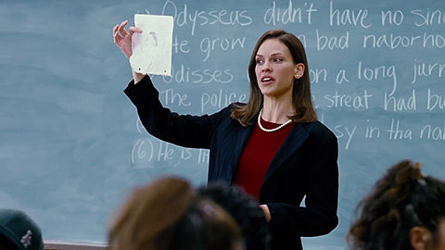
- Read the key information below
Mrs Gruwell: Close the workbooks.
Maybe we should talk about art.
Tito's got real talent, don't you think?

Students: - Yeah, yeah.
- Go, Tito.

Mrs Gruwell: You know something? I saw a picture just like this once in a museum. Only it wasn't a black man, it was a Jewish man. And instead of the big lips, he had a really big nose, like a rat's nose. But he wasn't just one particular Jewish man, this was a drawing of all Jews. And these drawings were put in the newspapers by the most famous gang in history.

Students: That's us, dawg.

Mrs Gruwell: You think you know all about gangs? You're amateurs. This gang would put you all to shame. And they started out poor and angry, and everybody looked down on them. Until one man decided to give them some pride, an identity and somebody to blame. You take over neighborhoods? That's nothing compared to them. They took over countries. And you wanna know how? They just wiped out everybody else.

Students: - Yeah.
- Yeah.

Mrs Gruwell: Yeah, they wiped out everybody they didn't like, and everybody they blamed for their life being hard. And one of the ways they did it was by doing this.
See, they'd print pictures like this in the newspapers. Jewish people with big, long noses. Blacks with big, fat lips.They'd also publish scientific evidence that proved Jews and blacks were the lowest form of human species. Jews and blacks were more like animals. And because they were just like animals it didn't really matter whether they lived or died. In fact, life would be a whole lot better if they were all dead. That's how a holocaust happens. And that's what you all think of each other.

- Copy and complete the summary table to check how much of the key knowledge you have retained:
Which student drew the offensive image?

Which group of people were victimised by a famous “gang” (the Nazis)?
Find a group of three Mrs Gruwell uses which shows what the “gang” (the Nazis) wanted.

Explain three things Mrs Gruwell says that the Nazis did.

What type of offensive images did the Nazis print in newspapers?

- Write two paragraphs explaining why Mrs Gruwell compares the students to the Nazis. Use quotations form the script.

