IEU Year 8 Term 5 Worksheet 4
In one of the most significant scenes in the film, Mrs Gruwell notices her students are passing round notes throughout the classroom which have racially offensive images on them. She realises that her students hate each other and that she must do something to challenge their ideas. She tells them about how dangerous “gangs” can be by teaching her students about the Nazis and the holocaust.
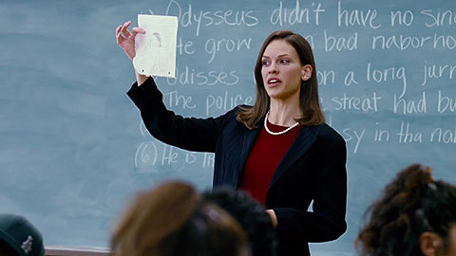
- Read the key information below
Mrs Gruwell: Close the workbooks.
Maybe we should talk about art.
Tito's got real talent, don't you think?

Students: - Yeah, yeah.
- Go, Tito.

Mrs Gruwell: You know something?

I saw a picture just like this once in a museum. Only it wasn't a black man, it was a Jewish man. And instead of the big lips, he had a really big nose, like a rat's nose. But he wasn't just one particular Jewish man, this was a drawing of all Jews. And these drawings were put in the newspapers by the most famous gang in history.

Students: That's us, dawg.

Mrs Gruwell: You think you know all about gangs? You're amateurs.This gang would put you all to shame. And they started out poor and angry, and everybody looked down on them. Until one man decided to give them some pride, an identity and somebody to blame. You take over neighborhoods? That's nothing compared to them. They took over countries. And you wanna know how? They just wiped out everybody else.

Students: - Yeah.
- Yeah.

Mrs Gruwell: Yeah, they wiped out everybody they didn't like, and everybody they blamed for their life being hard. And one of the ways they did it was by doing this.
See, they'd print pictures like this in the newspapers. Jewish people with big, long noses. Blacks with big, fat lips. They'd also publish scientific evidence that proved Jews and blacks were the lowest form of human species. Jews and blacks were more like animals. And because they were just like animals it didn't really matter whether they lived or died. In fact, life would be a whole lot better if they were all dead.
That's how a holocaust happens. And that's what you all think of each other.

- Answer these knowledge recall questions in full sentences:
- What type of prejudice did Jewish people face?
- Which emotion does Mrs Gruwell show in this extract and how do you know?
- Find a simile which Mrs Gruwell uses to highlight a very offensive stereotype.
- List three AFOREST devices Mrs Gruwell uses in her speech.
- Does Mrs Gruwell speak in a formal or informal tone? How do you know?

2. Copy and complete these application sentences using the knowledge you have learnt:
Mrs Gruwell feels furious and disgusted by the drawing being passed around her classroom.
For example, …..
In other words, ……
More specifically, when she says …….. it seems that ……

Mrs Gruwell teaches her students about offensive stereotypes and prejudice.
For example, ……
In other words, …..
Perhaps she wants them to understand that ….

Mrs Gruwell uses a number of persuasive devices in her speech to try to convince her students to stop being prejudiced towards each other and accept their differences.
For example, …..
More specifically, she uses …… . This is effective because ….
Overall she wants her students to think/feel that …….

