Absence Work
27 March 2020
Levels of Organisation

Read through the information and answer the questions that follow:
Plants and animals are multi-cellular. Many cells join together to make the living organism. There are approximately 37.2 trillion cells estimated in the human body. In most organisms, cells are arranged in to tissues. A tissue is a group of cells with a similar structure and function, which all work together to do a job; for example: muscle tissue contracts to produce movement and glandular tissue produces substances such as enzymes and hormones.
Organs are groups of different tissues, which all work together to perform a specific job. Each organ may contain several tissues, for example the stomach is an organ which contains muscle tissue that contracts to churn the contents, glandular tissue to cover the outside and inside of the stomach.
Organs are organised in to organ systems, which are groups of organs working together to do a particular job. The digestive system is an example of an organ system, in which serval organs work together to digest and absorb food. Lots of organ systems work together to make an organism.

Copy out the questions below and write your answers in full sentences
- Define tissue
- Define organ
- Define organ system
- Give an example of an organ system in the human body

Copy the key knowledge table into your exercise books.
Key knowledge- do your look, cover, write, check by learning the answers to the questions below.
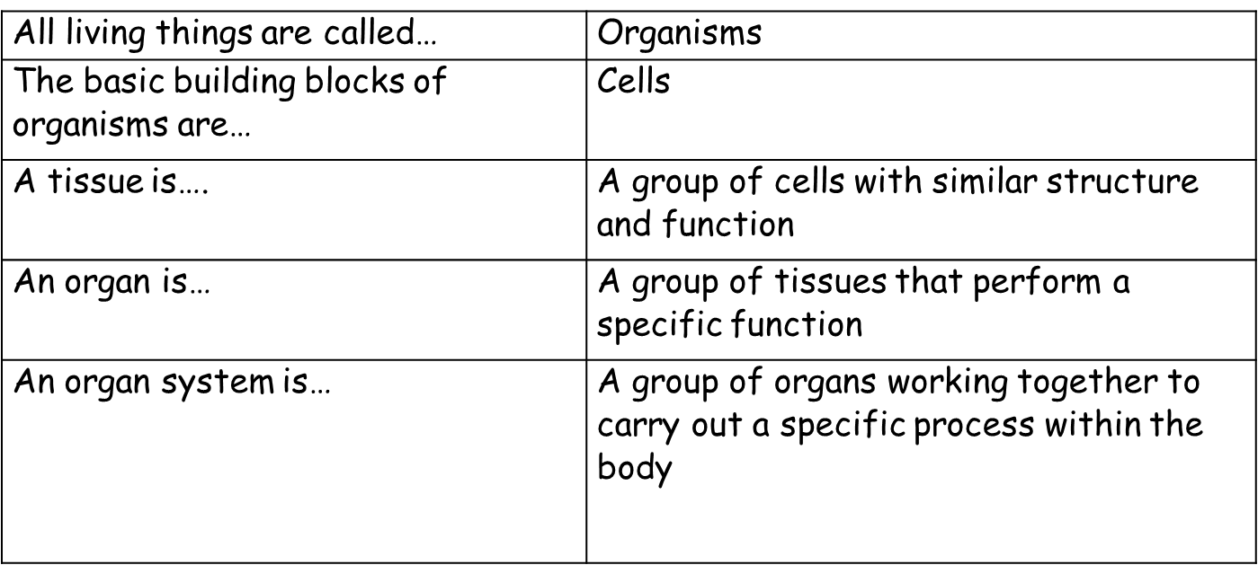

Recall Quiz: copy the questions below and write your answers in full sentences
- What do we call any living things?
- What is a tissue?
- What is an organ?
- What is an organ system?
- Put the following in order of increasing size:
organ tissue cell organ system

Application Task – I Do:

Read the paragraph and identify:
- Specialised cells:
- Tissues:
- Organs:
- Organ system:

Your lungs are made up of muscle tissue which allows the lungs to contract and expand, and epithelial tissue which covers the surface of the lungs. Muscle tissue is made up of muscle cells and epithelial tissue is made up of epithelial cells. Your lungs work together with your mouth and trachea to form the respiratory system.

Application Task – You Do:

Read the paragraph and identify:
- Specialised cells:
- Tissues:
- Organs:
- Organ system:

A plant makes glucose through a process called photosynthesis. In the leaf, there are many specialised cells called palisade cells. These cells have high number of chloroplasts. These palisade cells all work together forming the palisade tissue. Once the glucose has been made from photosynthesis, it needs to be transported to other parts of the plant. The phloem cells in the stem are used for this.
The leafs together with the phloem form the shoot system of the plant

