Absence Work
25 March 2020
Organisation – Cells

Read the information below, then answer the questions that follow.
Cells are often called the “building blocks of life”. All living things are made up of lots and lots of cells.
An animal cell has four main components – first the nucleus. The nucleus has two main roles – it controls all the activities of the cell and it contains all the genetic information. Secondly, a cell membrane – a cell membrane is around the outside of the cell. It controls what comes in and what goes out of the cell (i.e. lets waste products out). It is a bit like a sieve – it has very small holes in it to help control the entry and exit of substances. Thirdly, mitochondria – this is where energy is released and transferred into the cell. Finally the cytoplasm, this is a jelly-like substance that fills the cell – this is where the majority of chemical reactions take place.
Now plants cells are a little different to animal cells – they have a nucleus, cell membrane, mitochondria and cytoplasm, just like an animal cell, but in addition to this there are some extra sub-cellular structures. Firstly, outside of the cell membrane plant cells have a cell wall, the cell wall strengthens the cell – this is very important, animals have a skeleton to keep up upright and give us structure – a plant does not, therefore the cells need additional strength and support for the plant. It also has chloroplasts – these contain a pigment called chlorophyll, which is why plants are green, it is here that photosynthesis takes place. Finally a vacuole, this is a large store of sap which helps to support the cell.
Copy out the questions below and write your answers in full sentences
- State the function of the nucleus
- State the function of the mitochondria
- State the function of the ribosomes
- State the function of the cell membrane
- State the function of the chloroplast

Read the information below, then answer the questions that follow.
There are two main types of cell; prokaryotic and eukaryotic. Plant, animal and fungal cells are all eukaryotic. Bacterial cells are prokaryotic. There are a number of differences between the two types of cell. Prokaryotic cells are much smaller in size and the genetic material is not enclosed in a nucleus, the genetic material is a single loop, there may be more than one small ring of DNA, called plasmids and they do not contain mitochondria or chloroplasts.
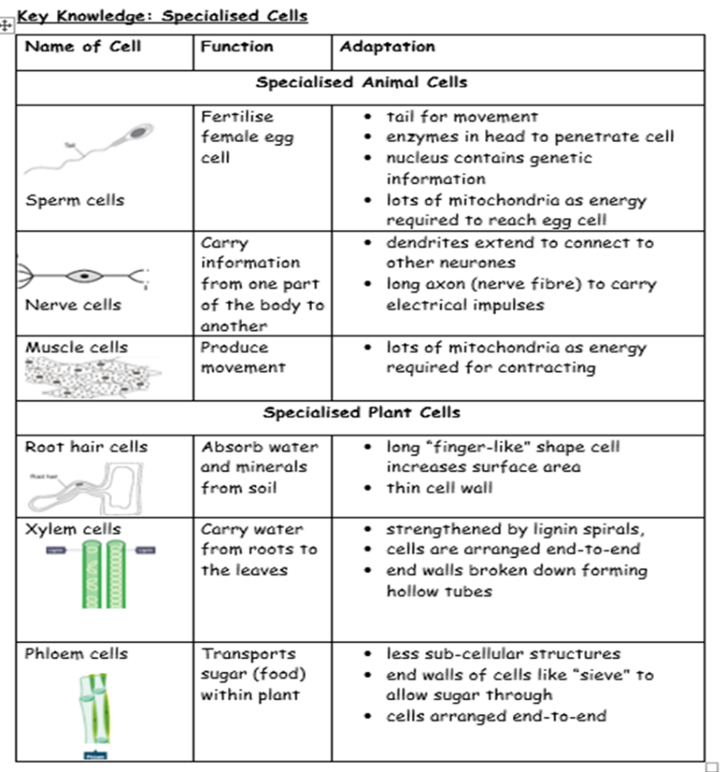
Bacterial cells come in many shapes and sizes, but they are all prokaryotic cells. In bacterial cells the roles of the mitochondria and chloroplasts are taken over by the cytoplasm. there may be one or more flagella, which are tail like structures that move the bacterium. Plasmids are present, which are loops of DNA that can be transferred from one cell to another. Plasmids allow bacteria cells to move genes from one cell to another.
Copy out the questions below and write your answers in full sentences
- Is a bacterial cell prokaryotic or eukaryotic?
- State the differences between prokaryotic and eukaryotic cells.
- State the function of the flagella
- Which key sub-cellular structure of bacterial cells not have?
Read the information below, and then answer the questions that follow.
As an organism develops, cells differentiate to form different types of cells. They become specialised. Most types of animal cell differentiate at an early stage, but many types of plant cell differentiate through their life. As a cell differentiates, it may change shape and develop different sub-cellular structures to let it carry out a specific function. Specialised animal cells include sperm, nerve and muscle cells.

Copy out the questions below and write your answers in full sentences
- Define cell differentiation
- State the function of a sperm cell
- State the function of a nerve cell
- State the function of a xylem cell
- State the function of a phloem cell

Copy the key knowledge table into your exercise books.
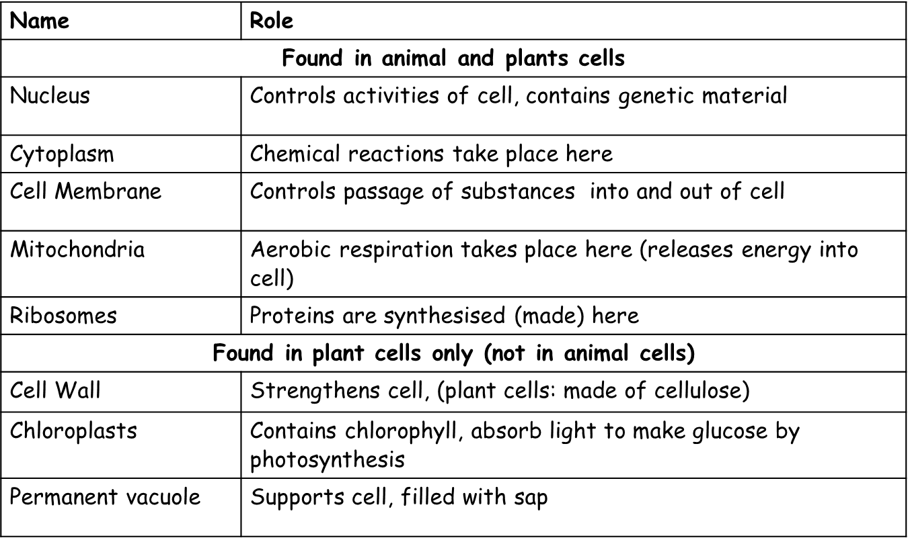
Key knowledge- do your look, cover, write, check by learning the answers to the questions below.

Complete the sentences below in your exercise book.
Recall Quiz:
- The role of the cytoplasm is to…
- The role of the vacuole is to…
- The only structures found in an animal cell are…

Application Task – I Do
Muscles produce movement, muscle cells are adapted for this because…
They have lots of mitochondria so that lots of energy can be transferred to allow the muscles to contract

Application Task – You Do
Complete the sentences below.

- Root hair cells need to absorb water and minerals from the soil.
They have a long “finger”-liked shape providing a large surface area this means that…

The cell wall is very thin so that it is easier..

There are no chloroplasts because…

- The role of sperm cells is to …
They need to travel from the male to the female therefore they have a…

Once they reach the egg, they need to penetrate it, therefore they have…

