Absence Work
30 March 2020
Digestion and Enzymes

Read the information, and answer the questions that follow.
Large complex food molecules (for example, proteins, fats and carbohydrates) must be broken down into simple units that are small enough to be absorbed by the lining of the small intestine; they are broken down using chemicals called enzymes.
Enzymes are biological catalysts – they speed up chemical reactions in living organisms. All enzymes are large proteins that have a space within the protein molecule called the active site. Each enzyme catalyses a specific reaction and works best at a specific temperature and pH called optimum.
The lock and key theory is a model used to explain how enzymes work: the chemical that reacts is called the substrate (key) and it fits into the enzyme’s active site (lock). High temperature and extreme pH make enzymes change shape; this is called denaturing. The enzyme cannot work once it has been denatured, because the substrate cannot fit into the active site – the lock and key no longer fit together.
- Define Enzymes
- Name the 2 conditions that need to be optimum for enzymes to work
- Describe the lock and key theory

Read the information and answer the questions that follow.
Digestive enzymes are produced by specialised cells in glands and the lining of the gut. The enzymes pass out of the cells into the digestive system where they come in to contact with food molecules and they catalyse (speed up) the breakdown of large insoluble food molecules into smaller soluble molecules.
The digestive enzymes protease, lipase and carbohydrase, digest proteins, lipids (fats and oils) and carbohydrates to produce smaller molecules that can be easily absorbed into the bloodstream.
- Amylase – is produced in the salivary glands and the pancreas. It is a carbohydrase that breaks down starch into sugar (maltose)
- Protease – is produced in the stomach, pancreas and small intestine. It breaks down proteins in to amino acids.
- Lipase – is produced in the pancreas and small intestine. It breaks down lipids (fats) into fatty acids and glycerol.
- Name the 4 digestive enzymes
- State which organ that produces all of these enzymes
- State what amylase breaks carbohydrates in to
- State what protease breaks proteins in to
- State what lipase breaks fats in to

Read the information and answer the questions that follow.
Bile is a liquid made in the liver and stored in the gall bladder. It is an alkaline to neutralise hydrochloric acid from the stomach. It also emulsifies fats to form small droplets, increasing the surface area for enzymes to act on. The alkaline conditions and large surface area increase the rate at which fat is broken down by lipase.
- State where bile is made
- State where bile is stored
- State the two functions of bile

Copy the key knowledge table into your exercise books.
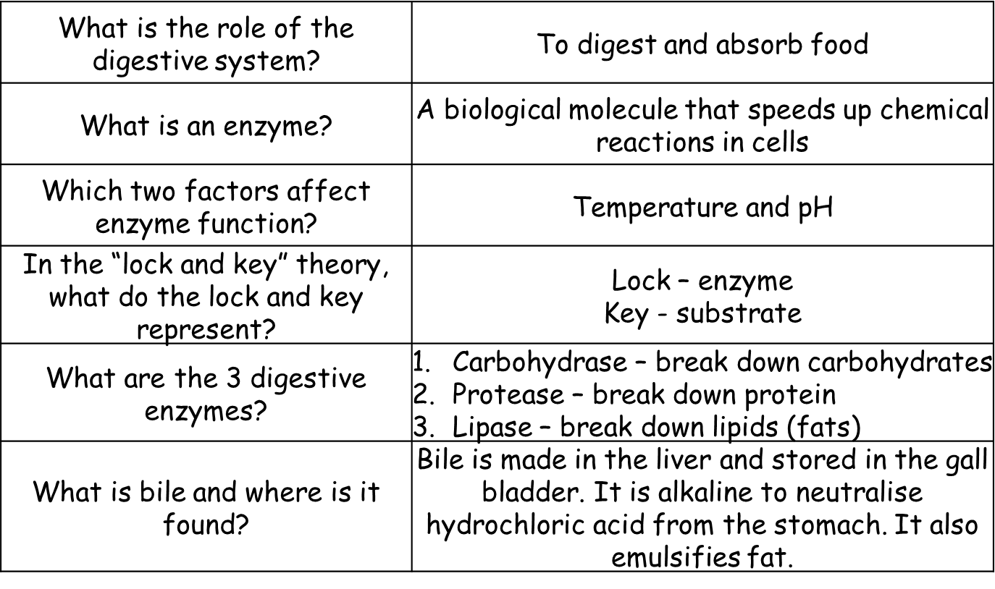
Key knowledge- do your look, cover, write, check by learning the answers to the questions below.

Recall Quiz: copy the questions below and write your answers in full sentences
- What is the role of the digestive system?
- What is an enzyme?
- What are enzymes affected by?
- What is the lock in the lock and key theory?
- What is the key in the lock and key theory?
- What are the three digestive enzymes?
- Is bile acidic or alkaline?
- Where is bile stored?
- What two things does bile do?

Application Task – I Do
1. Describe the shape of the graph.
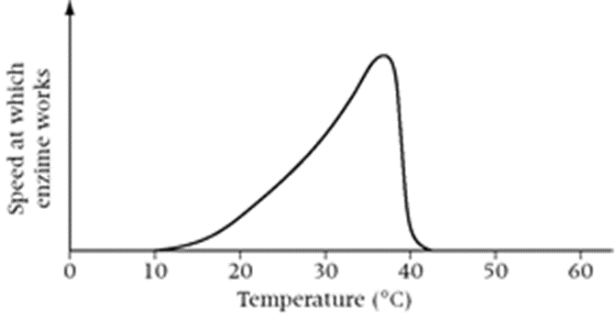
‘As the temperature increases, the speed of the enzyme activity starts to gradually increase. At 40⁰C, the speed of the enzyme activity starts to fall rapidly. At 42⁰C, the speed falls to zero because the temperature has caused the enzyme to become denatured.

2. Explain why the enzyme speed changes with temperature using these words:
Enzymes have an optimum working temperature of 37⁰C, as this is the human core body temperature. As the temperature increases, the active site of the enzyme starts to change shape; this means that the substrate can no longer fit in to the active site, so the substrate cannot be broken down. This means the enzyme has been denatured and can no longer work.

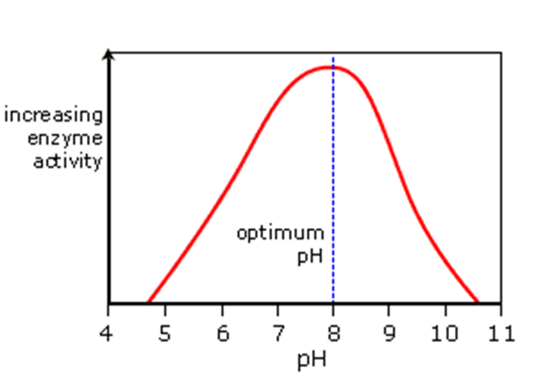
Application Task – You Do
1. Describe the shape of the graph.
‘As the pH increases, the speed of the enzyme activity . . . At pH 8 the speed of the enzyme activity starts to . . . . At pH 11, the speed falls to . . .because . . .’

2. Explain why the enzyme speed changes with pH using these words:

optimum, enzyme, pH, enzyme, denature, active site, shape, substrate, fit.

