Absence Work
30 March 2020
Respiration

Read the information below and answer the questions that follow.
Respiration releases the chemical energy stored in a molecule of glucose. It gives out thermal energy when it happens. We call this type of reaction exothermic.
Aerobic respiration means ‘with oxygen’. This means that the reaction needs oxygen to happen. We say that the glucose is oxidised. Aerobic respiration takes place inside the mitochondria of animal and plant cells.
Aerobic respiration releases carbon dioxide and water as waste products. We breathe these out as a waste product.
The word equation for aerobic respiration is: oxygen + glucose -> carbon dioxide + water
- What type of reaction is respiration
- What does aerobic mean
- State the word equation for aerobic respiration
Copy the key knowledge table into your exercise books.
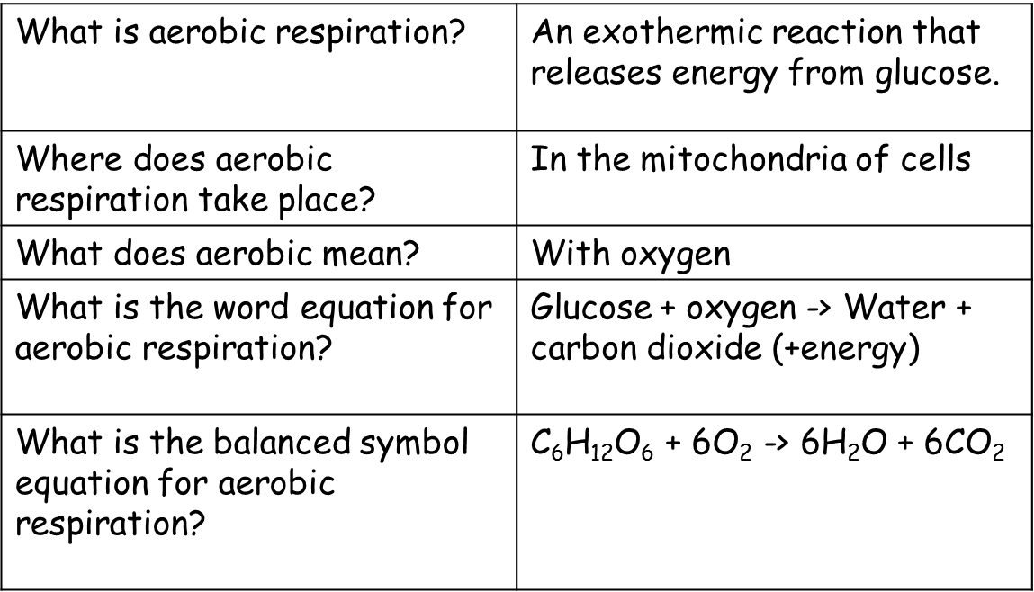
Key knowledge- do your look, cover, write, check by learning the answers to the questions below.

Recall Quiz: copy the questions below and write your answers in full sentences
- What is the word equation for aerobic respiration?
- What is the symbol equation for aerobic respiration?
- Where does aerobic respiration take place?
- What happens to heart rate during exercise?
- What happens to breathing rate during exercise?

Read the information below
When you exercise for a long period of time, or when you do a very short burst of exercise, you cannot get enough oxygen to the muscle cells to release energy from aerobic respiration. The muscle cells switch to using anaerobic respiration, which means without oxygen. They break down the glucose and release less energy and produce lactic acid, which is poisonous and causes cramps. The only way to remove the lactic acid is to breathe more oxygen in after you have finished exercising. This is called repaying your oxygen debt. The word equation for anaerobic respiration is: Glucose -> Lactic Acid.
Copy the key knowledge table into your exercise books.
Key knowledge- do your look, cover, write, check by learning the answers to the questions below.
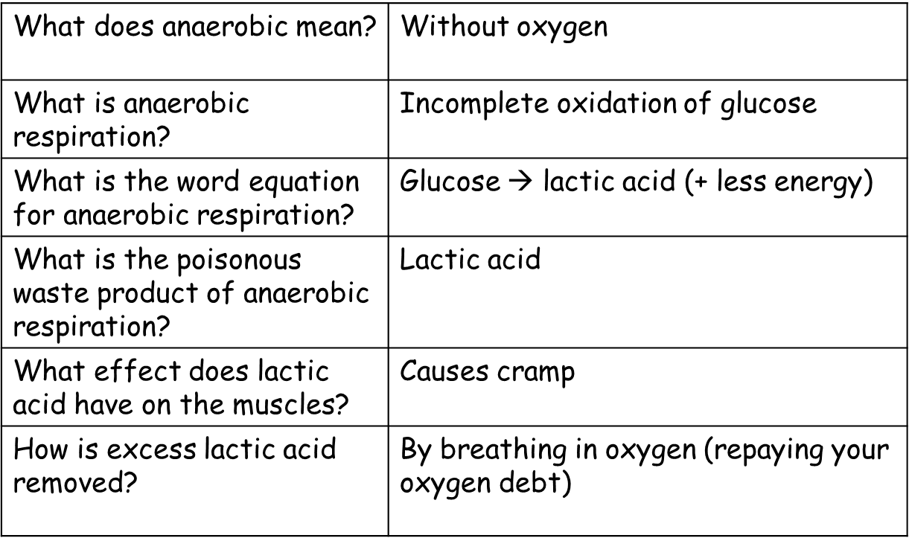

Recall Quiz: copy the questions below and write your answers in full sentences
- What does anaerobic mean?
- What is the word equation for anaerobic respiration in muscle cells?
- Give two examples of when we would respire anaerobically.
- How much energy, compared to aerobic respiration, is released?
- Why does lactic acid need to be removed?
- How is lactic acid broken down and removed?

Read the information below and answer the questions that follow.
Yeast are eukaryote cells. They also respire anaerobically. They produce ethanol (a type of alcohol). This is used to make alcoholic drinks. They produce carbon dioxide gas, which is used to make bread dough rise in baking.
The equation for fermentation is: Glucose -> Ethanol + Carbon Dioxide
- State what type of cells yeast cells are
- State how yeast cells respire
- Give the word equation for fermentation
Copy the key knowledge table into your exercise books.
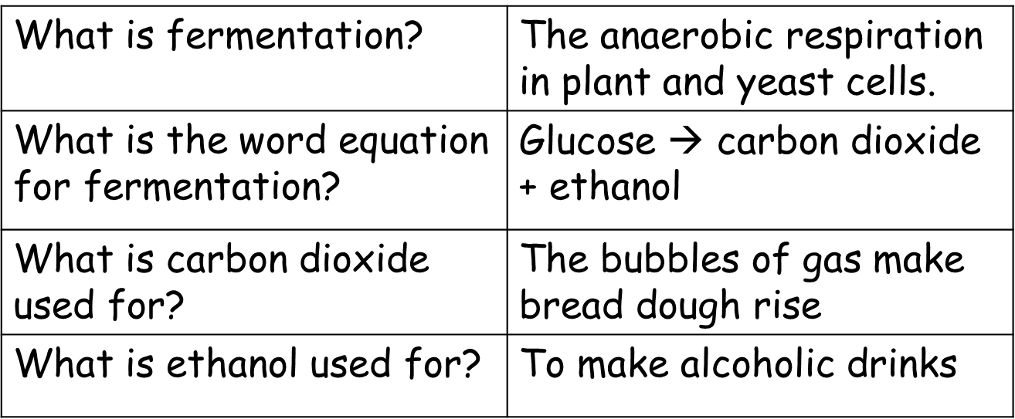
Key knowledge- do your look, cover, write, check by learning the answers to the questions below.

Recall Quiz: copy the questions below and write your answers in full sentences
- What is the word equation for aerobic respiration?
- What is the word equation for anaerobic respiration in muscles?
- What is the word equation for anaerobic respiration in yeast cells?
- What product of respiration causes cramp?
- What product of respiration causes bread dough to rise?
- What product of respiration is used to make alcoholic drinks?

Application Task – I Do
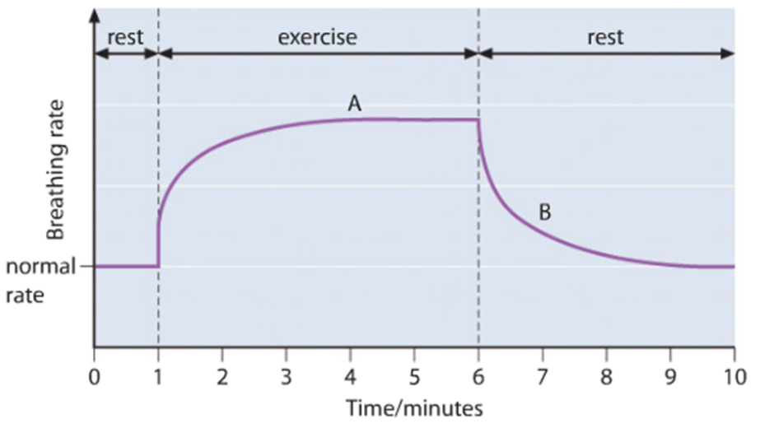
Explain what is happening at point A on the graph.
During exercise, at point A on the graph, the breathing rate is increasing.
This is because the muscle cells need more oxygen for aerobic respiration in order to get enough energy to contract

Application Task – You Do (complete the sentences)
Explain what is happening at point B on the graph.
After exercise, at point B on the graph, even though the breathing rate is _________ you still breathe faster than when _______. This is because we need to break down the _____ ___ made during ______ respiration. We call this paying back the ______ ____.
Key words
increasing decreasing time oxygen debt breathing rate contract anaerobic oxygen
respiration muscle lactic acid resting broken down resting

