Absence Work
30 March 2020
Cell Division

Read the information below and answer the questions that follow.
Just like us, our cells have a life cycle. Cells are constantly dying and new cells are being made to take their place. We call this the cell cycle. In fact, 80% of dust that you find in the home is made up of dead skin cells.
There are 3 main stages to the cell cycle.
- The cell copies its DNA, mitochondria and ribosomes – this is called interphase
- The two copies of DNA (chromosomes) move to opposite sides of the cell ready to separate – this is called mitosis
- The cell membrane and cytoplasm split into two new cells called daughter cells – this is called cytokinesis

Copy out the questions below and write your answers in full sentences.
- State how many stages of the cell cycle there are
- Describe what happens in each stage of the cell cycle.

Copy the key knowledge table into your exercise books.
Key knowledge- do your look, cover, write, check by learning the answers to the questions below.
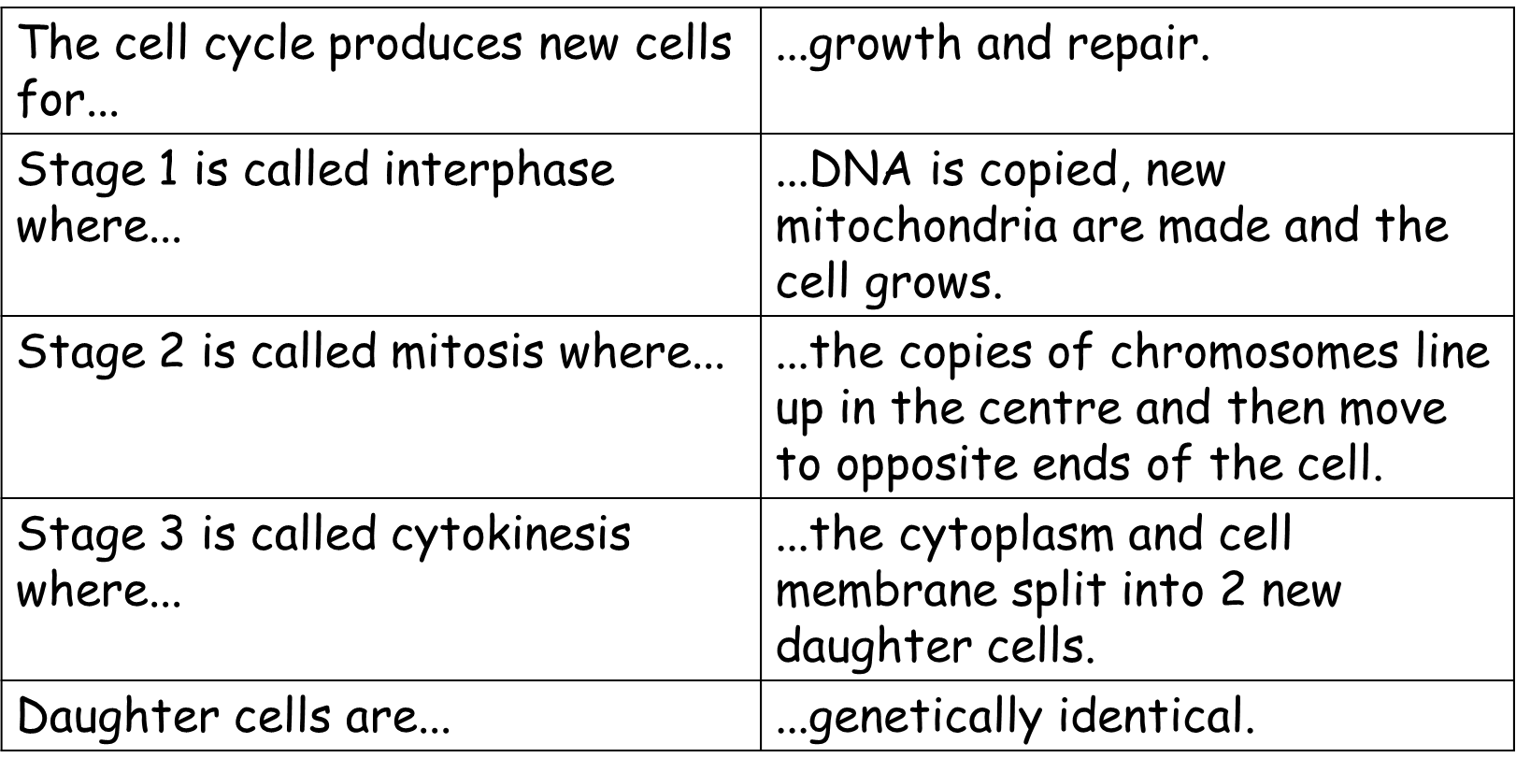

Recall Quiz: copy the questions below and write your answers in full sentences
- What happens to the chromosomes in the cell during interphase?
- How many copies of each chromosome will there be in the nucleus when the cell is ready to divide?
- In which phase does the cell grow and make copies of it’s chromosomes?
- In which phase are the chromosomes pulled to opposite ends of the cell?
- What is the name of the phase where the cytoplasm and cell membrane split into two?
- What are the two reasons for cells to undergo mitosis?
- What name do we give the two new cells?
- What is identical about these two new cells?

Read the information below
We all started out as a ball of identical cells called an embryo. None of our cells had become specialised (turned into nerve, bone, hair, skin, blood cells etc). These unspecialised cells are called stem cells. They can be really useful, because we can take these stem cells and make them turn into any kind of specialised cell that we want them to.
For example, if someone has nerve damage causing blindness or paralysis, we can take unspecialised stem cells and make them turn into nerve cells and inject these back into the person to cure them.
We can also find these stem cells in the centre of our bones (the bone marrow), in the umbilical cord blood of a new born baby, and in the meristem of plants (the part of the plant which is growing – shoots and roots)

Copy the key knowledge table into your exercise books.
Key knowledge- do your look, cover, write, check by learning the answers to the questions below.
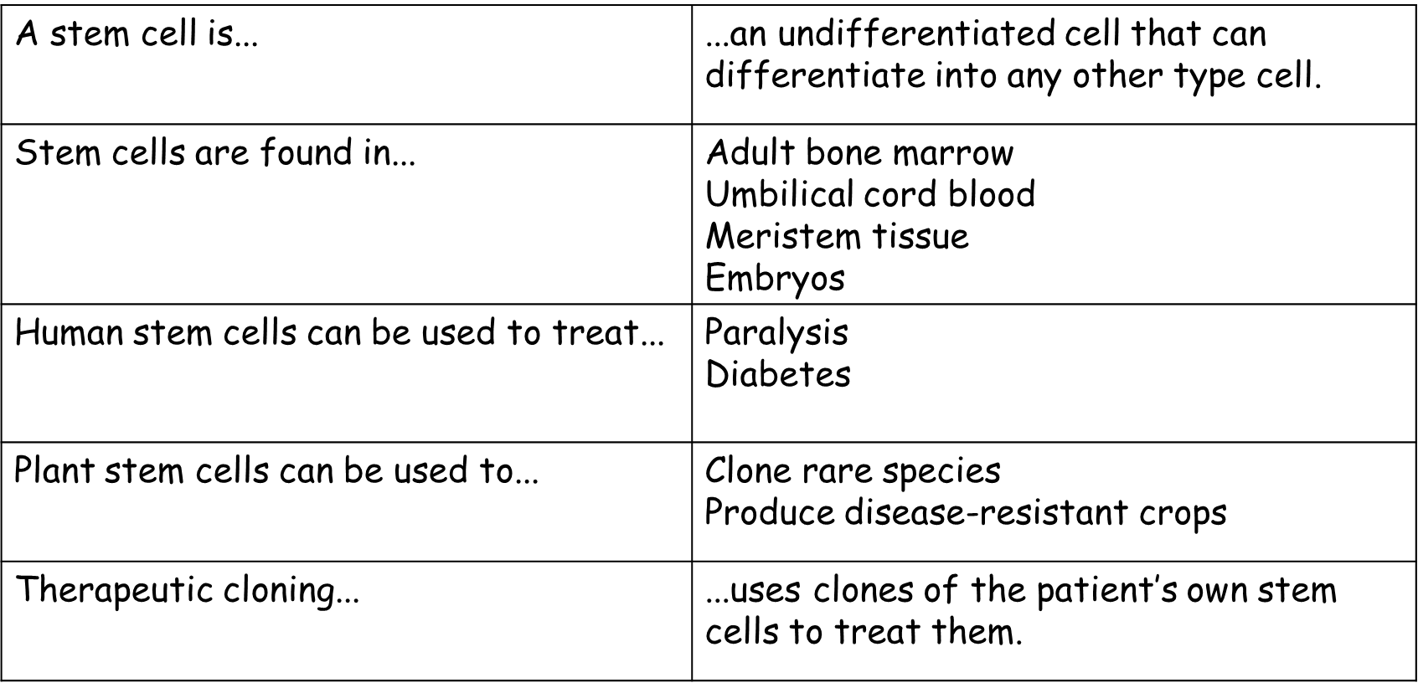

Recall Quiz: complete the sentences
- Stem cells are…
- In humans, stem cells are found in…
- In plants, stem cells are found in…
- Stem cells can be used to treat diseases such as…
- Stem cells can be used in plants for….

Application Task – I Do
Describe which stage of the cell cycle the cell is undergoing in the diagram
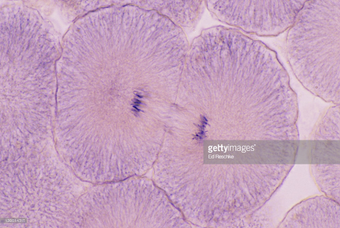
In the diagram, the cell is undergoing cytokinesis. I know this because the cytoplasm and cell membrane have begun to split into two new daughter cells.

Application Task – You Do (complete the sentences)
Describe which stage of the cell cycle the cell is undergoing in diagram 1.
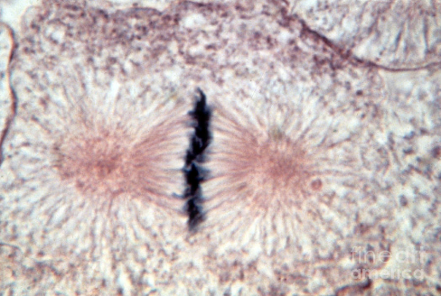
In diagram 1, the cell is undergoing __________. I know this because . . . . .

Describe which stage of the cell cycle the cell is undergoing in diagram 2.

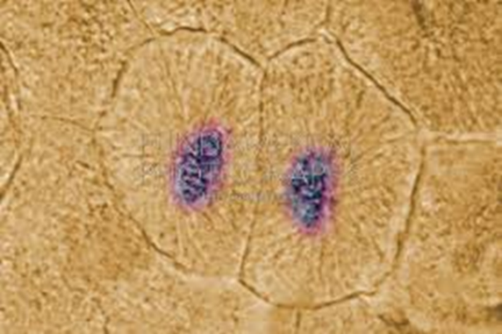
In diagram D, the cell is undergoing __________. I know this
because . . . . .

