Absence Work
01 April 2020
Transport in Cells

Read the information below.
Many substances move into and out of cells, across the cell membranes by diffusion. Diffusion is the net movement of particles from an area of high concentration to an area of lower concentration until they are evenly spread out (equilibrium). This happens because the particles move randomly and spread out. There are many examples of diffusion in living organisms: oxygen and carbon dioxide during gas exchange in lungs, gills and plant leaves. Urea diffuses from cells into the blood plasma for excretion by the kidney, and digested food molecules from the small intestine diffuse in to the blood.
The factors that affect the rate of diffusion are the concentration gradient (the difference in concentrations), the temperature and the surface area of the membrane. The small intestine and lungs in mammals, gills in fish, and the roots and leaves in plants, are all adapted for exchanging materials: they have a large surface area, the surface is thin so that molecules only have to diffuse a short distance, surfaces are usually kept moist so that substances can dissolve and diffuse across the cell membrane faster. In animals, a rich blood supply maintains the concentration gradient and ventilation occurs to speed up gas exchange.
Osmosis is the movement of water from a less concentrated solution to a more concentrated solution through a partially permeable membrane.
A partially permeable membrane allows small molecules of water through but NOT large solute particles

Copy the key knowledge table into your exercise books.
Key knowledge- do your look, cover, write, check by learning the answers to the questions below.
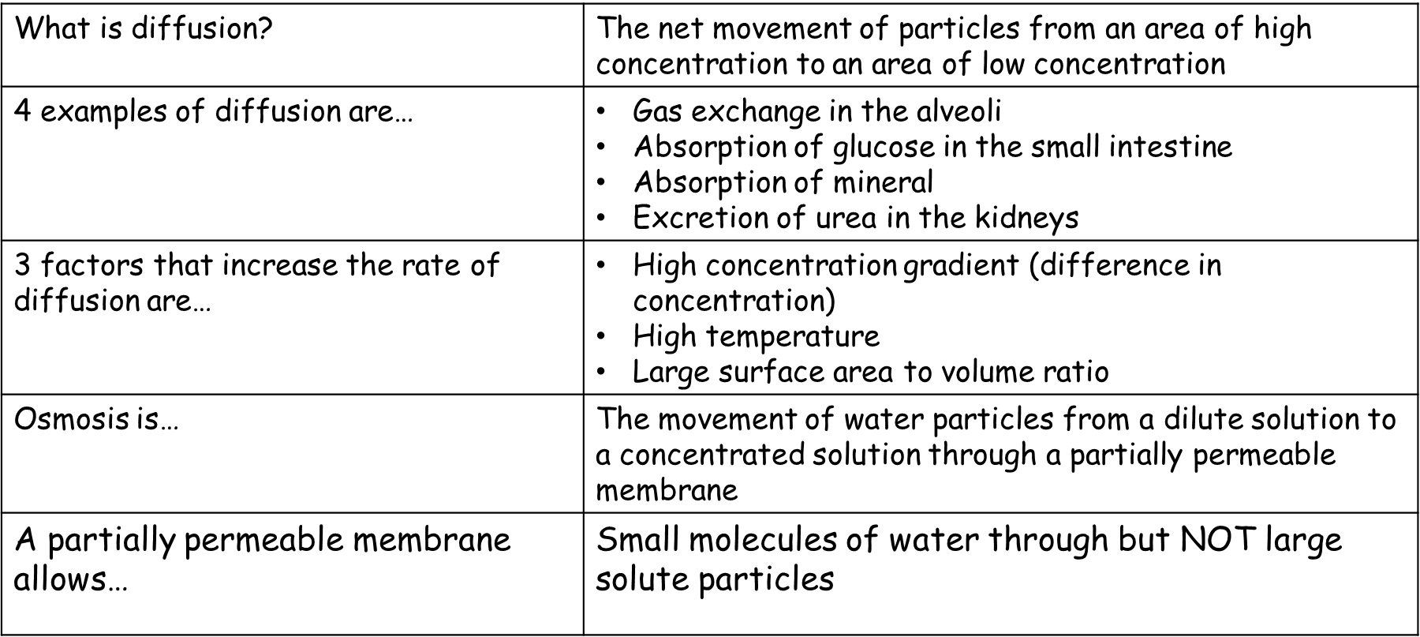

Recall Quiz: copy the questions below and write your answers in full sentences
- What is diffusion?
- In a high concentration, are there more or less particles?
- What is osmosis?
- Give two examples of diffusion in living things.
- Give four things that speed up the rate of diffusion.

Read the information below.
Active transport allows substances to move from a low concentration to a high concentration, against the concentration gradient. It required energy from respiration to happen. Active transport allows mineral ions to be absorbed into plant root hairs from very dilute solutions in the soil. Active transport also allows sugar molecules to be absorbed from lower concentrations in the gut in to the blood, which has a higher concentration.

Copy the key knowledge table into your exercise books.
Key knowledge- do your look, cover, write, check by learning the answers to the questions below.
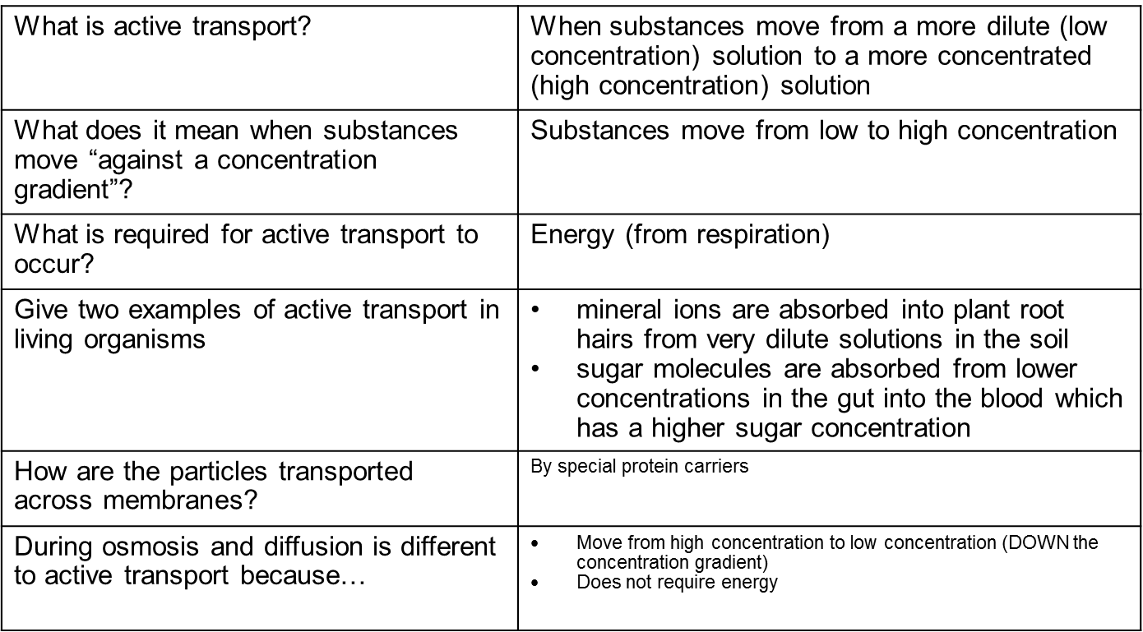

Recall Quiz: copy the questions below and write your answers in full sentences
- In what direction do substance move when going against the concentration gradient?
- Define active transport
- How do organisms get their energy for active transport?
- Give two examples of active transport in living things
- State one difference between osmosis and active transport

Application Task –comparing transport in cells
Copy and complete the table below.

Type of transport | Diffusion | Osmosis | Active Transport
Which substance moves?
What concentration do substances move from/to? | From high concentration to low concentration
Is energy required?
Example in living organisms
Application Task – I Do
For each scenario, decide which type of transport would occur and why you have chosen this method.
- Glucose ions moving through the villi in the small intestine.
Glucose will move through the villi in the small intestine through active transport. I know this because the glucose has to move through the small intestine from a low concentration to a high concentration, which will require energy to happen.

Application Task – You Do (complete the sentences)
For each scenario, decide which type of transport would occur and why you have chosen this method.
- Coloured dye moving from the bottom of the glass
Coloured dye will move through the glass by….
I know this because…

- Water molecules moving into a root hair cell
Water molecules move into a root hair cell by…
I know this because…

