Absence Work
02 April 2020
Atoms and Electrons

Read the information below.
In the nucleus (centre) of an atom, we have protons and neutrons. Around the outside of the atom, we find the electrons. The mass of these subatomic particles is very small, so it does not make sense to describe their mass in units of kilograms. Instead, we will say that both protons and neutrons have a relative mass of 1, while electrons have almost no mass. Two of these particles also have an electric charge. Protons have a positive charge of +1, and electrons have a negative charge of -1. Neutrons are neutral, and have no charge. We can use the periodic table to figure out how many protons, neutrons, and electrons there are in an atom of a given element. Each box on the periodic table is called a cell. The larger number in the cell is the atomic mass. This is the number of protons and neutrons combined. The bottom number is the atomic number. This gives the number of protons in the atom.
To work out the number of protons, you just need to look at the atomic number. Atoms have an overall neutral charge, because the number of positive protons and negative electrons is the same.
The number of neutrons in an atom may be different to the number of protons and electrons. The mass number is the number of protons and neutrons together. Therefore, to work out the number of neutrons simply subtract the number of protons (the atomic number) from the mass number.
It is important to remember that atoms are incredibly small. If you try to imagine just how many atoms there are in your body alone, it is hard to do. There are around a billion times more atoms in the human body than there are grains of sand on the Earth.
This means that atoms are incredibly, hilariously small. While some atoms are bigger than others are, the radius of an atom is about 0.1 nm (1 × 10⁻¹⁰ m). That’s one ten billionth of a metre across. The radius of the nucleus is even smaller than that: at (1 × 10⁻¹⁴ m) it is less than 1/10,000 of the radius of an atom.

Copy the key knowledge table into your exercise books.
Key knowledge- do your look, cover, write, check by learning the answers to the questions below.
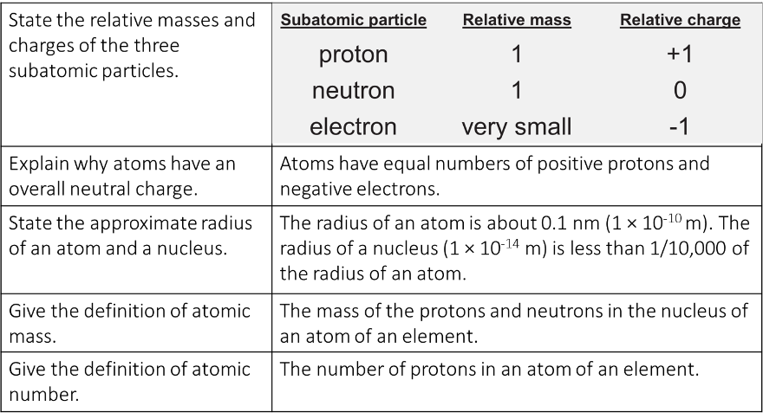

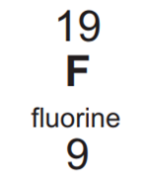
Recall Quiz: copy the questions below and write your answers in full sentences
- Protons and neutrons are found in the __________ of an atom.
- The charge of an electron is ________.
- The radius of an atom is around ___________.
- The atomic mass is the number of ____________ + ______________.
- The atomic number of fluorine is _________. Fluorine’s atomic mass is ________.

Read the information below.
Electrons are what make chemistry happen. In order to really understand why chemical reactions take place, why some elements bond easily while others are rejected by nearly every other atom, we have to understand the arrangement of the electrons. Electrons are arranged in shells, or energy levels. First, we need to know that different shells can hold different maximum numbers of electrons. The electrons in an atom fill the lowest available energy level first. This is the shell nearest the nucleus. When this shell is full, the electrons begin to occupy the next energy level. The first shell can hold 2 electrons, the second shell can hold 8 electrons, and the third shell can hold 8 electrons.
We represent the energy levels with simple rings. The nucleus can be represented with just the chemical symbol.
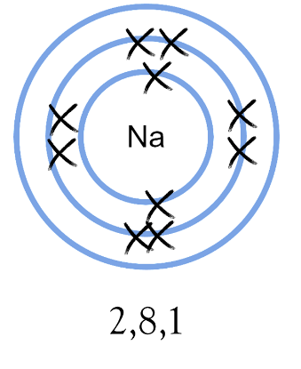
We fill the innermost shell first, with two electrons. We represent the electrons with neat crosses (or sometimes dots) drawn directly on the ring. It is good practice to draw the innermost electrons one at the top and one at the bottom. To write out the configuration, we write a 2, followed by a comma. Next, we fill the second shell. The second shell can hold eight electrons. We use crosses again, and again we want to draw them in this order: top, bottom, right, left, and then again to make pairs, top, bottom, right, left. To continue the configuration, we write an 8 followed by a comma. Finally, we place the remaining electron in the outmost shell. To finish the configuration, we write a 1. Two final things are important to note here. One is that the period number tells you how many shells there are. The second is that the group number tells you how many electrons are in the outermost shell.

Copy the key knowledge table into your exercise books.
Key knowledge- do your look, cover, write, check by learning the answers to the questions below.
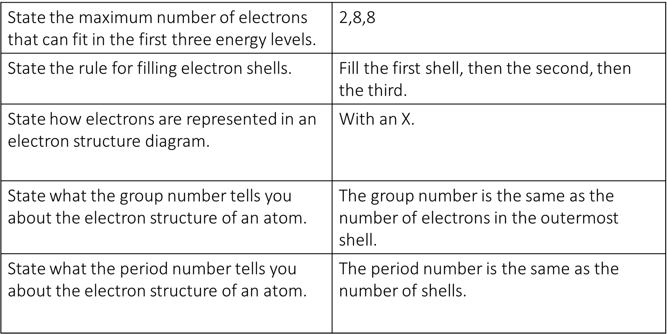

Recall Quiz: copy the questions below and write your answers in full sentences
- The maximum number of electrons in the first, second, and third shells is ____, _____, _____.
- The image at right shows the electron configuration for __________.
- The group number tells you…
- The period number tells you…
- Which of the following is the correct configuration for aluminium (atomic number 13): 2,9,2 | 8,2,3 | 2,8,3 | 8,3,2

Application Task – I Do
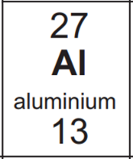
- How many protons, neutrons, and electrons are in an atom of aluminium?
Protons: 13
Electrons: 13
Neutrons: (27 – 13 = 14) 14

Application Task – You Do (complete the sentences)
- How many protons, neutrons, and electrons are in an atom of potassium
- How many protons, neutrons, and electrons are in an atom of sodium
- How many protons, neutrons, and electrons are in an atom of magnesium
- How many protons, neutrons, and electrons are in an atom of oxygen
- How many protons, neutrons, and electrons are in an atom of chlorine

