Absence work
20 March 2020
Scientific Equipment

Read the information below, then answer the questions that follow.
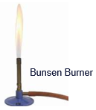
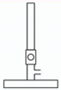
In science, it is important to be able to identify key scientific equipment from a picture. All students should be able to describe the role of each piece of scientific equipment and explain which piece of equipment is the best to use linking to accuracy and reliability.
To the right is a diagram of a Bunsen burner and a picture of a Bunsen burner.
A Bunsen burner is used to heat substances. For example, a student could be asked to heat up water until it reaches its boiling point. When we draw scientific equipment we use a simple scientific diagram so it is clear which piece of equipment we are referring to.
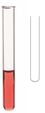
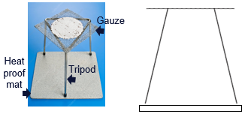
This is a tripod (named because it has THREE legs), gauze, and a heat proof mat. We place the gauze on top of the tripod and then place the substance that we are heating on top of the gauze. Their job is to keep the object stable so it doesn’t spill. The gauze also stops the flame from directly touching the substance. The heat proof mat is designed to stop the tripod or Bunsen burner from burning the table when it gets hot.
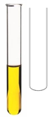
We place chemicals when we want to carry out a reaction into a glass tube known as a test tube. For example, we might want to test to see if something is an acid or an alkali so we would measure out a certain volume of the substance and pour it into the test tube.
This is a boiling tube. This is a tube made from a special material that is heat proof. We use boiling tubes if we need to heat up small volumes or masses of substances during a reaction. For example, we might want to add some metal oxide to the boiling tube and hold it over the Bunsen flame to observe the changes. It is a bit bigger than a test tube.
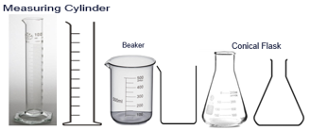
A measuring cylinder is used to measure the volume of a liquid, they come in a range of different sizes and you need to pick the correct one for the volume of liquid you need.
A beaker is used to hold substances before you use them, we don’t use them to measure volumes of liquids.
We use a conical flask to mix chemicals.
Copy out the questions below and write your answers in full sentences.
Checkpoint questions:
- Why would you use a heat proof mat?
- Which material is a test tube made from?
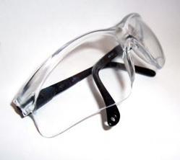
- Explain the difference between a test tube and a boiling tube.

You MUST wear safety goggles in every practical, they are there to protect your eyes and not your forehead. You must keep these on when anyone in the class is working on a practical.

Measuring instruments have a scale. Each little line on the measuring instrument represents an interval. The smallest interval on the measuring scale is called the resolution. On this ruler, the resolution would be 1mm.
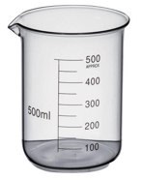

On this beaker, the resolution would be 50ml.

Copy the key knowledge table into your exercise books.
Key knowledge- Do your look, cover, write check by learning the answers to the questions below.
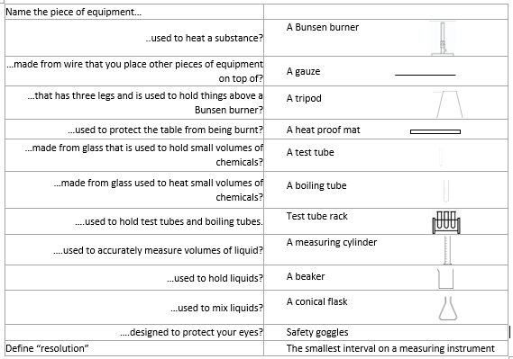
Complete the sentences below in your exercise book.
- A Bunsen burner is used for….
- A piece of equipment we used to keep us safe is…
- The piece of equipment we use to heat small quantities of liquid is…
- A conical flask is used for…
- A beaker is used for…
Complete the below application tasks in your exercise book.
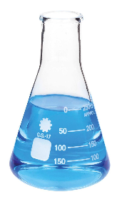
Application Task – I Do
Name this piece of equipment, describe what it is used for and draw it’s symbol.

Challenge: what is it’s resolution?
Model answer:
This is a measuring cylinder. It is used for mixing liquids. It’s symbol is
It’s resolution is 50ml.

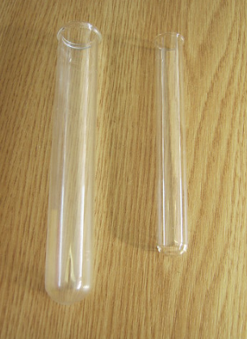
Application Task – You Do
Annie finds the piece of equipment on the right of the picture in the lab. Name it, describe what it is used for and draw it’s symbol.

Challenge: why might she choose to use the piece of equipment on the left instead?

Complete the below application tasks in your exercise book using full sentences.
