Absence work
02 April 2020
Changes of State
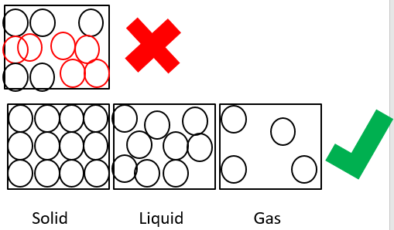
Read the information below, then answer the questions that follow.
You need to be able to draw the particles in a solid, liquid and gas. Notice that the particles in the solid are in a regular pattern, in straight lines. The particles in the liquid are in an irregular pattern but still touching and the particles in a gas are not touching at all.
You also need to be able to draw the particles so that they are all the same size as each other.
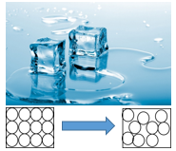
A change of state is when the particles change arrangement as they move between one state and another. This is because they either gain or lose energy.
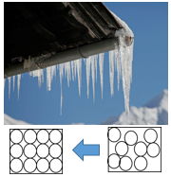
We can see in the picture that the ice is melting. This is when the substance changes from a solid to a liquid. This is because the particles gain some energy and start to break some of the bonds between the particle.

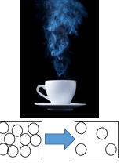
Here we can see the reverse happening, a liquid turning into a solid. This is called freezing or solidifying. This is because the particles are losing energy and forming more bonds forcing them back into a regular arrangement.

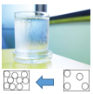
We can see a change of state here too. The tea at the surface is evaporating. This is because the particles at the surface are gaining enough energy to be able to break their bonds and escape from the liquid. Note, this is different to boiling as it can happen at any temperature but only at the surface of the liquid. Boiling occurs only at the “boiling point” of a substance and is where particles throughout the substance change from a liquid to a gas.
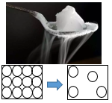
On the outside of the glass, we can see the water from the atmosphere condensing. This is where it changes from a gas in the atmosphere to a liquid on the surface of the glass. This occurs because the glass is colder the air so the water particles in the air lose energy and start to form bonds again becoming a liquid.

This final state change is sublimation. This is when a solid changes straight into being a gas. You can see this sometimes when you take an ice lolly out of the freezer!

Copy out the questions below and write your answers in full sentences.
Checkpoint questions:
- Name the state of matter change that happens when a solid turns into a liquid?
- Describe what happens to particles when they lose energy?
- Explain what is happening in terms of bonds during evaporation.

Copy the key knowledge table into your exercise books.
Key knowledge- Do your look, cover, write check by learning the answers to the questions below.
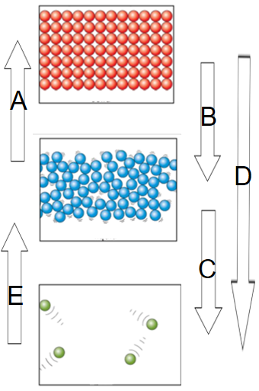
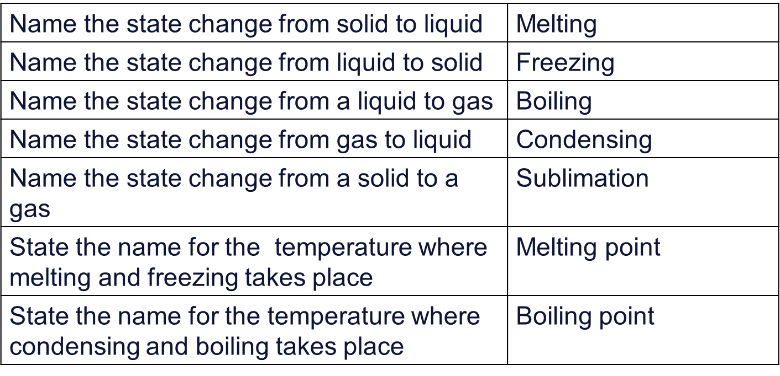
Complete the questions below in your exercise book.
Write your answer using full sentences.
- Identify the processes that are occurring at A, B, C, D and E.
Complete the below application tasks in your exercise book.
Application Task – I Do
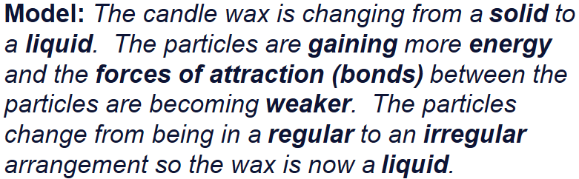
Describe the change of state occurring in the candle.
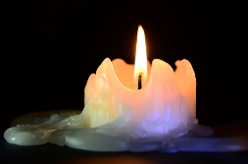

Application Task – You Do
Describe the change of state occurring at the bathroom mirror.

Complete the below application tasks in your exercise book using full sentences.
