Absence work 03 April 2020
Scientific Equipment

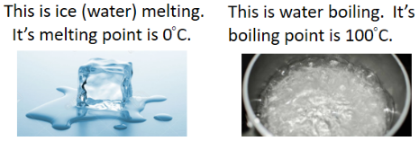
Read the information below, then answer the questions that follow.
The melting point of a substance is the point at which it changes from a solid to a liquid.
The boiling point of a substance is the point at which it changes from a liquid to a gas.
Temperature is a measure of the amount of kinetic energy that particles have.
As we heat a solid, the particles will absorb the energy and use it to move more – they gain kinetic energy. This means the temperature will increase.
When the particles reach their melting point, instead of absorbing more energy and moving more, the energy causes the forces of attraction between the particles to weaken and the arrangement of particles to change to an irregular arrangement. This will mean the substance will change from a solid to a liquid – i.e. melting. The energy is being used to weaken the forces of attraction (break the bonds) rather than being used by the particles to move more, so the temperature will stay constant.
Copy out the questions below and write your answers in full sentences.
Checkpoint questions:
- State the melting point of water.
- Define temperature.
- Explain why the temperature will stay constant when the particles reach melting point.
Copy the key knowledge table into your exercise books.
Key knowledge- Do your look, cover, write check by learning the answers to the questions below.
Name the temperature at which a solid turns into a liquid or a liquid turns into as solid | melting point
Name the temperature at which a liquid turns into a gas or a gas turns into a liquid | boiling point
Explain why the temperature does not change at the melting and boiling points | the thermal energy is being used to break the forces between the particles
State what the forces between particles in a solid do | hold the particles in a fixed position
State what the forces between particles in a liquid do | mean that almost all the particles are touching
Define “Latent Heat“ | The energy needed for a substance to change state

Complete the sentences below in your exercise book.
- The temperature at which a liquid turns into a gas or a gas turns into a liquid is the…
- At the melting and boiling points, the temperature does not change because…
- Forces between particles in a solid…
- Latent heat is…
- Latent means hidden, explain why this might be given to a substance changing state?
Complete the below application tasks in your exercise book.
Application Task – I Do
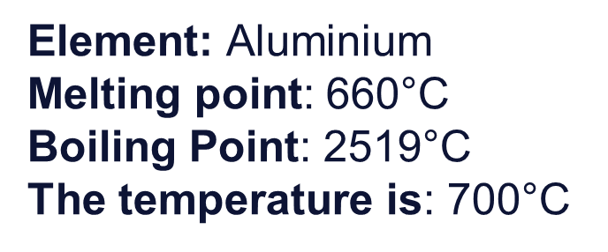
Aluminium will be a liquid at 700°C because this temperature is higher than its melting point so it will have melted and turned into a liquid, but lower than its boiling point, so it will not have evaporated and become a gas.
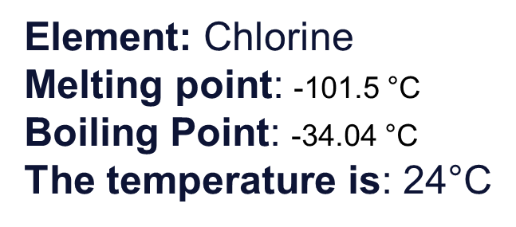
Chlorine will be a gas at 24°C because this temperature is higher than its melting point so it will have melted and turned into a liquid and higher than its boiling point so chlorine will have evaporated and become a gas.

Application Task – You Do
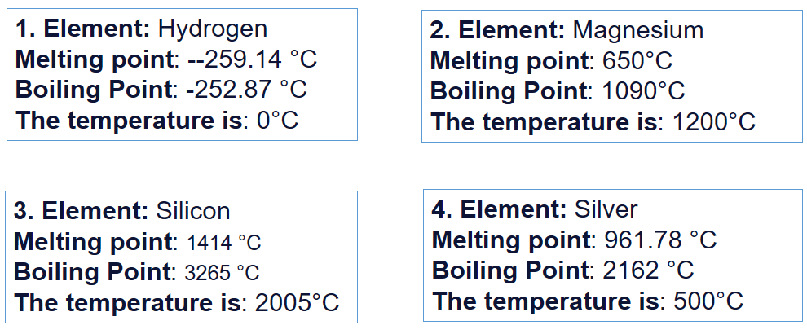
Complete the below application tasks in your exercise book using full sentences.
