**Absence work 06 April 2020**

**Diffusion**

**Read the information below, then answer the questions that follow.**

This is a picture showing diffusion. You can see that the green circles represent particles and they are moving from a high concentration, where there are a lot of them. To a low concentration where there are not so many.

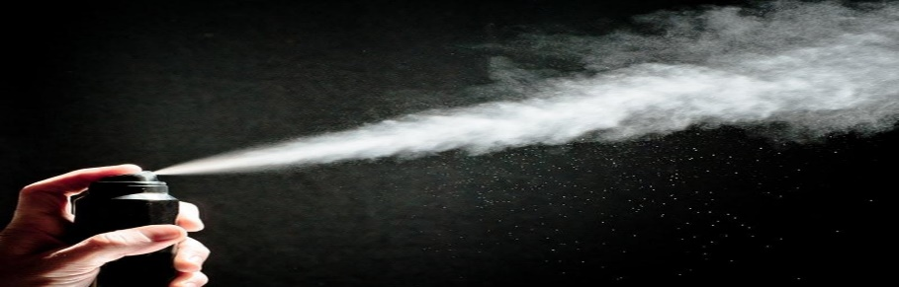This is a passive process and does not require any energy. Diffusion can only happen in gases and liquids because the particles are able to move. Diffusion cannot happen in a solid because the particles are unable to move.

When particles are heated, they have more kinetic energy (so move faster). This means that diffusion will happen faster.

**Copy out the questions below and write your answers in full sentences.**

**Checkpoint questions:**

1. How much energy is required for diffusion to occur?
2. In which state of matter can diffusion not occur?
3. Explain the outcome in terms of diffusion if the particles are heated.

**Copy the key knowledge table into your exercise books.**

**Key knowledge- Do your look, cover, write check by learning the answers to the questions below.**

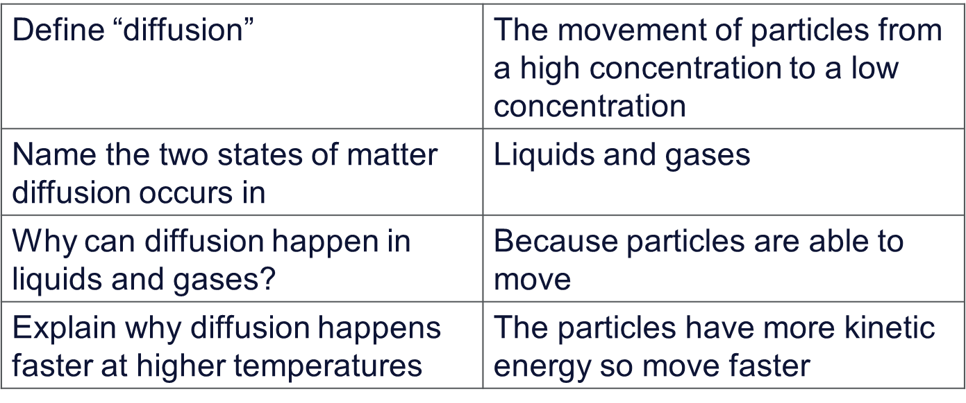

**Complete the sentences below in your exercise book.**

1. ***Give an examples of diffusion..***
2. ***Name the states of matter in which diffusion can occur***
3. ***Explain why diffusion can happen in those states of matter only.***

**Complete the below application tasks in your exercise book.**

**Application Task – I Do** **Explain diffusion.**

Diffusion is how particles move and mix by themselves without being stirred or shaken.

Only liquids and gas particles diffuse because they are moving all of the time. Gases diffuse quicker than liquids because they have more energy.

Diffusion happens more quickly at warm temperatures than at cooler temperatures.

**Application Task – You Do**

Liam likes to put blackcurrant squash in his water. Describe how the squash mixes with water.

You can also draw pictures to help.

**Complete the below application tasks in your exercise book using full sentences.**

1. Casey likes to burn scented candles. She lights one but her friend Jenny is sitting on the other side of the room says she cannot smell the candle.

Explain how Casey can smell the candle but Jenny cannot.

1. Explain why Jenny can smell the candle faster if the room is warmer using ideas about particles.