Absence work 14 April 2020
Mini Quiz
Copy and complete questions

Equipment and safety
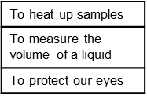
1. Match the equipment to its use. (3)
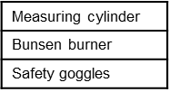

2. Which Bunsen burner flame do we use when heating up a sample? (1)
3. Name the Hazard symbols. (3) a) b) c)

Copy and complete the below sentences.

Changes of state
- When a liquid turns into a solid, it is called… (1)
- When a solid turns into a liquid, it is called… (1)
- When a gas turns into a liquid, it is called… (1)
- When a liquid turns into a gas, it is called… (1)
- When a gas turns into a liquid ____________ are formed between particles. (1)
- The melting point of water is… (1)
- In which state do the particles move fastest? (1)

Copy and complete questions

States
- Draw and label the particle diagrams with solids, liquids and gases. (3)
- Which of the three states of matter can be compressed (squashed)? (1)
- Which of the three states does not spread out to fill a container? (1)
- Which state is the least dense? (1)
- In which state do particles vibrate? (1)
- In which state are the particles in an ordered arrangement? (1)

Copy and complete questions

Behaviour of matter
- Does an object expand or contract when it is heated? (1)
- In which two states does diffusion happen? (2)
- How can you speed up the rate of diffusion in a liquid? (1)
- In which state does diffusion happen the fastest? (1)

