Absence work 11 April 2020
Active Transport

Read the information below, then answer the questions that follow.
Active transport is when a substance moves from a low concentration to a high concentration through a membrane. This is different from osmosis because the particles move against the gradient using energy. Active transport is the process used to move larger molecules like glucose.
As it is moving particles against the concentration gradient, it requires energy.
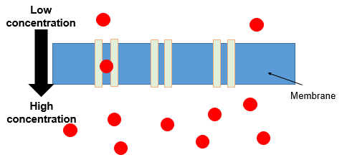
opy out the questions below and write your answers in full sentences.
Checkpoint questions:
- Define active transport.
- How is active transport different to osmosis?
- Explain why active transport requires energy.

Copy the key knowledge table into your exercise books.
Key knowledge- Do your look, cover, write check by learning the answers to the questions below.
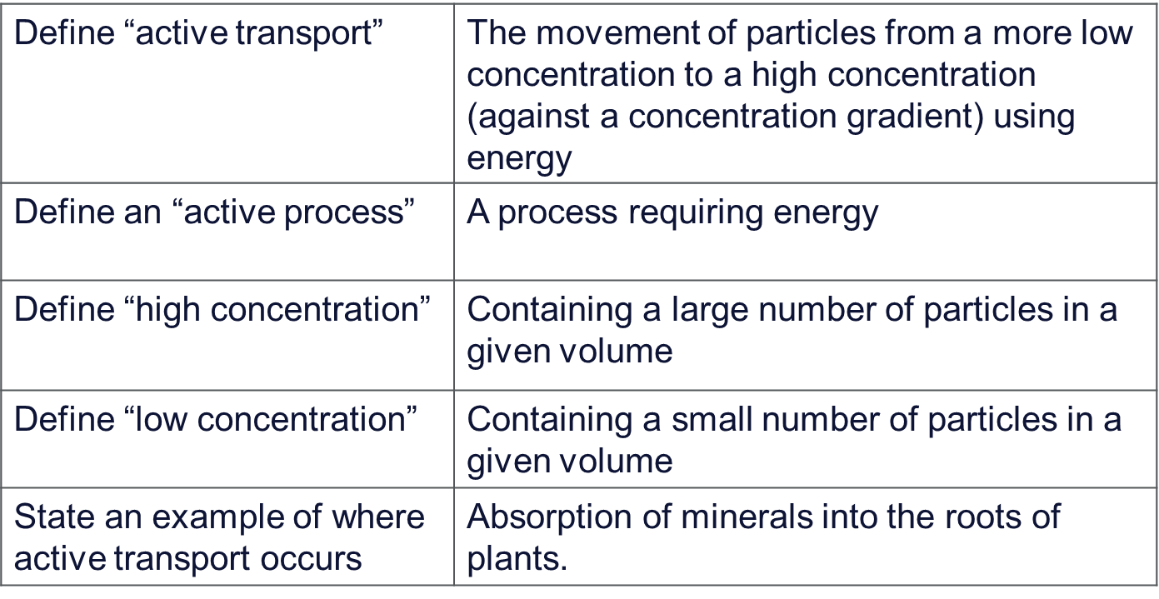

Complete the sentences below in your exercise book.
- Active transport involves the movement of particles from . .
- In active transport the particles move against . . .
- A high concentration means. . .
- Active transport requires . . .

Complete the below application tasks in your exercise book.
Application Task – I Do
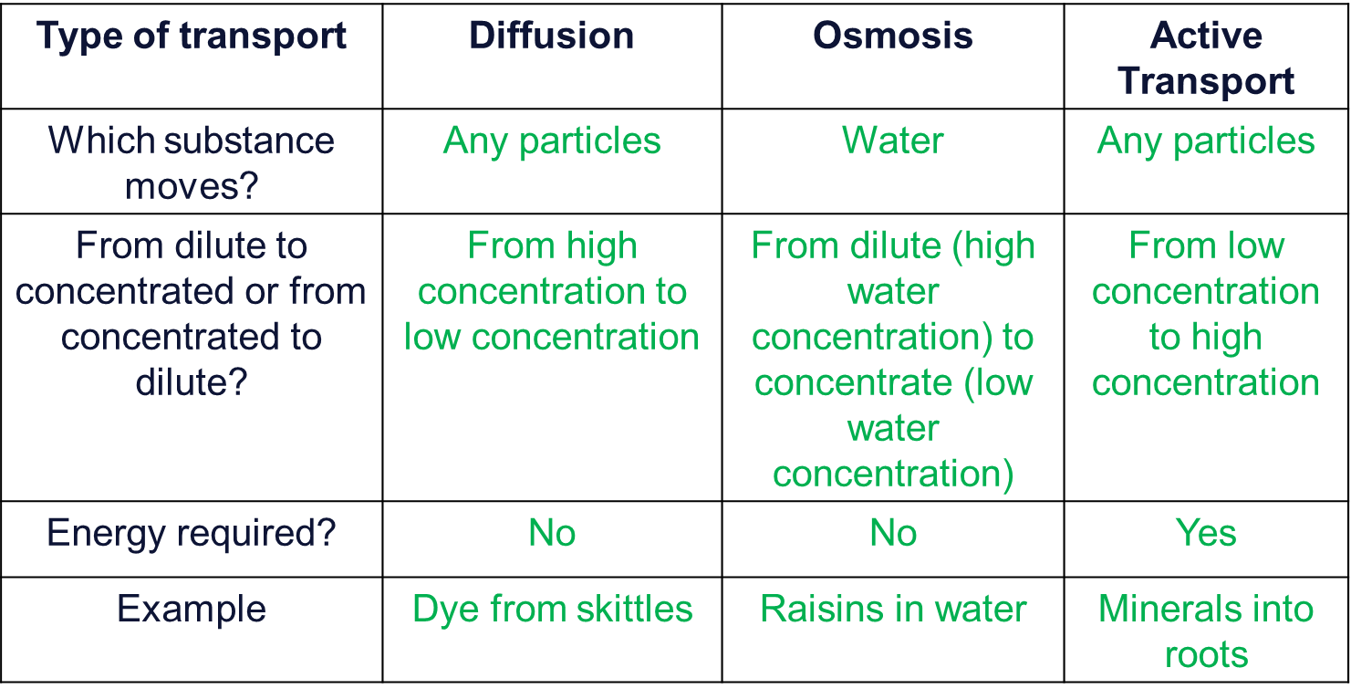
Application Task – You Do
Compare diffusion, osmosis and active transport (6 marks)
Success criteria:
- Describe diffusion, osmosis and active transport.
- Compare diffusion, osmosis and active transport in terms of
- the substances that are transported this way
- whether or not the substances move from high to low concentration or low to high concentration
- whether or not energy is used
- Draw a diagram showing each process
Complete the below application tasks in your exercise book using full sentences.
- Name the three types of transport (3)
- Which type of transport required energy? (1)
- Define a dilute solution? (1)
- Which transport process involves the movement of water particles only? (1)

