Absence work 14 April 2020
Mini Quiz 2
Copy and complete table
Metals and Non-Metals
Add these properties to the table in the correct column (6)

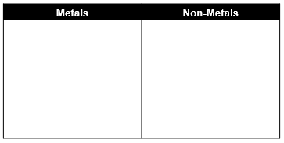
High melting and boiling point.
Thermal and electrical insulators.
Low density.
Shiny when polished.
Brittle as solids (break easily)
Malleable (can be hammered into shape).

Copy and complete questions
Atoms, Elements and Compounds
- Define a compound. (1)
- What is the difference between a compound and a mixture? (1)
- What does diatomic mean? (1)
- The following experiment was set up. Test-tubes containing substances B and C were placed together. The substances did not react. They were left for five minutes.
How many molecules are there in the mixture compared to the number in substances B and C? (1) 5. Complete the diagram, which is a model of this experiment. (1)
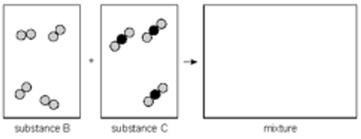

Copy and complete questions
Symbols and Formula
- How many elements are in this compound? (1)
- How many atoms are in the compound? (1)
- Which elements are present in this compound? (1)
- The equation below shows one way how sulphuric acid can be produced.
blue vitriol copper oxide + sulphur trioxide + water
Name three elements contained in blue vitriol. (3)

Copy and complete questions
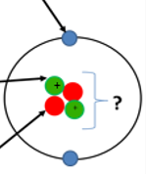
Structure of the Atom
- Label the arrows on the diagram. (3)
- What is the charge on a proton? (1)
- Mass number is the number of ____________ and ____________. (2)

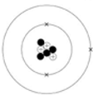
4. The diagram to the left shows a lithium atom. Give the number of protons, neutrons and electrons in the lithium atom shown in the diagram.
Number of protons ________
Number of neutrons _______
Number of electrons _______

