Absence work
14 April 2020
The Periodic Table

Read the information below, then answer the questions that follow.
Dmitri Mendeleev came up with the first version of the modern periodic table. He himself said that he saw, in a dream, a table where all elements fell into place as required. He awoke and immediately wrote it down on a piece of paper.
The modern periodic table arrange the elements in order of increasing atomic number. We move along periods to the right with increasing atomic number, for example, we jump straight from hydrogen on one side to helium to go from atomic number 1 to 2. We call these horizontal rows periods, listed down the left hand side of the table. The period of an element tells us the number of electron shells, for example, magnesium is in period 3 and has 3 electron shells whereas neon is in period 2 and so has 2 shells of electrons.
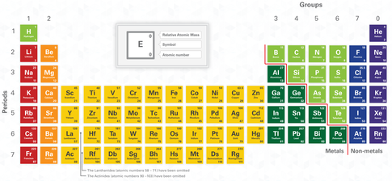
The groups are the vertical columns, listed across the top from left to right. The group of an element tells us the number of electrons in the outer most shell. For example, carbon has 4 electrons in its outer shell whereas oxygen has 6 electrons in its outer shell. They are both in period 2 and so have 2 electron shells.
Copy out the questions below and write your answers in full sentences.
Checkpoint questions:
- What does the period of an element tell us?
- What period is nitrogen in? How many electron shells does nitrogen have?
- How many electron shells does sodium have?
- What does the group of an element tell us?
- What group is nitrogen in? How many outer shell electrons does nitrogen have?
- How many outer shell electrons does lithium have?

Copy the key knowledge table into your exercise books.
Key knowledge- Do your look, cover, write check by learning the answers to the questions below.
Name the scientist who came up with the periodic table. | Mendeleev
Define “period”. | Rows in the periodic table
Define “group”. | Columns in the periodic table
State what the period of an element tells us. | The number of electron shells an atom has
State what the group of an element tells us. | The number of outer shell electrons an atom has

Complete the sentences below in your exercise book.
Recall Quiz:
- The scientist responsible for creating the Periodic table was called…
- Sodium (Na) is in the second period. This tells us that it has __ electron shells.
- Sodium is also in group 1. This means…
- _____ are rows, while ____ are columns.

Application Task - I do
- Name the element that is in Group 1 and Period 4. Potassium
- Name two elements in group 4. Carbon and Silicon
- State the number of outer shell electrons Fluorine has. 7
- State the number of electron shells Potassium has. 4
Application Task - We do
- Name the element that is in Group 2 and Period 3. M__________
- Name two elements in group 5. Nitrogen and _________
- State the number of outer shell electrons Oxygen has.
- State the number of electron shells Lithium has.
Application Task - You do
- Name the element that is in Group 7 and Period 2.
- Name two elements in group 2.
- State the number of outer shell electrons Phosphorus has.
- State the number of electron shells Calcium has.
Challenge: State the number of electron shells + number of outer shell electrons for the following:
Sn – I – Al – H –

