Absence work
14 April 2020
Electronic Configuration

Read the information below, then answer the questions that follow.
Electrons are arranged in shells or energy levels around the nucleus of an atom. A circle is used to represent each shell. Electrons are represented on each shell as a dot-‘ ’ or an ‘X’. The nucleus is represented by the chemical symbol of the atom. The shell closest to the nucleus is referred to as the first energy level and can hold a maximum of two electrons. The second and third shells can hold a maximum of eight electrons. When drawing the electronic configuration of an atom, the shells must be filled up in turns, starting at the first shell or energy level.
Lithium has an atomic number of 3, this tells us that it has 3 protons. In a neutral atom the number of protons is equal to the number of electrons, therefore it has 3 electrons. The electronic configuration of lithium is represented as a diagram or as numbers. Diagram: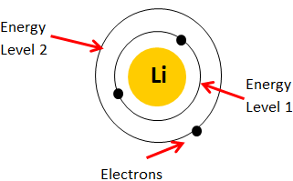
As numbers: Configuration = 2.1
Copy out the questions below and write your answers in full sentences.
Checkpoint questions:
- What is another word used to refer to an electron shell?
- How many electrons fit into the first shell of an atom?
- Where does the third electron in lithium go if the first shell is already full with two electrons?
- How many electrons fit into the second and third shell/energy level of an atom?

Copy the key knowledge table into your exercise books.
Key knowledge- Do your look, cover, write check by learning the answers to the questions below.
Where are electrons located in an atom? | Orbiting the nucleus in energy levels (shells)
What is the maximum number of electrons the first shell can fit? | 2 electrons
What is the maximum number of electrons the second shell can fit? | 8 electrons
What is the maximum number of electrons the third shell can fit? | 8 electrons
How do we represent the electron configuration short hand? | 2.8.8.
What does the electron configuration tell us? | Number of electrons in each shell.
What rule do we have when drawing the electron configuration? | The lowest energy levels (first shell) must be filled before adding electrons to the next level up
Complete the sentences below in your exercise book.
Recall Quiz:
- Which shell has the lowest energy?
- How many electrons can I have in the inner shell?
- How many electrons can I have in the second shell?
- How many electrons can I have in the third shell?
- What rule do we have when drawing the electron configuration?

Application Task - I do
Write and draw the electron configuration for Helium.
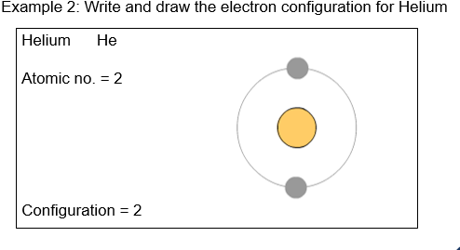

Application Task - We do
Write and draw the electron configuration for Lithium.
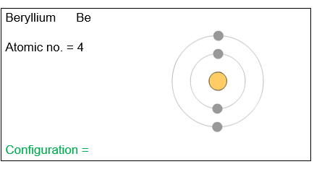

Application Task - You do
Write and draw the electron configuration for Sodium
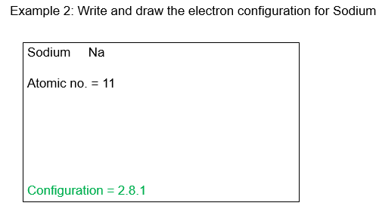
Draw diagrams to show the electronic configuration of the atoms below.

Carbon- C
Atomic number = 6

Configuration = 2.4

Magnesium - Mg
Atomic number = 12

Configuration=
Nitrogen - N
Atomic number = 7

Configuration=

