Absence work
14 April 2020
Reactivity of Group 1 and 7

Read the information below, then answer the questions that follow.
The group number of element tells the number of electrons in the outer most shell. We can see lithium has one electron in the outer most shell, therefore it is in group 1. Similarly, fluorine has seven electrons, therefore it is in group 7. As we move down Group 1 (starting with lithium), we can see that the distance between the nucleus and the outer shell increases. This means that the attraction between the nucleus and the outer shell electrons will become weaker. Overall, this means that the outer electron will be held less strongly in potassium (K) than in lithium (Li), making it easier for the atom to lose its outer electron. As a result, K is more reactive than Li, with reactivity increasing down the group.
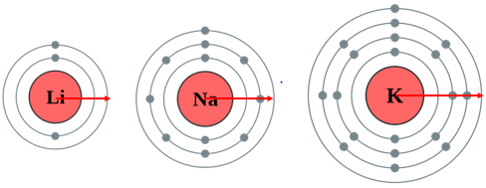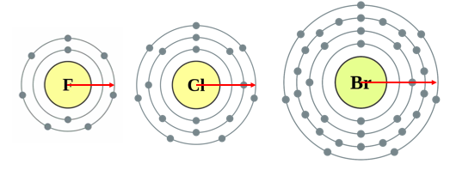
As we move down Group 7 (starting with fluorine), we can see that the distance between the nucleus and the outer shell increases. This means that the attraction between the nucleus and the outer shell electrons will become weaker. Overall, this means that the force of attraction in bromine will be weaker than in fluorine, making it harder for the atom to gain another electron. As a result, Br is less reactive than F, with reactivity decreasing as we move down the group
Copy out the questions below and write your answers in full sentences.
Checkpoint questions:
- An atom of lithium or sodium has its outer shell further from the nucleus?
- Which outer electron is held more strongly? Potassium or lithium?
- What happens to reactivity moving down group 1?
- Which is harder to gain an outer electron? Fluorine or bromine?
- What happens to reactivity moving down group 7?
Copy the key knowledge table into your exercise books.
Key knowledge- Do your look, cover, write check by learning the answers to the questions below.
What happens to distance between the nucleus and the outer shell, as you go down a group? | It increases
What happens to the attraction between the nucleus and the outer shell electrons, as you go down the group? | It gets weaker.
Which elements in group 1 more readily lose the outer shell electron? | Elements lower down in the group.
Which elements in group 7 more readily gain an outer shell electron? | Elements higher up in the group.
Why are the noble gases inert (unreactive)? | They have a full outer shell and so are already stable

Complete the sentences below in your exercise book.
Recall Quiz:
- As you go down a group, the distance between the nucleus and the outer shell ________.
- As you go down a group the attraction between the nucleus and the outer electrons will becomes _______.
- For the halogens, as you go down the group, the change in attraction makes it _______ to gain an electron, meaning the most reactive halogen is ________.
- For the alkali metals, as you go down the group, the change in attraction makes it _______ to lose an electron, meaning the least reactive alkali metal is ________.

Write your answers to the application questions in your exercise book.
Application Task - I do
Explain, in terms of electronic structure, why fluorine is more reactive than bromine.
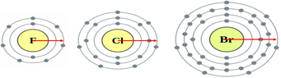

As you go down Group 7 (starting with fluorine), the distance between the nucleus and the outer shell increases. This means that the attraction between the nucleus and the outer electrons will become weaker. Overall, this means that the force of attraction in fluorine will be stronger than in bromine, making it easier for fluorine to gain another electron.

Application Task - You do
Explain why, in terms of electronic structure, astatine is less reactive than bromine.
As you go down Group 7, the distance between…
This means that the attraction between…
Overall, this means that the force of attraction…

Application Task - I do
Explain, in terms of electronic structure, why potassium is more reactive than lithium.
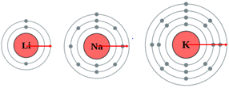
As you go down Group 1 (starting with lithium), the distance between the nucleus and the outer shell increases. This means that the attraction between the nucleus and the outer electrons will become weaker. Overall, this means that the force of attraction in potassium will be weaker than in lithium, making it easier for potassium to lose an electron.

Application Task - You do
Explain, in terms of electronic structure, why francium is more reactive than lithium
As you go down Group 1, the distance between…
This means that the attraction between…
Overall, this means that the force of attraction…

