Absence work
15 April 2020
Writing Ionic Formulae

Read the information below, then answer the questions that follow.
An ion is an atom that has lost or gained an electron. Atoms gain or lose electrons so that they can have a full outer shell, which makes them more stable, like the noble gases. For sodium, it is easier to lose one electron than gain 7 electrons. Atoms always take the easiest route to gain a full outer shell. Fluorine gains one electron rather than lose 7 electrons.
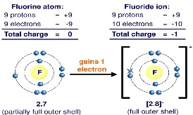
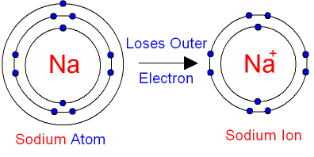

When atoms lose electrons they become positive (+). When atoms gain electrons they become negative (-). This makes sense because electrons are negatively charged so if an atom gains electrons, it becomes more negative. Metals are elements that react to form positive (+) ions. Non-metals are elements that do not form positive (+) ions.
We can figure out what ion and charge an atom will have based on the group. For example, group 1 atoms all lose one electron to become one positive, which we simply written as +. Group 7 gain one electron to become one negative simply written as -. Group 6 gain 2 electrons to be come 2 negative. We write these charges in the top right hand corner of the symbol of an ion.

Copy out the questions below and write your answers in full sentences.
Checkpoint questions:
- What is an ion?
- Why do atoms want to gain or lose electrons?
- What makes an ion negative?
- What makes an ion positive?
Copy the key knowledge table into your exercise books.
Key knowledge- Do your look, cover, write check by learning the answers to the questions below.
What is an ion? | An atom that has gained or lost electrons to become charged.
What charge do atoms have when they gain electrons? | Negatively charged
What charge do atoms have when they lose electrons? | Positively charged
What charge ions do metals make? | Positive ions(because they lose electrons)
What charge ions do non-metals make? | Negative ions(because they gain electrons)
What does the group an element is in tell us? | The number of electrons in the outer shell of an atom.
Why are compounds which are salts neutrally charged? | Because the charges of all the ions in the salt add up to zero
Complete the sentences below in your exercise book.
Recall Quiz:
- An ion is…
- An atom that has gained electrons forms a…
- An atom that has lost electrons forms a…
- Salts are neutrally charged because…
- Metals ions are _________ charged whereas non-metal ions are ____________ charged

Application Task - I do
1. State the ion formed by sodium.
Which group sodium is in? Group 1.
How much electron sodium loses? One electron to form Na⁺ (positive charge because it lost a negative electron)
Answer: Na⁺
2. State the ion formed by fluorine.
Which group fluorine is in – group 7.
How many electrons Fluorine gains? Gains one to form a F⁻ (negative charge because it gained a negative electron)
Answer: F⁻

Application Task – You do
State the ions formed by each of the elements listed below e.g. Magnesium = Mg²+
- Sodium =
- Chlorine =
- Hydrogen =
- Oxygen=
- Sulphur =

Some ions are made up of more than one atom, chemically-bonded together which we call polyatomic ions. The formulae of compounds containing polyatomic ions are worked using the cross over rule. When there is more than one polyatomic ion, then its formula is written inside brackets.

Application Task - I do
1. Write the formula for aluminium oxide
2. Write the formula for ammonium phosphate

Application Task – You do
Write the formula of the compounds shown below in your exercise book.
- Sodium nitrate
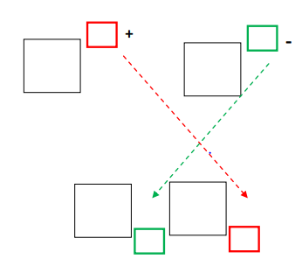
- Calcium hydroxide

