Absence work
09 April 2020
Metals and Non metals

Read the information below, then answer the questions that follow.

Metals are found to the left side of the periodic table. We use many of these metals due to their useful properties. For example, wires are often made of copper which conducts electricity and is ductile, which means it can be drawn into a thin wire. We use metals to make saucepans because they conduct heat well and have a high melting and boiling point. Metals are also malleable, meaning they can be bend into shape, such as for paperclips or drinks cans. Metals are also highly dense. Density is the amount of mass per unit volume and so a dense substance is a substance with a large amount of mass in a given space. Finally, metals are sonorous, they make a sound when hit, which is useful for bells.
Non-metals are found on the right side of the periodic table. They are usually poor conductors of heat and electricity, which we call insulators. They also have lower melting points (Change of state between a solid and a liquid) and lower boiling points (change of state between a liquid and a gas). They are usually brittle (break/shatter easily). In contrast to metals, which are usually shiny when cut, non-metals are dull and are typically either solids or gases at room temperature.

Copy out the questions below and write your answers in full sentences.
Checkpoint questions:
- What makes metals a good material for saucepans?
- What two properties make copper useful for wires?
- What do we call materials that are poor conductors?
- What property defines an object that is hard but breaks easily?

Copy the key knowledge table into your exercise books.
Key knowledge- Do your look, cover, write check by learning the answers to the questions below.
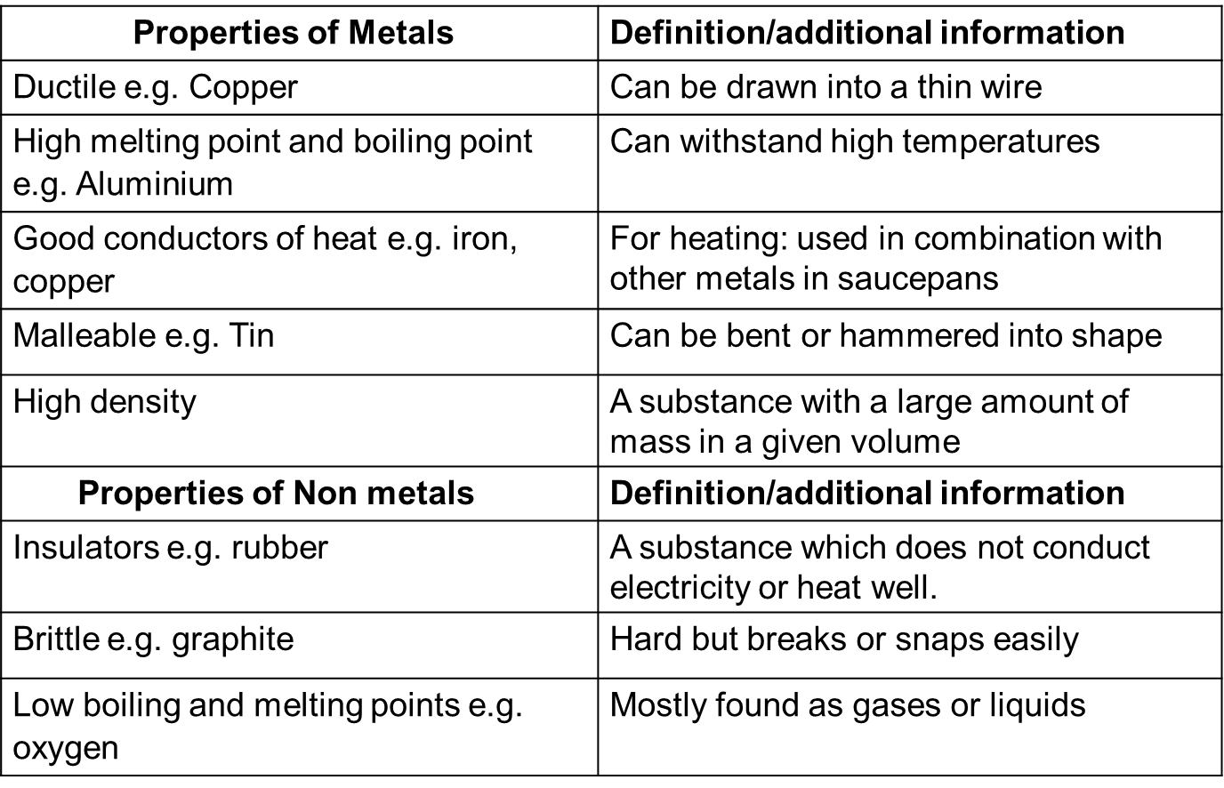
Complete the sentences below in your exercise book.
Recall Quiz:
- A ductile metal is a metal that can be…
- Metals that are good conductors of heat are used for…
- Malleable metals can be…
- A dense metal is a metal with a large amount of…
- A brittle substance is hard but…
Copy the table in your exercise books and complete it with the listed properties.
Recall Task:
- High melting and boiling point.
- Low melting and boiling point.
- Thermal and electrical insulators.
- Thermal and electrical conductors.
- Low density.
- High density.
- Shiny when polished.
- Dull
- Brittle as solids (break easily).
- Can be hammered into shape (malleable).
- Ductile
Metals | Non-Metals

Plenary
Write your answers in complete sentences in your exercise books.
- State where you would find non-metals on the periodic table.
- What does the group number of an element tell us about its structure?
- State two properties of metals, giving examples.
- Define malleable.

