Absence work
14 April 2020
Relative Formula Mass

Read the information below, then answer the questions that follow.
The atomic mass number shows the number of protons + the number of neutrons found in an atom. 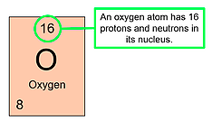 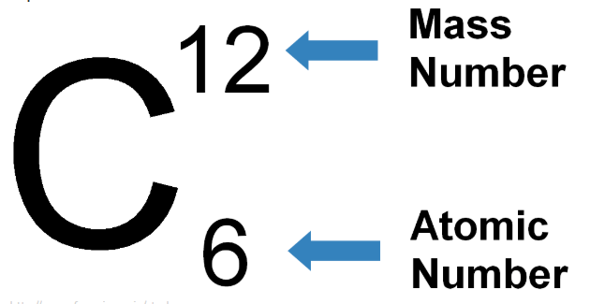
Molecules are made up of atoms, bonded together. In the formula CO_{2,} the small 2 next to the O tells us that in a carbon dioxide compound, there is one carbon and two oxygen.
The relative formula mass (M_{r}) of a compound is the sum of all the atomic masses of each element within the compound. Let’s calculate this for carbon dioxide.
CO₂
Mass of Carbon = 12
Mass of Oxygen = 16. There are 2 Oxygen atoms, thus 16x2 = 32
32+12 = 44 (relative formula mass of carbon dioxide)

Copy out the questions below and write your answers in full sentences.
Checkpoint questions:
- How many oxygen atoms are there in CO₂?
- How many carbon atoms are there in CO₂?
- How do we calculate the Mr of a compound?
- Which number on the periodic table is the mass number?
- How many hydrogen atoms are there in water (H₂O)?
- How many oxygen atoms are there in water (H₂O)?
Copy the key knowledge table into your exercise books.
Key knowledge- Do your look, cover, write check by learning the answers to the questions below.
What is the atomic mass number of an element? | The total number of protons and neutrons.
What is the relative formula mass of a compound? | The sum of all the atomic masses of each element.
What is atomic mass number shortened to? | Ar
What is relative formula mass  Shortened to? | Mr
Which number is the atomic mass number on the periodic table? | The bigger number.
Complete the sentences below in your exercise book.
Recall Quiz:
- The atomic mass number is the ______ number on the periodic table.
- The atomic mass number shows the number of _______ + __________ in a single atom of an element.
- Atomic mass number is shortened to ___ whereas relative formula mass is shortened to ___.
- The relative formula mass of a compound is…

Application Task - I do
Example 1: the M_{r} of the compound H₂O is calculated by:
Ar of H = 1 x 2
Ar of O = 16 x 1
Total = 18

Application Task - We do
Example 2: the M_{r} of the compound NH₃ is calculated by:
Ar of H = 1x 3
Ar of N = __ x__
Total = ______

Application Task – You do
Example 3: the M_{r} of the compound CO₂ is calculated by:
Ar of C =
Ar of O =
Total =

Independent Task
Find the Mr of these compounds using the following format in your exercise books.
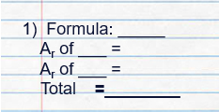
- Hydrogen gas (H₂)
- Carbon monoxide (CO)
- Sulphur dioxide (SO₂)
- Sulphur monoxide (SO)
- Hydrochloric acid (HCl)

Extension
Sometimes we will come across compounds with formulas including brackets. For example: magnesium hydroxide Mg(OH)₂
With brackets, everything inside the brackets is multiplied by the small number after the brackets. That means that we need to multiply the Ar of oxygen by 2, as well as the Ar of hydrogen by 2.
Mg(OH)₂
Mass of Magnesium = 24
Mass of Oxygen = 16x2
Mass of Hydrogen = 1x2
24+32+2 = 58
Example 2: Al₂ (SO₄)₃
Mass of Aluminium = 27x2
Mass of Sulphur = 32x3
Mass of Oxygen = 16x4x3
54+96+192 = 342
Independent Task
Find the Mr of these compounds using the following format in your exercise books.
- Magnesium nitrate Mg(NO₃)₂
- Calcium nitrate Ca(NO₃)₂
- Beryllium nitrate Be(NO₃)₂

