Absence work
14 April 2020
Halogens

Read the information below, then answer the questions that follow.
Group 7 are also called the halogens. They are all non-metals as they are found on the top right hand side of the periodic table. They are fluorine, chlorine, bromine, iodine and astatine.
Just like with the alkali metals, the halogens gain one electron shell as you go down the group. However, unlike the alkali metals, the halogens have 7 electrons in their outer shells.
All the halogens have low melting and boiling points and there is a trend in the melting and boiling points whereby they increase down the group. We see this in the states of each halogen at room temperature. For example: fluorine is a pale yellow gas at room temperature, chlorine is a pale green gas at room temperature , bromine is an orange liquid and iodine is a grey solid. The colour of each halogen also darkens as you go down each group. The halogens exist as simple molecules. Each molecule contains two halogen atoms joined by a single bond. We say they are diatomic, di-standing for 2, atomic standing for atom.
Copy out the questions below and write your answers in full sentences.
Checkpoint questions:
- Which element has the symbol Br?
- What is one similarity between halogens and alkali metals, in electron structure, as you go down the group?
- What is one difference between halogens and alkali metals, in electron structure, as you go down the group?
- How many electrons do halogens have in their outer shell?
- Which halogen is a pale yellow gas at room temperature?
- What state and colour is bromine at room temperature?
- What does diatomic mean?

Copy the key knowledge table into your exercise books.
Key knowledge- Do your look, cover, write check by learning the answers to the questions below.
In what form do the group 7 halogens naturally occur? | Diatomic (Each molecule contains two halogen atoms joined by a single bond)
What are the trends in melting points and boiling points of the halogens? | Low melting and boiling points which increase as you go down the group.
Give the state and colour of fluorine at room temperature. | A pale yellow gas
Give the state and colour of chlorine at room temperature. | A green gas
Give the state and colour of bromine at room temperature. | a brown/orange liquid
Give the state and colour of iodine at room temperature. | A grey solid
How many electrons do the halogens have in the outer shell? | 7 electrons
State the trend in number of shells as you move down the group. | Number of shells increases meaning the atom gets larger
Complete the sentences below in your exercise book.
Recall Quiz:
- Which halogen is a green gas?
- Which halogen is a solid at room temperature?
- Which halogen is a pale yellow gas?
- Which halogen is an orange/brown liquid?
- Describe the trend in the melting and boiling points as you go down the group.
- How many electrons do halogens have in their outer shell?

Application Tasks- these tasks are based on the graph below
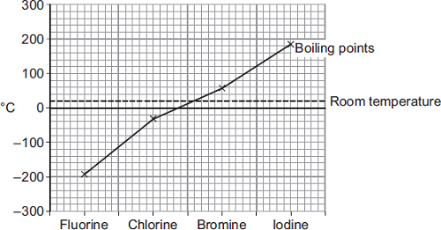
- I do: Copy the question and the model answer in your book.
Explain how the graph shows that Fluorine is a gas at room temperature. Use data from the graph.
Fluorine is a gas at room temperature because it has a boiling point between -180 and to -200ºC, which is far lower than room temperature.
We do: Copy and complete the sentence in your exercise book.
Explain how the graph shows that Iodine is not a gas at room temperature. Use data from the graph.
Iodine is not a gas at room temperature because ……
You do: Copy the question and write your answer in complete sentences in your book.
Explain how the graph shows that chlorine is a gas at room temperature. Use data from the graph.
Extension Task- Write your answer as a paragraph in your exercise book.
Comparing the trends in properties of the halogens to the properties of the alkali metals (4 marks)
Success criteria:
- Compare the trend in reactivity of group 1 and 7 elements
- Compare the state of group 1 and group 7 elements at room temperature
- Compare the trend in melting and boiling point of group 1 and group 7 elements.
- Compare the number of electrons found in the outer shells of group 1 and group 7 elements.

