Absence work
16 April 2020
Gas Tests

Read the information below, then answer the questions that follow.
During a chemical reaction a gas can sometimes be produced, however, many commonly produced gases are colourless and odourless (no smell). We can carry out a test to check which gas is being produced. When carbon dioxide is bubbled through limewater, it turns cloudy. When oxygen is produced it causes a glowing splint to relight. Hydrogen is another colourless and odourless gas, which we test for by putting a lit splint near to the reaction. If you hear a squeaky popping sound, it tells you that hydrogen is being produced. The following reactions produce carbon dioxide, oxygen and hydrogen respectively.
- hydrochloric acid + calcium carbonate metal chloride + water + carbon dioxide
- hydrogen peroxide oxygen + water
- hydrochloric acid + metal metal chloride + hydrogen
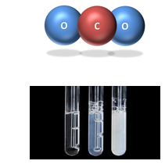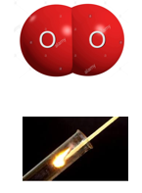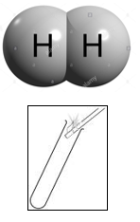

Copy out the questions below and write your answers in full sentences.
Checkpoint questions:
- Why are gas tests important?
- Which gas burns with a squeaky pop?
- Which gas relights a glowing splint?
- What do acids need to react with to produce hydrogen gas?
- Which gas is produced when an acid reacts with a carbonate?

Copy the key knowledge table into your exercise books.
Key knowledge- Do your look, cover, write check by learning the answers to the questions below.
Why is sometimes hard to tell which gas has been produced in a reaction? | Lots of gases are colourless and odourless
What happens to limewater when carbon dioxide is bubbled through it? | The limewater turns cloudy
What happens to a glowing splint when exposed to oxygen gas? | The glowing splint relights
What happens to a lit splint when exposed to hydrogen gas? | The lit splint burns with a squeaky pop

Complete the sentences below in your exercise book.
Recall Quiz:
- We use gas tests because most common gases produced in reactions are __________ and __________.
- To test for carbon dioxide, bubble the gas produced through __________, which turns _______.
- To test for oxygen, use a…, which will _______.
- To test for hydrogen, use a…, which will produce a…

Application Question -I do
Sophie dropped a lump of magnesium (Mg) into a test tube of hydrochloric acid (HCl), the chemical magnesium chloride (MgCl₂) was formed. Sophie also noticed a gas being formed. When a lit splint was placed in the gas it made a squeaky ‘pop’ sound.
1. Which gas did Sophie make? Hydrogen
2. What would be the word equation for this chemical reaction?
Magnesium + Hydrochloric Acid Magnesium Chloride + Hydrogen
3. What would be the symbol equation for this chemical reaction?
Mg + 2HCl MgCl₂ + H₂

Application Question – You do
Copy the questions then write your answers in complete sentences
- Sodium combines with Hydrochloric Acid to produce Sodium Chloride and a colourless gas. The gas makes a squeaky pop when a lit splint is put near it.
- What is the gas that has been produced?
- What is the word equation for this experiment?
- What is the symbol equation for this experiment (use your planner to help you).

- In photosynthesis, plants use Carbon Dioxide and Water to produce Glucose (C₆H₁₂O₆) and a colourless gas. The colourless gas will relight a glowing splint.
- What is the gas that has been produced?
- What is the word equation for this experiment?
- What is the symbol equation for this experiment (use your planner to help you).

- Copper Carbonate reacts with Sulphuric Acid to form Copper Sulphate, Water and a colourless gas. The gas makes limewater turn cloudy.
- What is the gas that has been produced?
- What is the word equation for this experiment?
- What is the symbol equation for this experiment (use your planner to help you).

