Absence work
09 April 2020
Alloys

Read the information below, then answer the questions that follow.

In metals, the atoms are all the same size and arranged in regular rows. This means that the rows of atoms can slide over each other if a force is applied. This makes the metal softer and malleable. To make metals stronger we can add other elements to make a mixture, we call this mixture an alloy.
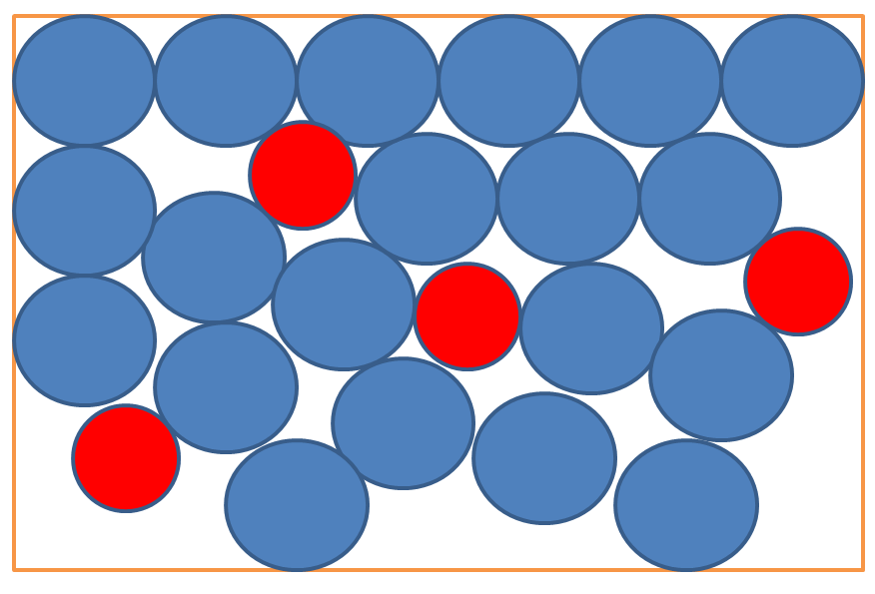
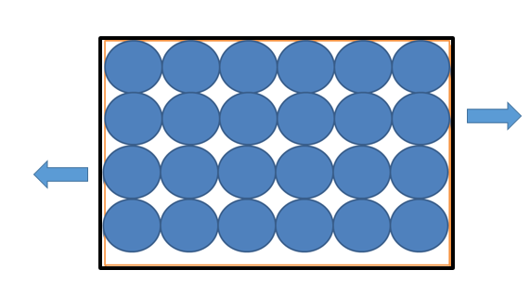To make metals stronger we can add other elements to make a mixture, we call this mixture an alloy. In an alloy the rows of atoms are broken up by atoms that are different sizes. This distorts the regular rows so that they cannot slide over each other when a force is applied. This makes the alloy stronger than pure metals.

Copy out the questions below and write your answers in full sentences.
Checkpoint questions:
- What happens to the rows of atoms to make metals malleable?
- How are atoms in an alloy arranged?
- How are the atoms in an alloy arranged?
- Why are allows stronger than pure metals?
Copy the key knowledge table into your exercise books.
Key knowledge- Do your look, cover, write check by learning the answers to the questions below.
Define alloy, giving examples. | Mixture of two or more elements, one is a metal. E.g. Bronze, Brass and Steel.
Describe the size of the atoms in a pure metal. | The same size as one another
Describe the arrangement of the atoms in a pure metal | In regular rows
Describe the size of the atoms in an alloy. | Different sizes because more than one type of element is present
Describe the arrangement of the atoms in an alloy. | Irregularly
Describe what happens to the rows of atoms when a pure metal is hit. | The rows slide over each other

Answer the questions below in your exercise book.
Recall Quiz:
- Describe the size of the atoms in a pure metal?
- How are the atoms in a pure metal arranged?
- Describe the size of the atoms in an alloy?
- How are the atoms in an alloy arranged?
- What happens to the rows of atoms when a pure metal is hit?
- Would the atoms slide over each other in this metal shown here: 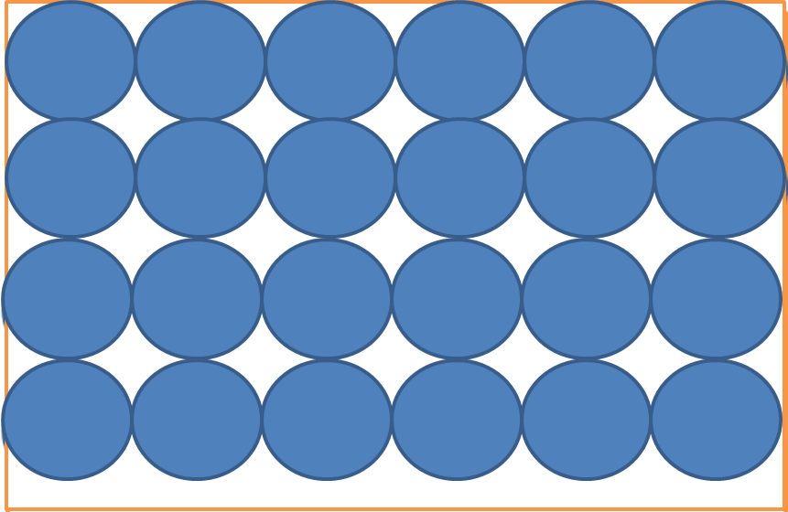

Application Task – I do

Is this an alloy or a pure metal? Justify your answer.
I know this is a pure metal because all the atoms are the same size and they are arranged in regular rows. This means the rows can slide over each other when the metal is hit.
Application Task – We do
Copy and complete the question in your exercise book.

Is this an alloy or a pure metal? Justify your answer.
I know this is a (pure metal/alloy) because… This means the rows (can/cannot)…

Application Task – You do
Copy and complete the question in your exercise book.

Is this an alloy or a pure metal? Justify your answer.
I know this is a (pure metal/alloy) because… This means the rows (can/cannot)…

