Absence work
14 April 2020
Atomic Structure

Read the information below, then answer the questions that follow.
All substances are made of atoms. An atom is the smallest part of an element that can exist. An atom is made up of three sub-atomic particles. Sub-atomic means smaller than or within an atom. The three subatomic particles are the protons, neutrons and electrons. Protons and neutrons are located at the centre of atoms, which we call the nucleus. The electrons are located around the outside of the atom, orbiting the nucleus. 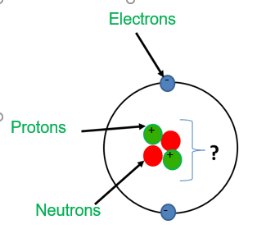
The periodic table gives us information about the number of protons, neutrons and electrons in an atom of each element. Firstly, we have the atomic mass number. The atomic mass number shows the number of protons + the number of neutrons found in an atom. Secondly, we have atomic number, which tells us the number of protons in an atom of an element. We can figure out the number of electrons in an atom because a neutral atom will always have the same number of electrons as protons.
Copy out the questions below and write your answers in full sentences.
Checkpoint questions:
- What do we call the centre of an atom?
- What two sub atomic particles are found in the nucleus?
- What does the atomic mass number of an element tell us?
- What does the atomic number of an element tell us?
- How do we calculate the number of neutrons an atom has?
- How do we find out the number of protons an atom has?
Copy the key knowledge table into your exercise books.
Key knowledge- Do your look, cover, write check by learning the answers to the questions below.
Define atomic mass number. | The number of protons added to the number of neutrons.  (this is the bigger number for each element)
Define atomic number. | The number of protons.  (this is the smaller number for each element)
How do you calculate the number of protons for an element? | Use the atomic number
How do you calculate the number of electrons for an element? | Use the atomic number
How do you calculate the number of neutrons for an element? | Atomic mass number - atomic number

Complete the sentences below in your exercise book.
Recall Quiz:
- An atom of titanium contains 22 protons. This means that it has __ electrons.
- Adding the number of protons to the number of neutrons give us an atom’s…
- The number of protons, on the other hand, gives us…
- In order to calculate the number of neutrons, we must…
Application Task – I do
Calculate the number of protons, neutrons and electrons in a Boron atom
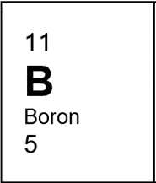
Protons: Look at the atomic number (smaller number) – 5 protons
Electrons: Look at the atomic number (smaller number) – 5 electrons
Neutrons: Atomic mass number – atomic number 11-5 = 6 – 6 neutrons

Application Task – You do
In your exercise books calculate the number of protons, neutrons and electrons in a Sulphur, Sodium and Magnesium atom.
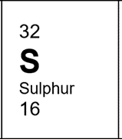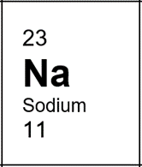
Sulphur: Protons = electrons = Neutrons =
Sodium: Protons = electrons = Neutrons =
Magnesium: Protons = electrons = Neutrons =

Independent Task
Copy the table and calculate the number of protons, electrons and neutrons for the first 5 elements in the periodic table.
Element | Symbol | Atomic number | Atomic mass | Number of protons | Number of neutrons | Number of electrons
Hydrogen | H | 1 | 1
Helium | He | 2 | 4
Lithium | Li | 3 | 7
Beryllium | Be | 4 | 9
Boron | B | 5 | 11

