- Look at the information below and complete all exercises!
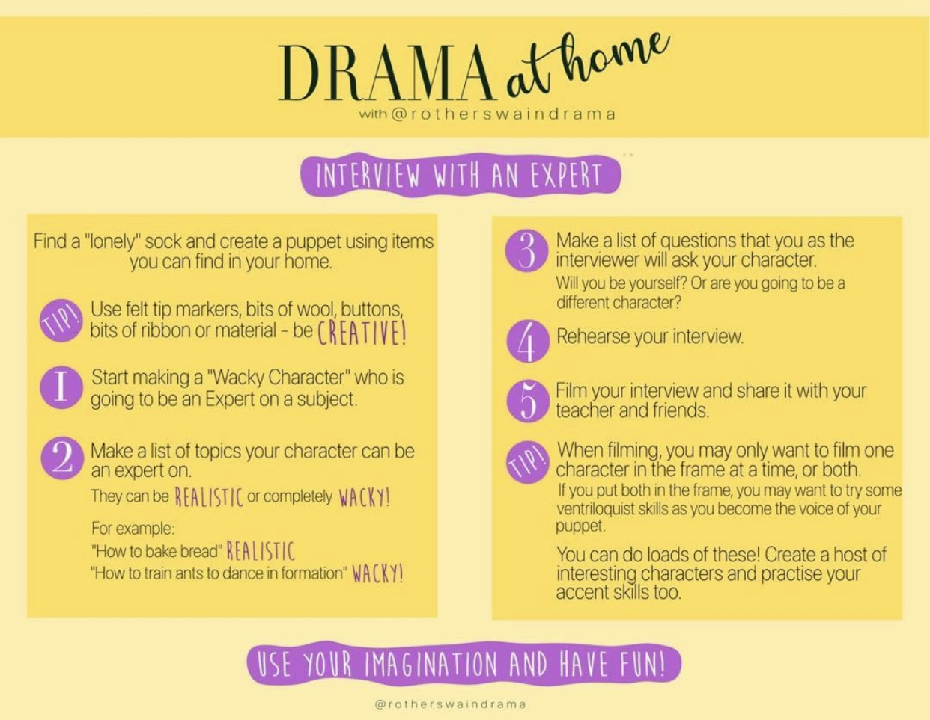
- Try and have fun with this and be as creative as you possibly can!

