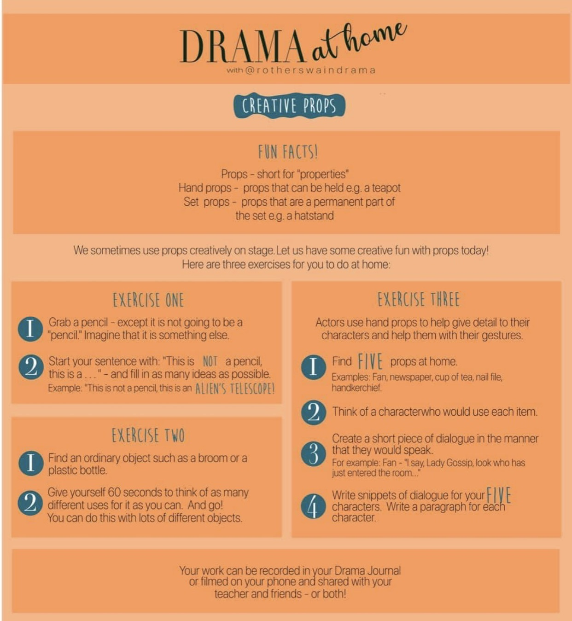
- Look at the information below and complete all three exercises!
- Try and have fun with this and be as creative as you possibly can!

