Year 8 – Drama Work
Look at the picture:

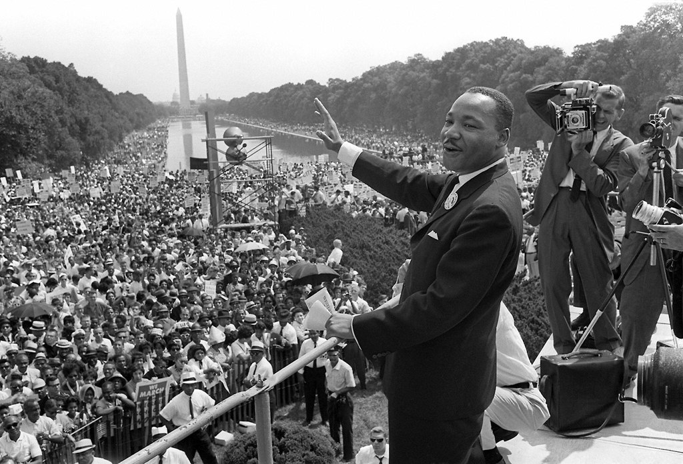

Task 1:
Consider the following about this picture:
- Who is involved?

- What is the story about?

- When does the story take place?

- Where does the story take place?

- Why has this happened?

Task 2:
Now write a script based around the picture. You could write about any of the following or any other idea you may have:
- The back story of how this event happened?
- What happens after this picture?

