Term 6 Week 5 Lesson 2 Year 10: Presenting
Do now:
- What is feedback?
- What does ‘elaborate’ mean?
- How should you respond to questions about your speech to get a distinction?

Keywords:
- formal language - language used in situations that are serious or that involve people we do not know well.
- body language - the conscious and unconscious movements and postures by which attitudes and feelings are communicated.

Task 1:
Formal or informal?
1) “Hi, Laura. How’s it going?”
“Not bad, ta.”
2) “We would like to interview you for the role of prefect.”
“Thank you.”
3) “Why-dya do that?”
“Dunno.”
4) “What time is the exam?”
“It starts at nine o clock.”
5) “Did you always want to be an actor?”
“I did.”

Task 2:
Your presentation can be delivered in many different ways.
- You may wish to simply speak to your audience.
- You may want to use props to help your audience to understand what you are talking about.
- you may wish to use a PowerPoint to support what you are saying.
If you are going to use a PowerPoint there some things you need to think about:
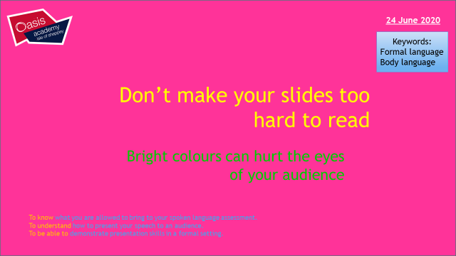

- Check for spelling mistakes and grammar. You will ruin the amazing things you are saying if everyone can see a mistake on your PowerPoint!
- Don’t put too much information on one slide. Your audience will be reading instead of listening to you.
- Don’t use animations – YOU are the star of your exam, not your PowerPoint!
- Don’t read every single word of your speech from your PowerPoint. You won’t be making eye contact with your audience and it will be boring. Just have key points or pictures to support what you are saying.
If you don’t have access to PowerPoint – don’t worry. You don’t have to use technology to give a great speech.
You can use props or photos.
You can just stand up and give your speech with your flashcards.

Depending on HOW you are going to present:
- Create your PowerPoint to support your speech
- Create your flashcard to help prompt you on key points / dates / statistics (you can only have 8-9 points and NO FULL SENTENCES.
- Make a list of any props or photos you want to bring with you
Task 3:
If you have not already done so, finish your speech and check through for SPaG.
Practise reading it out loud and check it with these bullet points:
- Does it sound good? Are there parts that sound clumsy or wrong? Correct them.
- Is it long enough? It needs to be at least 4 minutes long to allow you to get the marks.
- Have you used a range of AFORREST?
- Have you used personal pronouns?
- Have you acknowledged the counter-argument?
- Have you structured it so it flows well?
- Do you have a hook at the beginning to engage your audience?
- Have you summed up your speech in your conclusion?

