Term 6 Week 5 Lesson 1 Year 9: Unseen Poetry
Do Now:
Q1 ‘A Christmas Carol’ | Who is Scrooge’s clerk?
Q2 ‘A Christmas Carol’ | Complete the quotation:  “As solitary as…………………….”
Q3 ‘An Inspector Calls’ | Priestley held what kind of political views?
Q4 ‘An Inspector Calls’ | Which character does Priestley use as his mouthpiece?
Q5 Subject Terminology | “No warmth could warm, no wintery weather chill him”  Name the linguistic device being used in this quotation.

When I am dead, my dearest,
Sing no sad songs for me;
Plant thou no roses at my head,
Nor shady cypress tree:
Be the green grass above me
With showers and dewdrops wet;
And if thou wilt, remember,
And if thou wilt, forget.

I shall not see the shadows,
I shall not feel the rain;
I shall not hear the nightingale
Sing on, as if in pain:
And dreaming through the twilight
That doth not rise nor set,
Haply I may remember,
And haply may forget.
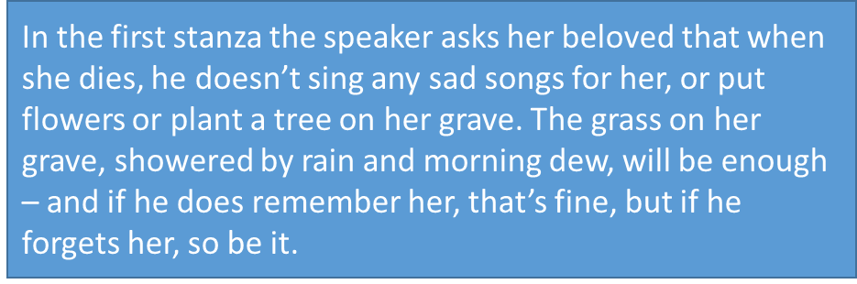

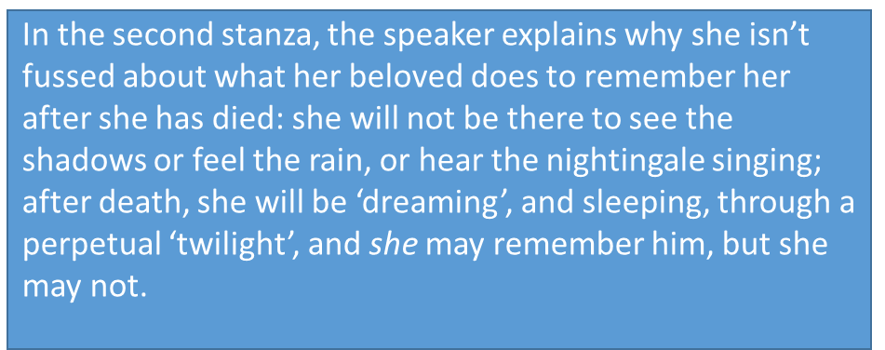

What is the tone of the poem?_________________________________________________________
Does the poem have a rhyme scheme?__________________________________________________
Does it sound cheerful or sad?_________________________________________________________
Can you see a semantic field in the poem?_______________________________________________

Analytical paragraph: In When I Am Dead My Dearest how does the poet show attitudes towards death?
Model paragraph:
The writer does not appear to be bothered by death. At the end of each stanza she tells her lover he can ‘remember’ or ‘forget’ her. In other words, she realises that when she is dead it won’t matter what he does as she won’t be there to know. More specifically, the juxtaposition of ‘remember’ and ‘forget’ shows how open minded she is about the idea of death, with no real opinions or feelings on it.
Your turn (at least two paragraphs)…

