Term 5 Week 3 Lesson 1 Year 10: Unseen poetry - Solitude
Do now:
- What is the definition of ‘solitude’?
- What is ‘enjambment’?
- List as many personal pronouns as you can.

Exam Question:
QUESTION 11: Compare the ways the writers present solitude in The Clown Punk and Solitude.
In your answer, you should compare:
- the ideas in the poems
- the poets’ use of language
- the poets’ use of form and structure.
Use evidence from the poems to support your comparison.
(Total for Question 11 = 20 marks)

Annotate the poems
Answer the questions below to show that you have read and annotated the two poems on the next page:
Poem 1 – The Clown Punk
- What is the poem about? Who is the person talking to in the poem? (form)
- Does this poem rhyme? Why / why not? What effect does this have on the reader? (structure)
- Explain why the poet has used so much enjambment in the poem – what effect does it have on how you read it? (structure)
- Find the simile and explain what it shows about the man. (language)
- What does “every pixel of that man’s skin
is shot through with indelible ink;” mean? Why would the poet use those particular words to describe his appearance? (language)
- What technique is used on the last line? What does it mean? How does this ending affect the reader? (language and structure)

Poem 2 - Solitude
- What is the poem about? What person is the poem written in? what effect does this have on the reader? (form)
- Does this poem rhyme? Why / why not? (structure)
- How is the tone of this poem different to Poem 1? (form)
- Find two examples of personification and explain their effect on the reader. (language)
- How is the poem split? Look at the two stanzas and think about how he describes sound. (structure)
- “Of sound the shadowy sun-pierced silences.” What technique is used here? This technique is usually used to create a sinister tone BUT the poet has created a positive tone here – how has he accomplished this? What do the ‘s’ noises sound like in this line? (language)

Poem 1: The Clown Punk

Driving home through the shonky side of town,
three times out of ten you’ll see the town clown,
like a basket of washing that got up
and walked, towing a dog on a rope. But

don’t laugh: every pixel of that man’s skin
is shot through with indelible ink;
as he steps out at the traffic lights,
think what he’ll look like in thirty years’ time –

the deflated face and shrunken scalp
still daubed with the sad tattoos of high punk.
You kids in the back seat who wince and scream
when he slathers his daft mush on the windscreen,

remember the clown punk with his dyed brain,
then picture windscreen wipers, and let it rain.

Simon Armitage

Poem 2: Solitude
How still it is here in the woods. The trees
Stand motionless, as if they did not dare
To stir, lest it should break the spell. The air
Hangs quiet as spaces in a marble frieze.
Even this little brook, that runs at ease,
Whispering and gurgling in its knotted bed,
Seems but to deepen with its curling thread
Of sound the shadowy sun-pierced silences.
Sometimes a hawk screams or a woodpecker
Startles the stillness from its fixed mood
With his loud careless tap. Sometimes I hear
The dreamy white-throat from some far-off tree
Pipe slowly on the listening solitude
His five pure notes succeeding pensively.
Archibald Lampman

Planning
Remember the house plan?
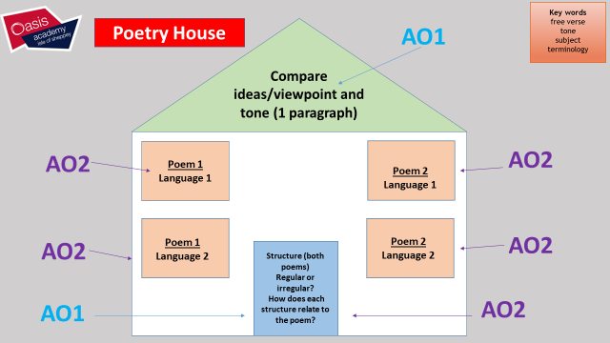

I have created a ‘house’ plan out of text boxes so that you can fill in your comparisons and show your plan. It has a flat roof for more room.
Please complete the house on the next page.

HOUSE PLAN
Structure – last paragraph
FORM – 1st paragraph
Poem 2 – Language 2
Poem 1 – language 2
Poem 2 - language
Poem 1 - language
:

Exam Question:
QUESTION 11: Compare the ways the writers present solitude in The Clown Punk and Solitude.
In your answer, you should compare:
- the ideas in the poems
- the poets’ use of language
- the poets’ use of form and structure.
Use evidence from the poems to support your comparison.
(Total for Question 11 = 20 marks)

Model language paragraph:
Armitage uses aggressive language to describe the solitary man in ‘The Clown Punk’: “every pixel of that man’s skin / is shot through with indelible ink.” In other words, the man is covered with tattoos. More specifically, Armitage uses the inhuman noun “pixel” to suggest that the man is simply a canvas that has been painted on. In addition, the aggressive verb “shot” refers to the tattoo gun that made the images. As tattoos can be seen as anti-social and worn by individuals not accepted by polite society, this line would make the reader understand why the man is a social outcast and living in solitude. In contrast to ‘The Clown Punk’, Lampman uses calm and magical language in ‘Solitude’: “The trees / Stand motionless, as if they did not dare / To stir.” In other words, it is peaceful and calm in the woods. More specifically, Lampman has used personification to imply that even the trees “did not dare” to disturb the silence. He continues the peaceful atmosphere of his solitude by suggesting the trees do not want to “break the spell”, emphasising the positive, even magical, experience the persona is having alone in the woods. The reader would feel the connection that the persona shares with nature in his solitude.
Your turn!
Continue the answer to this question with the 2nd language comparison and a short paragraph on structure.
Use your house to help you organise your writing.
Remember to keep using comparison connectives!

