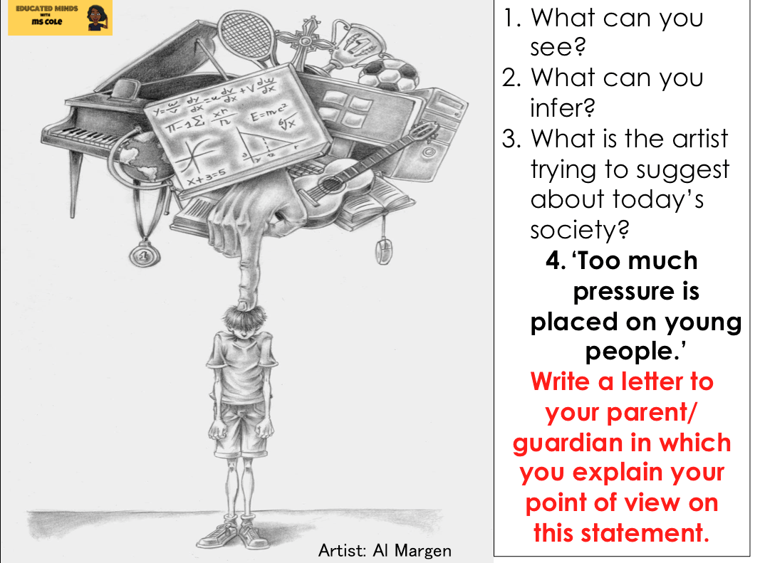
Term 5, Wk 4, Lesson 2, Y11
Remember EPIIIC:
Establish your audience, their views and where they might be.
Picture this: (appeal to the reader’s emotions or pathos)
Imagine… (paint a picture of the ideal situation)
Information (appeal to the reader’s reason or logos)
I (create credibility using person experience: ethos)
Counter argument + conclusion

Language Paper 2

