Year 8 Large Numbers 20-99 L4 Term 5
DO NOW
Revise the numbers from 1-20
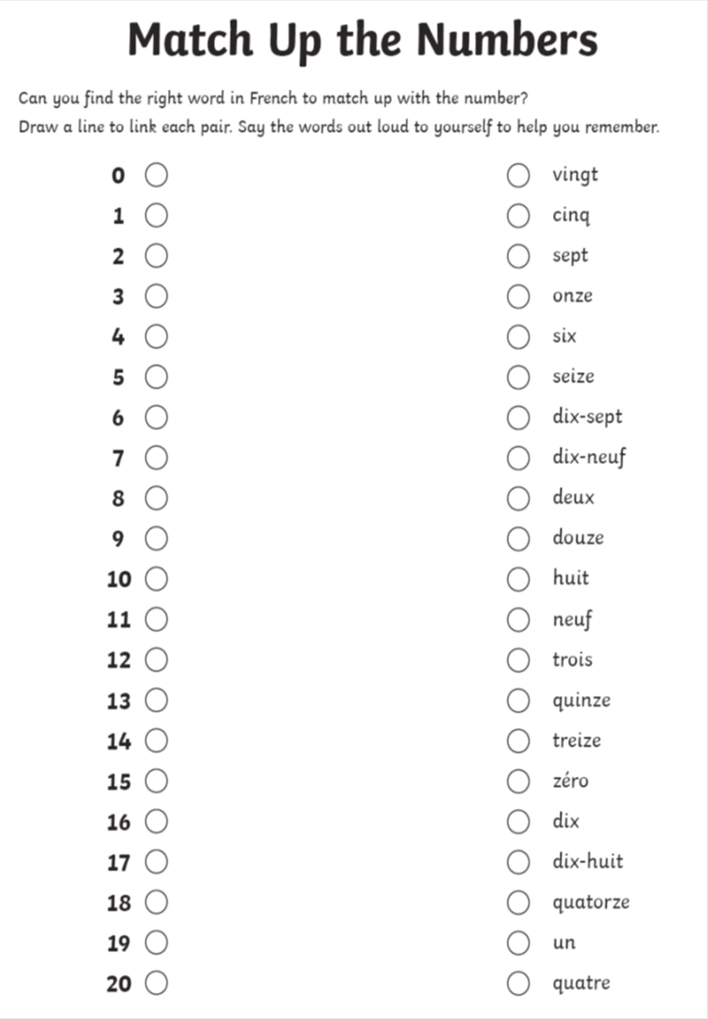
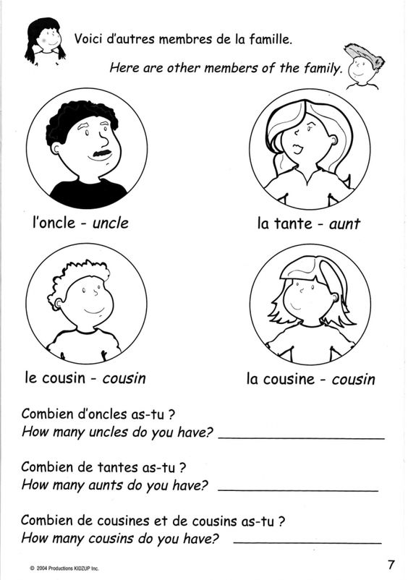
NOTE : Combien = How many ?
Answer the questions below. Write the answers in words, in French.

Look at the larger numbers below. Counting up to 60 is pretty straightforward, once you have learnt it! However, it starts to get a bit trickier from 70! See ‘70’, ‘80’ and ‘90’ below.
cent
100
quatre-vingts
(four-twenty-ten)
quatre-vingt-dix
90
80
(four-twenties)
(sixty-ten)
soixante-dix
70
quarante
cinquante
soixante
60
50
40
trente
30
20
vingt
To count up in units is very simple, just use your knowledge of the smaller numbers in French.
vingt-et-un = 21 vingt-deux = 22 vingt-trois = 23
trente-et-un = 31 trente-deux = 32 trente-trois = 33
Extension: Can you now count to fifty in your head? Have a go!
Can you say the ages of your parents? i.e. ‘Ma mère a quarante-cinq ans et mon père a cinquante ans’

Exercise 1: The numbers in the boxes are not in the correct order. Write out the words in the correct order (smallest first), next to the numbers on the right.

46
53
56
27
33
38
59
45
41
39
24
22
vingt-sept
quarante-six
trente-huit
cinquante-neuf
vingt-quatre
cinquante-trois
cinquante-six
trente-trois
vingt-deux
quarante-et-un
trente-neuf
quarante-cinq

Exercise 2
Look at the following sums:

Write the answers in numbers.

- trente-trois + vingt-six =
- vingt-sept + quarante-cinq =
- onze × trois =
- quatre-vingt-treize – quarante-deux =
- soixante-dix-huit – soixante-huit =

Write the answers in words, in French
- 15 + 32 =
- 41 + 35 =
- 52 + 28 =
- 21 + 43 =
- 66 + 33 =
And finally, here’s 2 puzzles for you.
- complete the number crossword.

- Complete the wordsearch

