Complete quiz A and answer a range of exam questions that add up to 18 marks in total. For example 3x 6markers or 1x9marker + 1x 6 marker + 3marker.
QUIZ A:
- Food consumption refers to….
- Food security is….
- Undernourishment is….
- A physical cause of food insecurity is…. + More specifically…..
- A human cause of food insecurity is…. + More specifically….
- A social impact of food insecurity is famine. A famine occurred in Somalia in……………, which killed….
- Food insecurity = increased food prices because…..
Figure 1
Figure 2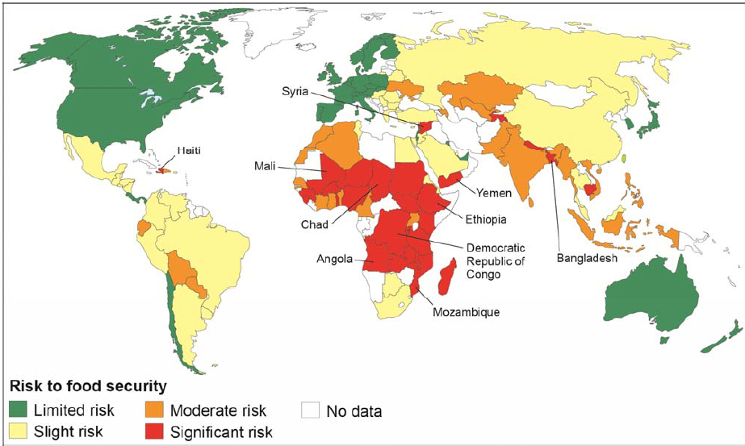
Figure 3

- Increase in food prices = food riots. An example of a food riot occurred in…..
- This food riot resulted in……and lasted…..
- Food insecurity can result in farming on marginal land. Farming on marginal land = soil erosion. More specifically……
- To reduce the risk of food insecurity they launched the green revolution. This is…..
- Why did they launch the new green revolution?

PRACTICE EXAM QUESTIONS
- Study Figure 1, a map showing the percentage of population that was undernourished in Africa in 2014.
- What percentage of the population was undernourished in Chad in 2014? (1 mark)
- Using the map, describe the distribution of countries in Africa where there are high and very high levels of undernourishment. (2 marks)
- Describe the distribution of countries with a significant risk to food security shown in Figure 2. (3 marks)
- Figure 3 shows a list of impacts that are caused by using irrigation in farming. Using Figure 3 and your own understanding discuss the impacts of using irrigation as a method to increase food security. (6 marks)
- Outline the physical and human causes of food insecurity. (6 marks)
- Suggest how food insecurity might affect the quality of life of people. (3 marks)
- Assess the effectiveness of strategies used to increase global food security. (6 marks)

