Russia geography, curse or benefit?
Do Now

- Russia has how many time zones?
- Russia borders ………… countries, including………
- Russia lies on two oceans which are……
- The two major biomes in Russia are……
- Russia has ……………………km of coastline
- A resource that Russia has an abundance of is…..
- A challenge of accessing these resources is ….
- Russia has a population of………..
- Most of Russia is in ………………..
- The natural feature that separates the two continents that Russia lies on is…..
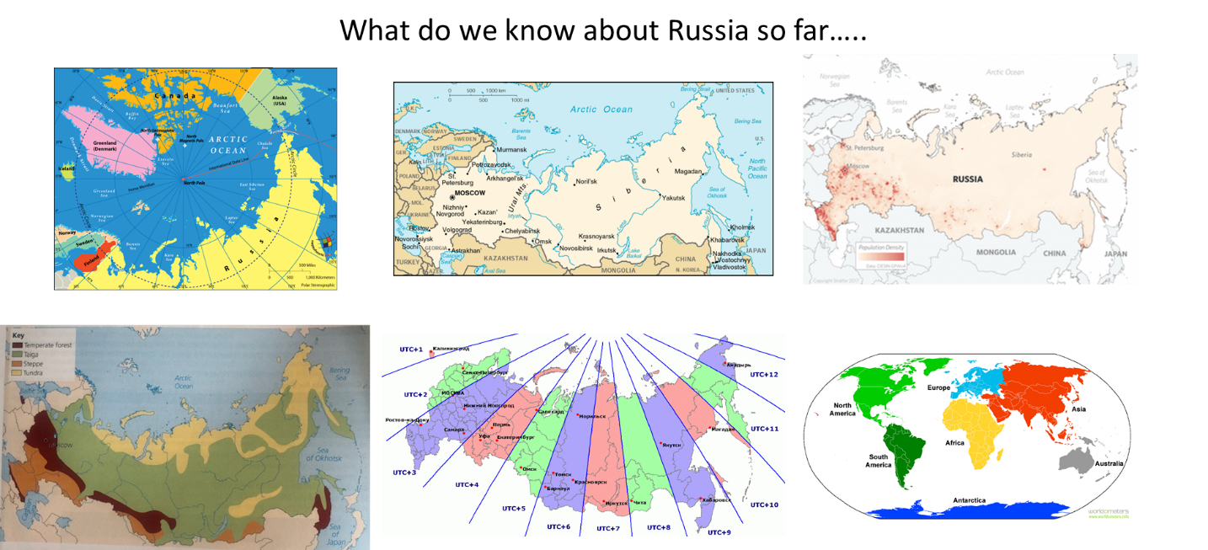
These are all images that we have used throughout the term. Using these images, recall six facts or pieces of information that we have learned about Russia. List them below.

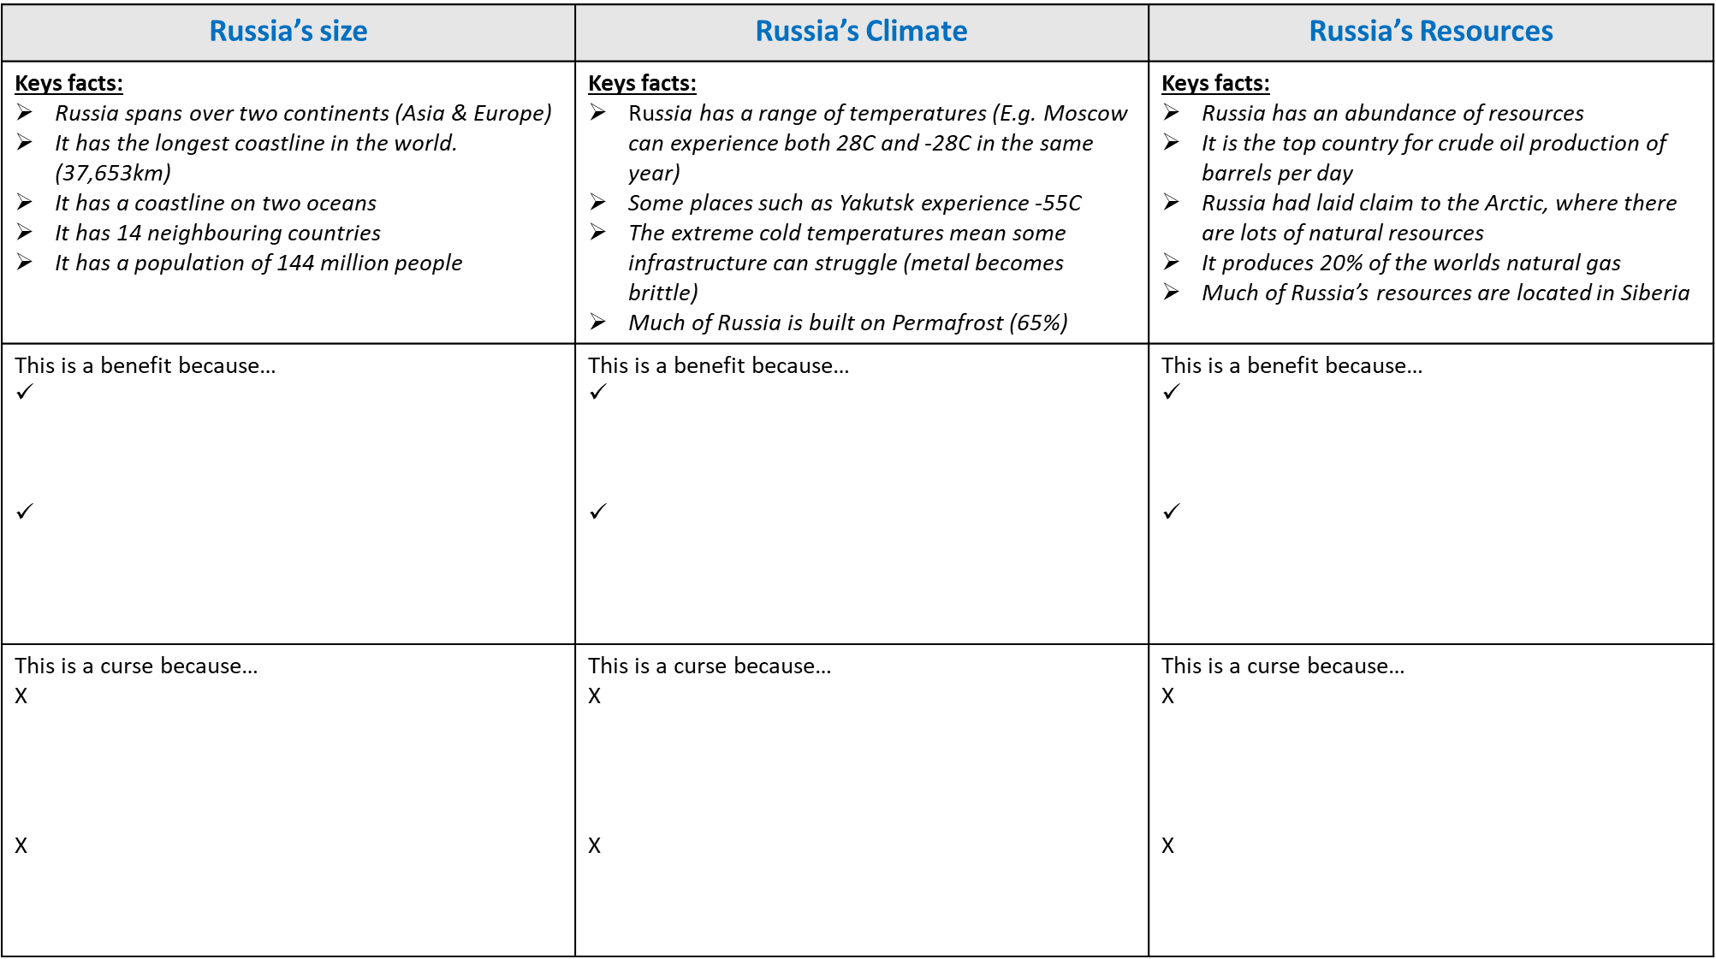
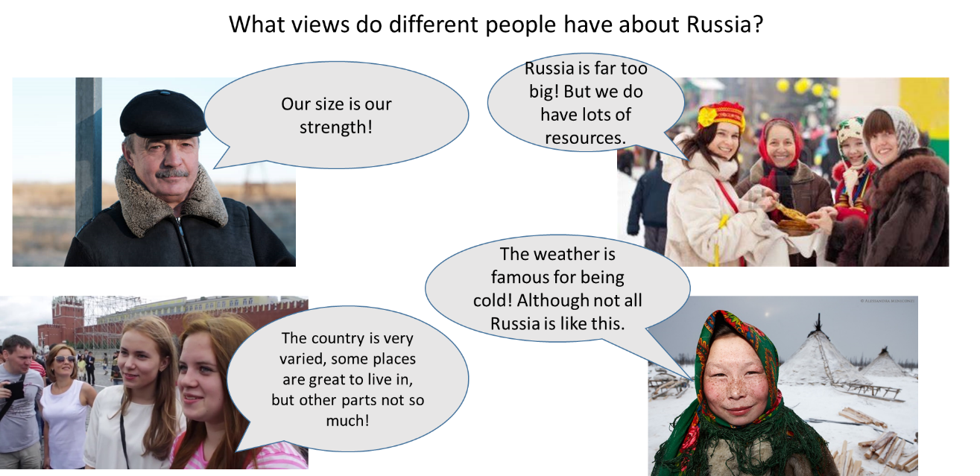

TASK: Using the image above and the Russia facts, complete the tables below.

TASK: Complete the exam question using the writing framework.
To What extent is Russia’s Geography a curse?
Russia is a vast country with an interesting geography. Russia’s geography is both a benefit and a curse.
On one hand Russia’s geography is a benefit for example……………..
More specifically…….
On the other hand Russia’s geography is a curse for example……………..
More specifically…….
Overall…………………
Use this page to write your answer.

